Linköping University | Department of Physics, Chemistry and Biology
Master’s thesis, 60 hp | Applied Ethology and Animal Biology
Spring term 2024 | LITH - IFM -A -EX - 24/4467- SE

Size matters – but how much?
Assessing the ability of spider monkeys (Ateles geoffroyi) to visually discriminate between different sizes of food and non-edible objects

Anne-Sophie van Herwijnen

Lina Roth, examiner
Matthias Laska, tutor
Laura Teresa Hernández Salazar, co-tutor


Contents

1. Abstract 1
2. Introduction 1
3. Materials and methods 3
3.1. Animals 3
3.2. Preference test: Visual size discrimination of food items 4
3.2.1. Behavioural test 4
3.2.2. Experimental design 5
3.3. Operant conditioning test: Visual size discrimination of wooden blocks 8
3.3.1. Behavioural test 8
3.3.2. Test apparatus 8
3.3.3. Experimental design 8
3.4. Data analysis 12
3.4.1. Preference test: Visual size discrimination of food items 12
3.4.2. Operant conditioning test: Visual size discrimination of wooden blocks 12
4. Results 13
4.1. Preference test: Visual size discrimination of food items 13
4.2. Operant conditioning test: Visual size discrimination of wooden blocks 17
5. Discussion 20
6. Societal & ethical considerations 27
7. Acknowledgements 27
8. References 28

Abstract

As all nonhuman primates in the wild inhabit dynamic environments where they encounter a range of foods, they must frequently make decisions about food options in order to meet their metabolic needs. Black-handed spider monkeys (Ateles geoffroyi) live in environments with widely dispersed food patches; therefore, it should be important for them to have a well-developed ability to visually discriminate between fruits that differ in size. Accordingly, this study investigated the ability of ten black-handed spider monkeys to visually discriminate between different sizes of food and non-edible objects. In a two-choice test based on spontaneous preferences, all ten spider monkeys preferred the larger of two simultaneously presented food pieces with increasing size difference, demonstrating a well-developed ability to visually discriminate between food that differs only in size. The smallest size difference for which the monkeys displayed a significant preference for the larger food piece was 11%. Percentages of decisions for the larger food pieces were higher for ball-shaped pieces than for cube-shaped and hemisphere-shaped food pieces. In a two-choice test based on an operant conditioning paradigm, the animals learned to choose the larger of two simultaneously presented wooden blocks with increasing size difference, indicating that spider monkeys can visually discriminate efficiently between different sizes of the same object. All nine spider monkeys who partook in this test successfully reached the learning criterion for the stimulus combinations with a minimum of a 49% size difference. These findings contribute to our understanding of spider monkeys’ abilities to visually discriminate between differently sized objects, providing valuable insights into their adaptive capacities in changing environments.

Keywords: Ateles geoffroyi, food choice, operant conditioning procedure, size discrimination, spider monkey, spontaneous preferences, Weber ratio

Introduction

All animals need to efficiently find and choose between available food resources in order to obtain a sufficient amount of critical nutrients and metabolic energy (Emlen, 1966; Oates et al., 1980; Perry & Hartstone‐Rose, 2010; Flörchinger et al., 2010). Virtually all nonhuman primates in the wild inhabit dynamic environments where they encounter a range of foods and frequently must make decisions about their food choices (Huskisson et al., 2021; Dominy et al., 2001). Nonhuman primates do not select food randomly but rather display marked food preferences (Milton, 1984; Laska et al., 2000). This can be affected by both intrinsic and extrinsic factors (Huskisson et al., 2021) such as an animal’s relative preference for one food item over another, the nutritional composition of the food, its relative spatial and temporal availability, to what extent an animal is willing to go (in terms of energy expenditure, social conflict, etc.) in order to obtain a specific resource, and the respective quantity of food items present.
It has been demonstrated that animals are able to effectively discriminate between various food quantities; primates, in particular, have been extensively studied in these types of tests and are capable of accurately judging different quantities (Beran et al., 2009). A recent study (Bosshard et al., 2022) demonstrated that spider monkeys consistently choose the larger of two simultaneously presented quantities of a given food item (e.g., they choose a bowl containing four sunflower seeds over a bowl containing only two). However, in the wild, primates do not only have to decide between different quantities of food but also between different sizes of food items.
Field studies suggest that nonhuman primates prefer to consume larger fruits compared to smaller fruits of the same plant species (Ungar, 1995; Leighton, 1993; Dias da Silva et al., 2020; Valenta et al., 2020). Similarly, captive primates have shown a preference for larger food items over smaller ones even if they have to wait for them (Menzel and Draper, 1965) and that they have a well-developed ability to visually discriminate between three-dimensional objects that only differ in size (Pribram and Mishkin, 1955; Matsuno and Fujita, 2009).
The black-handed spider monkey (Ateles geoffroyi) is one of the most widespread New World primate species and can be found in the upper canopy of forests in Central- and South America (Gonzalez-Zamora et al., 2009; Campbell, 2008). They are highly specialised frugivores and complement their diet with other plant parts, including young leaves and flowers (Di Fiore et al., 2008; Gonzalez-Zamora et al., 2009). Numerous morphological and physiological traits of spider monkeys are linked to their highly frugivorous diets, i.e., disproportionately long limbs, a more dorsal position of the scapula, and a prehensile tail (Di Fiore et al., 2008; Rosenberger et al., 2008). These modifications may be adaptations that enable them to move quickly and effectively between widely dispersed food patches. Nevertheless, the complex spatiotemporal distribution of patchy food sources and the great distances between fruit-bearing trees require high travel costs and considerable processing capacity (Milton, 1981; Suarez, 2006).
Accordingly, it should be important for spider monkeys to have a well-developed ability to visually discriminate between fruits that differ in size in order to maximise their net gain of metabolic energy while minimising handling time (Stephens et al., 2007; Dias da Silva et al., 2020). The ability to discriminate between three-dimensional objects based on size differences may also be important outside the context of food selection, such as in social conflict (e.g. when sizing up a competitor) or in object manipulation (e.g. when choosing the optimal size of a tool).
It was therefore the aim of the present study:
- to assess the ability of spider monkeys to visually discriminate between different sizes of a given type of food and
- to determine the limits of their visual size discrimination with non-edible objects.

I expected that the spider monkeys would be able to visually discriminate between different sizes of a given type of food or non-edible objects and to display a preference for the larger of two simultaneously presented food pieces.

To this end, I conducted two different experiments with a group of captive black-handed spider monkeys: a two-choice test based on spontaneous preferences and a two-choice test based on an operant conditioning procedure. Performing these experiments on spider monkeys contributes to understanding the food choices of this endangered species in tropical environments and to improving the daily husbandry of captive primates.

Materials and methods

3.1. Animals
The present study was carried out with ten adult black-handed spider monkeys (Figure 1). The group consisted of five males (Bart, Chanel, Homero, Primo and Sorujo) and five females (Trilce, Thalia, Frida, Nena and Juanis), all aged between five and 20 years. The experiment on visual size discrimination of food items included ten individuals and the experiment on visual size discrimination of wooden blocks included nine individuals.
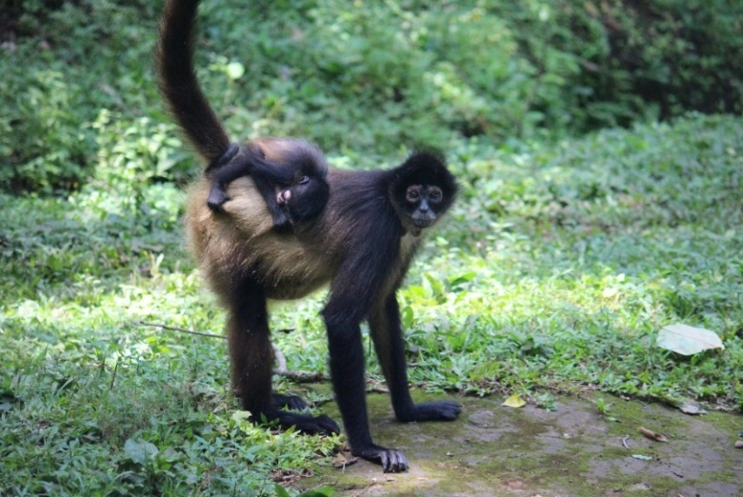
Figure 1. Black-handed spider monkeys (Ateles geoffroyi).
The animals were housed at the field station UMA Doña Hilda Ávila de O’Farrill of the Universidad Veracruzana, located in a nature reserve near Catemaco, Veracruz, Mexico. They were kept in one enclosure, composed of several compartments that were connected by sliding doors. The enclosure had walls of mesh and concrete blocks (up to a height of 1 meter), so that the animals were exposed to ambient temperature, humidity, and light conditions. The compartments were equipped with ropes, branches, tires and other enrichments designed for swinging and climbing. Once per day the animals were provided with fresh fruits and vegetables.
The experiments were carried out in the morning before feeding. All animals have participated in previous cognitive studies; therefore, the animals were accustomed to participating in behavioural tests and interacting with humans. All monkeys were tested individually and temporarily separated from each other by closing the sliding doors between neighbouring compartments of the enclosure, to prevent distraction and interference. Data collection took place between May and September of 2023.

3.2. Preference test: Visual size discrimination of food items

3.2.1. Behavioural test
A two-choice test based on spontaneous preferences was used to assess the ability of spider monkeys to visually discriminate between different sizes of a given type of food. The animals were simultaneously presented with two pieces of food of the same kind which only differed in size (= weight). The weight of the food items (in grams) was used as a directly proportional proxy of their size because it was difficult to cut food to exactly defined dimensions. Three different shapes were presented: cubes, balls and hemispheres.
In each trial, the animal was allowed to choose only one of the two pieces of food, thus it had to make a decision based on its spontaneous preference. By systematically varying the size of the food items it was possible to determine the minimum difference in size for which the spider monkeys still display a spontaneous preference.

3.2.2. Experimental design
In this experiment all ten animals participated. Each monkey was presented with ten stimulus pairs per session, with one to two sessions per day being performed depending on the willingness of the monkey to come to the mesh and participate in the experiment. The larger-sized piece of food was presented equally often on the left and the right side, respectively, and both food pieces were only presented on the same side for a maximum of three times in a row, to control for potential side biases.
For a start, the animals were presented with cube-shaped melon pieces of two of three potential sizes: small (10 x 5 x 5 mm), medium (15 x 15 x 10 mm), and large (15 x 15 x 20 mm). The pieces were cut using a commercial fruit cutter (Uppfylld, Ikea, Sweden). All three possible stimulus combinations were tested: small versus medium, small versus large, and medium versus large. Each of these three stimulus pairs (e.g. 10 x 5 x 5 mm versus 15 x 15 x 20 mm) was presented for a total of 20 times. After these first six sessions, the sizes of the pieces to be presented to the monkeys were changed. In the following six sessions that were performed, food pieces of varying intermediate sizes were cut from the three melon piece sizes that were previously used. These intermediate-sized pieces were randomly picked at moment of presenting and again weighed to determine which of the two similar-sized pieces was the smaller one and which was the bigger one. Therefore, the difference between the food pieces was generally smaller than in the first six sessions.
To start the session, I called the monkey to come to the front of the enclosure, where the animal sat on a platform at the mesh. With my back facing the tested animal, two pieces were weighed on a scale (Ruhhy, M: 00019899 (I2000), 500x0,01g) and the number of grams was recorded. The two pieces were placed on a tray (36 x 26 x 1,5 cm) at a distance of approximately 20 cm apart and presented out of reach for a few seconds while facing the monkey, to ensure the monkey paid attention to both alternatives. Next, I approached the animal, with the tray in the middle of the monkeys’ position, so it could reach through the mesh and select one of the two food pieces (Figure 2). To avoid the monkey grabbing both food pieces, the tray was moved downwards as soon as the monkey grabbed the desired food piece. The monkey’s choices were recorded: ‘large’ if the individual chose the larger piece of the two presented melon pieces, and ‘small’ if the smaller piece of the two presented melon pieces was chosen. To indicate the end of each session, the monkey received a piece of biscuit.
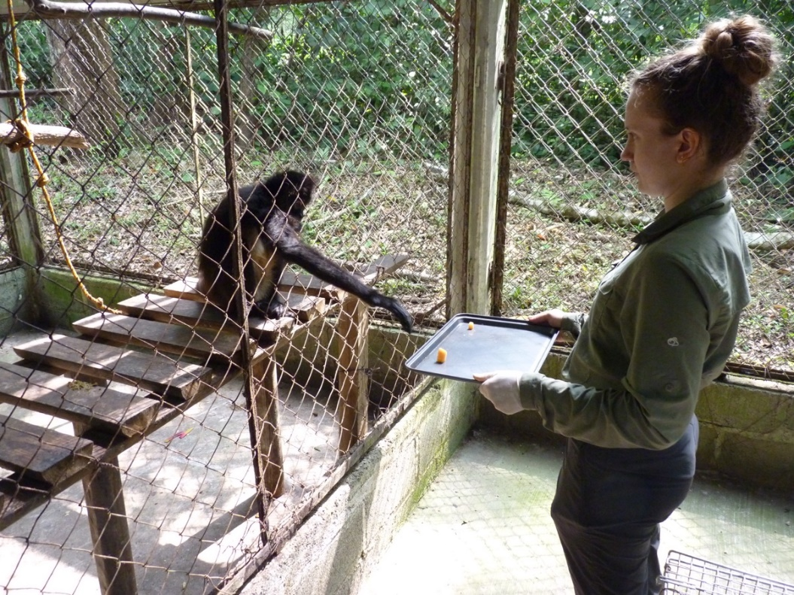
Figure 2. Tray with two differently sized pieces of melon presented to a spider monkey.
After 12 sessions of presenting the cube-shaped melon pieces, the animals were presented with ball-shaped melon pieces to assess and compare the differentiating ability of the spider monkeys with more natural food shapes. For this shape only two different sizes were presented: ‘small’ with a diameter of 15 mm and ‘large’ with a diameter of 30 mm. The pieces were ´scooped´ from the melon using two spoon-shaped scoops of 30 x 30 x 10 mm and of 15 x 15 x 8 mm, respectively. This stimulus pair was presented for a total of 60 times. After these six sessions, small and roughly ball-shaped pieces were cut from the ‘small’ and the ‘large’ pieces to make intermediate-sized pieces that were presented for the next six sessions, representing a total of 120 decisions per monkey across all 12 sessions. The pieces were weighed to determine which of the two similar-sized pieces was the smaller one and which was the larger one. The pieces were again placed on the tray and presented to each monkey. The choices of the monkey were recorded and at the end of each session the animal was rewarded with a piece of biscuit.
Lastly, the ball-shaped melon pieces were cut in half and the animals were presented with ‘small’ and ‘semi-large’ hemisphere-shaped melon pieces. The same procedure was carried out as for the cube- and ball-shaped melon pieces, however here the stimulus pair was presented a total of 30 times. Afterwards, a piece of the flat side of the hemisphere-shaped pieces was cut off to make intermediate sizes that were weighed and presented another 30 times.
Due to an unforeseen arrival of a new animal, Sorujo was too distracted and on his guard so he did not continue the ball-shaped discrimination tests, nor did he show interest in participating in the semi-sphere discrimination tests afterwards.
I used Excel to calculate the absolute difference in grams between the smaller- and larger food piece, by subtracting the number of grams of the smaller food piece from the number of grams of the larger food piece.
Additionally, Weber ratios were calculated for each trial to express the difference in volume between two food pieces presented to each monkey. Weber ratios (K) are defined as the ratio between the size of a reference stimulus (I) and the difference between the size of the reference stimulus and the comparison stimulus (ΔI) (Hecht, 1924). The resulting value is used to describe the degree of similarity between two stimuli. The difference between the two stimuli decreases with decreasing Weber ratio. In this study, for example, a Weber ratio of 0.1 means that there is a difference of 10% in the volume of the corresponding two food pieces presented to the animals. Accordingly, a Weber ratio of 0.5 means that there is a difference of 50% in the volume of the corresponding two food pieces presented to the animals.
Weber fraction formula:
$$\frac{ΔI}{I}=K$$
The Weber ratio was calculated for each trial by dividing the absolute difference in grams by the number of grams of the larger food piece. The Weber ratios were divided into ten ranges with steps of 0.10. Then, the percentage of choices for the larger food piece made by every animal per Weber Ratio range was calculated by dividing the number of choices for the larger food piece by the total number of decisions. The percentage of choices for the larger food piece made by the entire group per Weber Ratio range was calculated by dividing the sum of all the animals’ choices for the larger food piece by the sum of all animals’ total number of decisions.

3.3. Operant conditioning test: Visual size discrimination of wooden blocks

3.3.1. Behavioural test
In this experiment, a two-choice test based on an operant conditioning procedure was used to determine the limits of the spider monkeys’ visual size discrimination with non-edible objects. The test apparatus consisted of two boxes which the animals could open. The animals were allowed to choose and open one of the boxes. The box bearing the larger of the two simultaneously presented cube-shaped wooden blocks contained a food reward whereas the box bearing the smaller one of the cube-shaped wooden blocks contained no food reward. In this experiment I assessed the spider monkeys’ ability to learn that the larger of the two simultaneously presented cube-shaped wooden blocks indicated the presence of a food reward in the corresponding box. By systematically varying the wooden blocks I assessed the minimum difference in size that the spider monkeys were able to visually discriminate and the limits of the animals’ capabilities to tell size differences apart.

3.3.2. Test apparatus
I used an apparatus that consisted of a metal bar that was 50 cm long by 6 cm wide, with two PVC boxes (5 x 5 x 5 cm) that were attached to the bar at a 22 cm distance. The boxes were fitted with metal lids (6 cm x 6.8 cm) onto which I could attach nine flat square-shaped PVC plates using Velcro, which allowed me to remove the plates from the metal lids. On top of the PVC plates, cube-shaped wooden blocks of nine different sizes were secured with glue (Figure 3). The boxes had a shallow interior which allowed the spider monkeys to retrieve a food reward when they chose the box bearing the larger of two simultaneously presented wooden blocks. The food reward used in this test were pieces of Cheerio cereal.
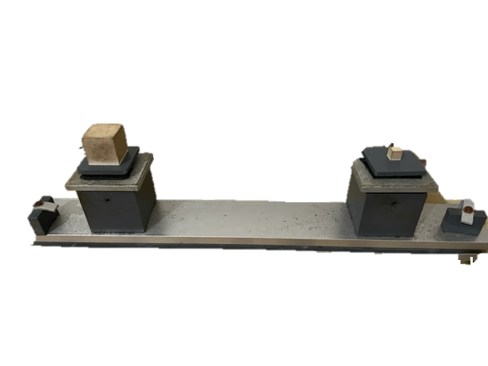
Figure 3. Apparatus equipped with two differently sized wooden blocks on top of PVC plates that are attached to the metal lids via Velcro.

3.3.3. Experimental design
In this experiment nine of the ten animals participated, as Juanis stopped showing interest after the first session. In each session a monkey was presented with two differently sized wooden blocks on top of either the left or the right box of the apparatus. Each session included ten trials and both wooden blocks of a pair were presented equally often on each side of the apparatus in a pseudo-random order. This way, a given wooden block was only presented on the same side for a maximum of three times in a row to control for potential side biases. Each animal participated in one to two sessions per day, depending on the willingness of the monkey to come to the mesh and participate in the experiment.
To start the session, I called the monkey to come to the front of the enclosure, where the animal sat on a platform at the mesh. With my back facing the participating animal, two wooden blocks differing in size were placed onto the boxes and the food reward was placed in the box with the larger of the two wooden blocks, leaving the other box with the smaller wooden block empty. This was done to prevent the animal from seeing in which box the food reward was placed. Next, I turned to the mesh and presented the apparatus at a 45-degree angle, to help the monkey to open the box in a natural way, at a distance from the mesh while facing the monkey. This way, the monkey could take a few seconds to look at the boxes and the wooden blocks before making its decision. Then I approached the mesh with the apparatus, in the middle of the monkeys’ position, so the monkey could select one of the two boxes by opening the lid of the chosen box (Figure 4). This resulted in the monkey finding and retrieving the food reward in the case of a correct response, or finding out the box was empty in the case of an incorrect response. The choice of the monkey for every stimulus pair was recorded: correct if the individual chose the box bearing the larger wooden block, and incorrect if the individual chose the box bearing the smaller wooden block. To indicate the end of the session, each monkey received a piece of biscuit. At the end of the sessions, I cleaned the wooden blocks so contamination of the blocks with dirt and odour would be minimal.
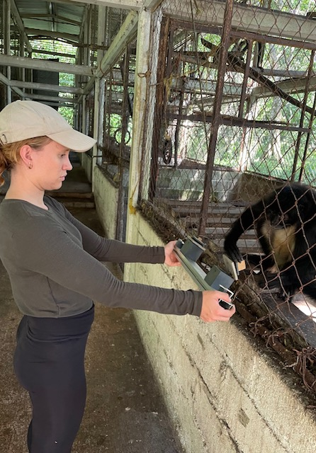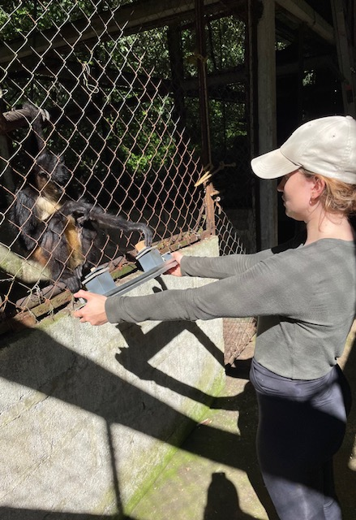
Figure 4. Apparatus with wooden blocks presented to two animals, at a 45-degree angle.
The experiment was divided into five different steps. In each step different pairs of the wooden blocks were presented, with the size differences between the wooden blocks becoming successively smaller in each step. Therefore, these steps represented an increasing challenge to the animals.
In step zero the stimulus combination with the largest size difference of the wooden blocks was introduced: 30 x 30 x 30 mm versus 10 x 10 x 10 mm. This step was the training phase and used to familiarize the animals with the task.
Step one included a new size of the wooden blocks that was introduced: 20 x 20 x 20 mm. This resulted in two additional stimulus combinations, besides the initial stimulus combination of 30 x 30 x 30 mm versus 10 x 10 x 10 mm, being presented: 30 x 30 x 30 mm versus 20 x 20 x 20 mm and 20 x 20 x 20 mm versus 10 x 10 x 10 mm.
Step two included new sizes of the wooden blocks and smaller size differences. The following stimulus combinations were presented: 25 x 25 x 25 mm versus 12 x 12 x 12 mm, 25 x 25 x 25 mm versus 20 x 20 x 20 mm and 20 x 20 x 20 mm versus 12 x 12 x 12 mm.
In step three a size difference of 5 mm was presented, including the following stimulus combinations: 15 x 15 x 15 mm versus 10 x 10 x 10 mm, 20 x 20 x 20 mm versus 15 x 15 x 15 mm and 30 x 30 x 30 mm versus 25 x 25 x 25 mm.
In the final step with the smallest size difference of 2 mm was presented with the following stimulus combinations: 16 x 16 x 16 mm versus 14 x 14 x 14 mm, 18 x 18 x 18 mm versus 16 x 16 x 16 mm and 20 x 20 x 20 mm versus 18 x 18 x 18 mm.
An animal was considered as successfully having learned that the larger wooden block of the stimulus combinations indicated the presence of the food reward in the corresponding step, once the animal reached a learning criterion of 80% correct choices on average in three consecutive sessions, i.e. 30 trials. Upon achieving this criterion, I introduced the subsequent and new step, with its corresponding stimulus combinations, to the animal. The learning criterion is above random level (two-tailed binomial test, p < 0.05).
As step zero was the training phase, I started the data collection after the learning criterion was reached for this step with the stimulus combination of 10 x 10 x 10 mm versus 30 x 30 x 30 mm.
Again, Weber ratios were calculated (Table 1). Here, to express the difference in volume between each stimulus combination of the wooden blocks presented to the animals by dividing the difference in volume between the smaller- and larger wooden block by the volume of the larger wooden block. The stimulus combinations within step two to five with the largest-sized wooden blocks have the smallest Weber ratio within that step. Then, the percentage of choices for the larger wooden block made by every animal per Weber Ratio was calculated by dividing the number of choices for the larger wooden block by the total number of decisions. Lastly, the average percentage of decisions made by the entire group for the larger-sized wooden block per stimulus combination was calculated, by dividing the sum of all the animals’ choices for the larger-sized wooden block by the sum of all animals’ total number of decisions.
Table 1. Weber ratios of the 12 different stimulus combinations per step calculated by dividing the difference in volume between the smaller and larger wooden block by the volume of the larger wooden block.
Step | Stimulus pair | Weber ratio
1 | 30 vs 10 | 0.96
1 | 20 vs 10 | 0.88
1 | 30 vs 20 | 0.70
2 | 25 vs 12 | 0.89
2 | 20 vs 12 | 0.78
2 | 25 vs 20 | 0.49
3 | 15 vs 10 | 0.70
3 | 20 vs 15 | 0.58
3 | 30 vs 25 | 0.42
4 | 16 vs 14 | 0.33
4 | 18 vs 16 | 0.30
4 | 20 vs 18 | 0.27

3.4. Data analysis

3.4.1. Preference test: Visual size discrimination of food items
I used one-sample Student’s t-Tests in Excel to calculate the p-values of the mean numbers of decisions for the larger food pieces for the group per Weber ratio range. This was done to determine if there was a significant difference between the mean number of observed frequencies and mean number of expected frequencies. The group was then considered as showing a significant preference for the larger of two simultaneously presented food pieces.
I performed two-tailed Binomial tests in Excel for each individual’s choices for the larger of two simultaneously presented food pieces in order to assess whether the ratio of the choices, respectively, significantly differed from chance. For the ball- and hemisphere-shaped melon pieces, there were not enough data points for some animals for the Weber ratio ranges 0.61-0.70 and 0.71-0.80 to be significant at a score of 100 percent decisions for the larger of the two food pieces.

3.4.2. Operant conditioning test: Visual size discrimination of wooden blocks
The average number of sessions that all nine animals needed to reach the learning criterion in steps zero, one and two (with all the stimulus pairs included) was calculated and the double of this average was used as the maximum number of sessions for the following steps: three and four. If an animal did not reach the learning criterion at this number of sessions, I considered the animal as having failed with the corresponding size difference and stopped testing those stimulus combinations. The animal was then assumed to be unable to successfully discriminate between the stimulus pairs of that step.
I used one-sample Student’s t-tests in Excel to calculate the p-values of the mean numbers of decisions for the larger-sized wooden blocks for the group per Weber ratio. This was done to determine if there was a significant difference between the mean number of observed frequencies and mean number of expected frequencies. The group was then considered as significantly choosing the larger of two simultaneously presented wooden blocks.
I performed a two-tailed Binomial test in Excel for each individuals’ choices for the larger wooden blocks in order to assess whether the ratio of the correct choices significantly differed from chance.

Results

4.1. Preference test: Visual size discrimination of food items
I found that all ten animals increasingly preferred the larger of two simultaneously presented food pieces with increasing Weber ratio. In other words, when the size difference between the two food pieces increased, the animals showed an increase in choosing the larger-sized piece of food. Furthermore, less variation in individual preference was found with increasing Weber ratio (Figure 5).
In total, the ten monkeys as a group, performed 1200 trials with the cube-shaped food. For this shape the monkeys showed significant preferences from the Weber ratio range 0.11-0.20 onwards (one-sample Student’s t-test, p < 0.05). In other words, the group displayed on average a significant preference for the larger of two simultaneously presented cube-shaped food pieces when the size difference was at least 11% or larger.
The ten monkeys, as a group, performed a total of 1125 trials with the ball-shaped food. For this shape the monkeys showed significant preferences for all Weber ratio ranges (one-sample Student’s t-test, p < 0.05). In other words, the group displayed on average a significant preference for the larger of two simultaneously presented ball-shaped food pieces even for the smallest of size differences tested, when the food pieces differed by less than 10%.
The nine monkeys, as a group, performed a total of 540 trials with the hemisphere-shaped food. For this shape the monkeys showed significant preferences from the Weber ratio range 0.11-0.20 onwards (one-sample Student’s t-test, p < 0.05). In other words, the group displayed on average a significant preference for the larger of two simultaneously presented hemisphere-shaped food pieces when the size difference was at least 11% or larger.
Comparing all three food shapes, the results show that the percentages of decisions for the larger of two simultaneously presented food pieces were generally higher when the pieces had the shape of a ball (Figure 5). The percentage of decisions for the larger hemisphere-shaped food pieces was similar to that of the ball-shaped food pieces, except for the Weber ratio range 0-0.10 for which the hemisphere-shaped food were chosen 14% less for the larger food pieces. The percentage of decisions for the larger cube-shaped food pieces was similar to that of the ball-shaped food pieces when the Weber ratios were low, however from Weber ratio 0.41 onwards the animals chose the larger food pieces less often for the cube shape than the ball shape.
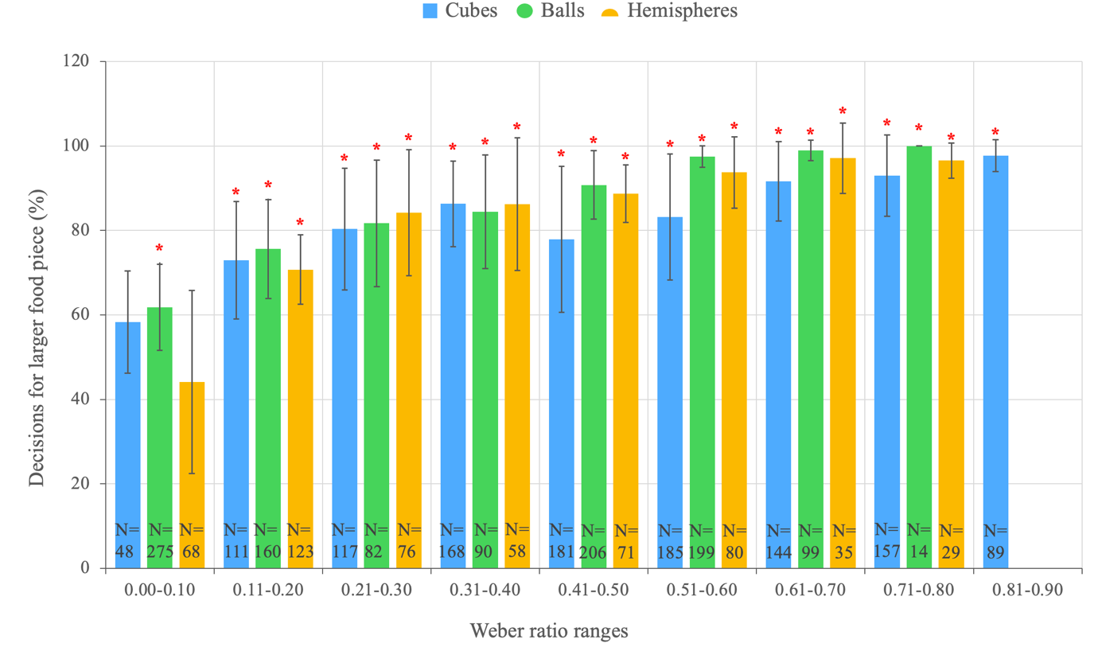
Figure 5. Mean (+/- SD) percentages of decisions for the larger of two simultaneously presented food pieces of all shapes for the group of spider monkeys (N = 10), subdivided by Weber ratio ranges. * = Significant differences between observed frequencies and expected frequencies (one-sample Student’s t-test, p < 0.05). N = Number of decisions made by the group for the Weber ratio range, with a total of 2865 trials.
At the individual level for the cube-shaped food pieces, five out of ten animals displayed a significant preference for the larger of two simultaneously presented food pieces when the size difference, expressed as a Weber ratio, was at least 0.21 or larger (two-tailed Binomial test, p < 0.05; Table 2). Notably, Frida, Juanis and Nena chose the smaller food pieces more often than the other individuals. Trilce and Homero displayed a significant preference for the larger food pieces for all Weber ratios except the smallest range of 0-0.10.
Table 2. Mean percentages of decisions for the larger of two simultaneously presented cube-shaped food pieces made by each individual monkey, subdivided by increasing Weber ratio ranges. The percentages of decisions that significantly differed from chance are highlighted in green (two-tailed Binomial test, *p < 0.05, **p < 0.01).
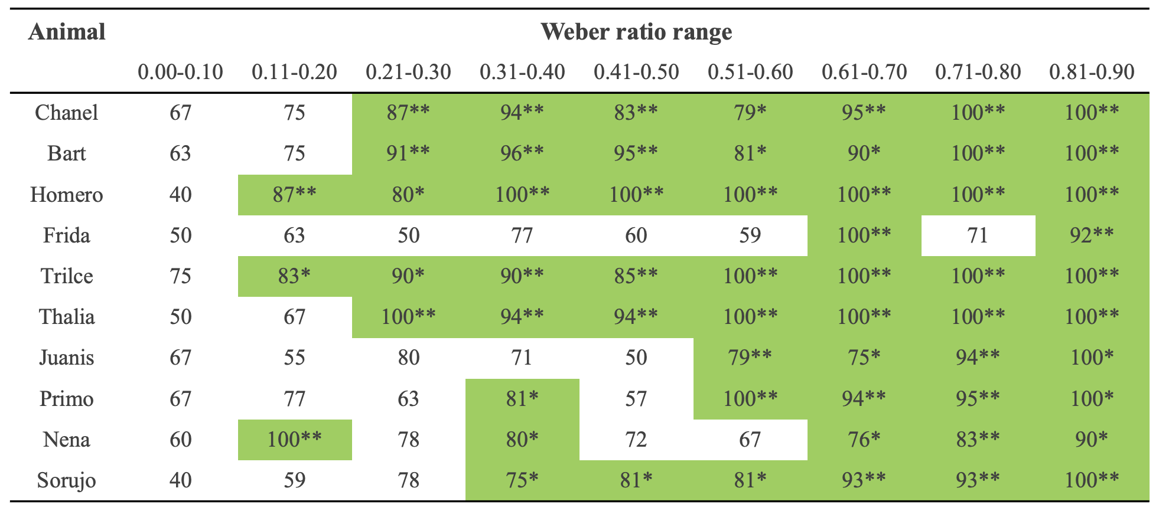
At the individual level for the ball-shaped food pieces, six out of ten animals displayed a significant preference for the larger of two simultaneously presented food pieces when the size difference, expressed as a Weber ratio, was at least 0.11 or larger, with non-significant preferences for other Weber ratio ranges (two-tailed Binomial test, p < 0.05; Table 3). Frida and Nena chose the smaller food pieces more often than the other individuals. Trilce displayed a significant preference for the larger food pieces for all Weber ratios except the largest range of 0.71-0.80. There were not enough data points for Weber ratio range 0.71-0.80 to be significant.
Table 3. Mean percentages of decisions for the larger of two simultaneously presented ball-shaped food pieces made by each individual monkey, subdivided by increasing Weber ratio ranges. The percentages of decisions that significantly differed from chance are highlighted in green (two-tailed Binomial test, *p < 0.05, **p < 0.01).
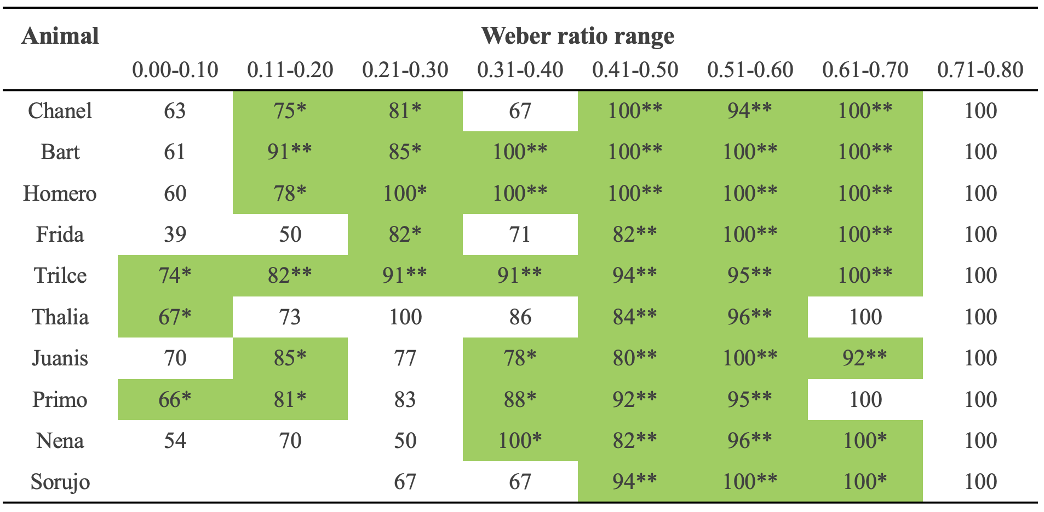
At the individual level for the hemisphere-shaped food pieces, six out of nine animals displayed a significant preference for the larger of two simultaneously presented food pieces when the size difference, expressed as a Weber ratio, was 0.21-0.30 (two-tailed Binomial test, p < 0.05; Table 4). For Weber ratio ranges 0.31-0.40 and 0.41-0.50, fewer animals displayed a significant preference. Notably, Homero chose the larger food pieces significantly more often for the other two shapes than for this shape, while Juanis chose the larger food pieces significantly more often for this shape than for the other two shapes. However, Juanis did not choose any of the larger pieces with the smallest Weber ratio. Nena never scored 100% decisions for the larger food pieces for this shape. There were not enough data points for Weber ratio range 0.71-0.80, and for some individuals for Weber ratio range 0.61-0.70, to be significant.
Table 4. Mean percentages of decisions for the larger of two simultaneously presented hemisphere-shaped food pieces made by each individual monkey, subdivided by increasing Weber ratio ranges. The percentages of decisions that significantly differed from chance are highlighted in green (two-tailed Binomial test, *p < 0.05, **p < 0.01).
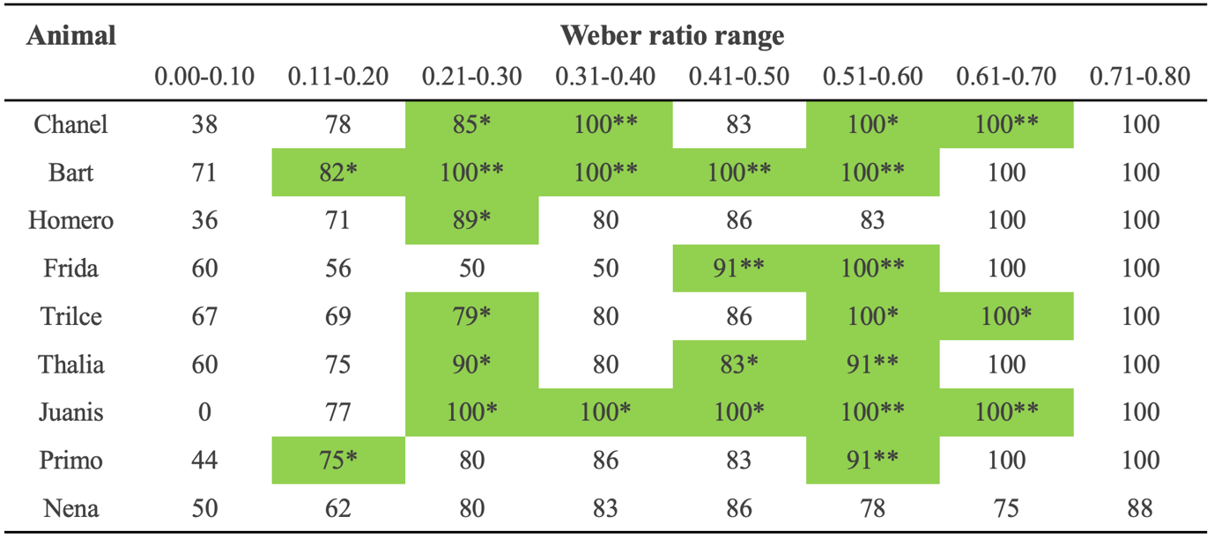

4.2. Operant conditioning test: Visual size discrimination of wooden blocks
I found that the number of sessions the animals – as a group – required to meet the learning criterion slightly increased for every step (Figure 6). The variation also slightly increased for every step, whereas the number of animals that successfully reached the learning criterion decreased. All nine animals successfully reached the learning criterion during steps one and two, representing those stimulus combinations with larger size differences between the wooden blocks. Eight out of nine animals were able to master the stimulus combinations of step three, representing more challenging stimulus combinations with smaller size differences between the wooden blocks. None of the nine animals mastered the stimulus combinations of step four, representing the most challenging stimulus combinations, within the allotted number of sessions.
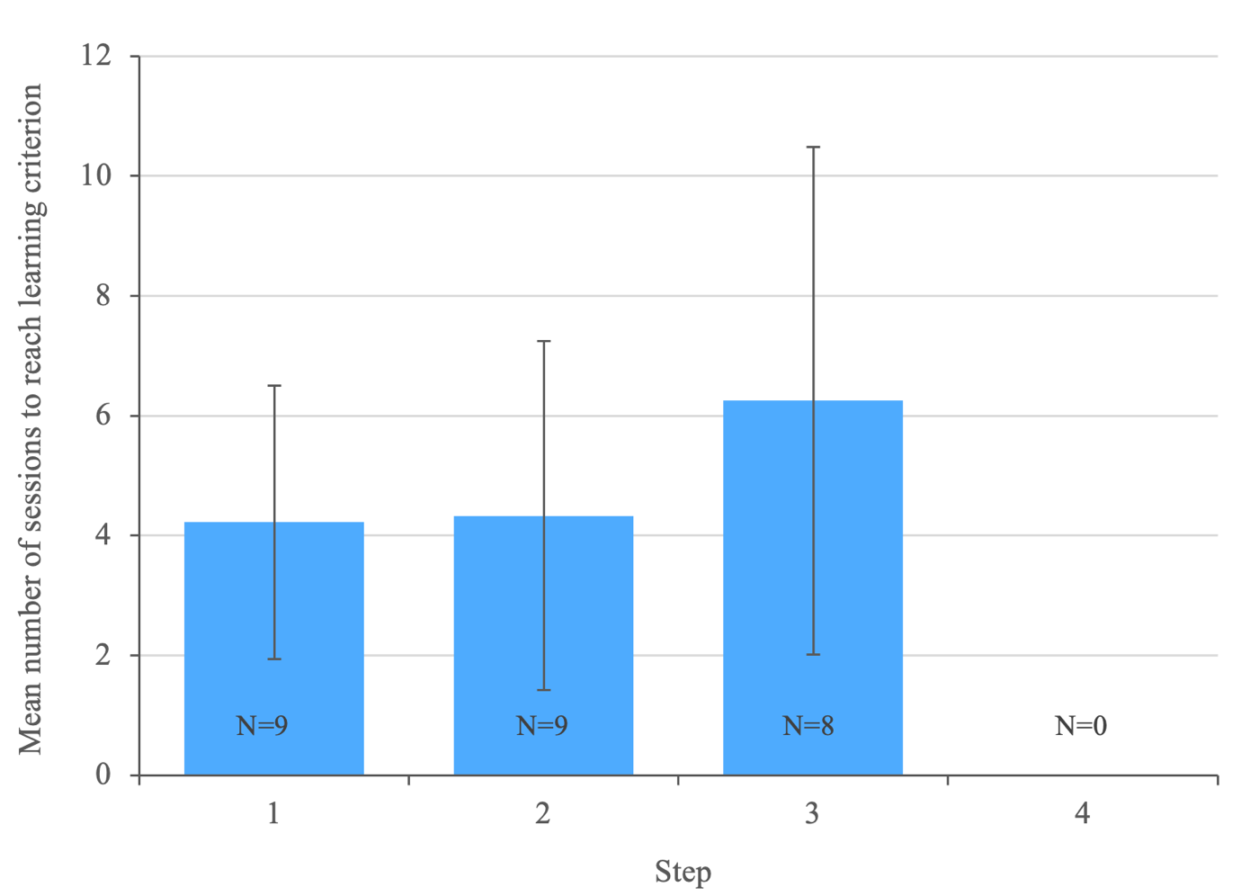
Figure 6. Mean (+/- SD) number of sessions required to meet the 80% learning criterion for the group per step. In step 4 the spider monkeys reached the maximum number of sessions and therefore not the learning criterion. N = Number of spider monkeys that reached the learning criterion.
Expectedly, the monkeys needed the highest number of sessions to reach the learning criterion during the training phase to get familiar with the task (Table 5). At the individual level, Homero, Thalia and Nena needed the highest number of sessions during this training phase, whereas Chanel Bart and Trilce needed the least. This tendency can as well be noted for the following steps. Nena was the only monkey that did not meet the learning criterion within the allotted number of sessions at step three.
Table 5. Number of sessions each individual monkey needed to reach to 80% learning criterion for the training phase and the four following steps.
Animal | Step
 | 0 | 1 | 2 | 3 | 4
Chanel | 9 | 3 | 3 | 8 | Criterion not met
Bart | 9 | 3 | 3 | 4 | Criterion not met
Homero | 33 | 3 | 12 | 5 | Criterion not met
Frida | 20 | 4 | 4 | 3 | Criterion not met
Trilce | 10 | 3 | 4 | 3 | Criterion not met
Thalia | 31 | 10 | 4 | 15 | Criterion not met
Primo | 27 | 4 | 3 | 9 | Criterion not met
Nena | 34 | 5 | 3 | Criterion not met | Criterion not met
Sorujo | 18 | 3 | 3 | 3 | Criterion not met

I found that all nine monkeys increasingly chose the larger of two simultaneously presented wooden blocks with increasing Weber ratio (Figure 7). In other words, with a larger size difference between two wooden blocks, the animals showed an increase in choosing the larger-sized wooden blocks. The animals - as a group - significantly chose the larger-sized wooden blocks for all Weber ratios, meaning all presented size differences (one-sample Student’s t-test, p < 0.05). They scored the lowest percentage of correct choices for the smallest Weber ratios: 0.27, 0.30 and 0.33, representing the most challenging stimulus combinations. Furthermore, less variation in individual performance is found for those three Weber ratios. In total the nine monkeys, as a group, performed 3889 trials.
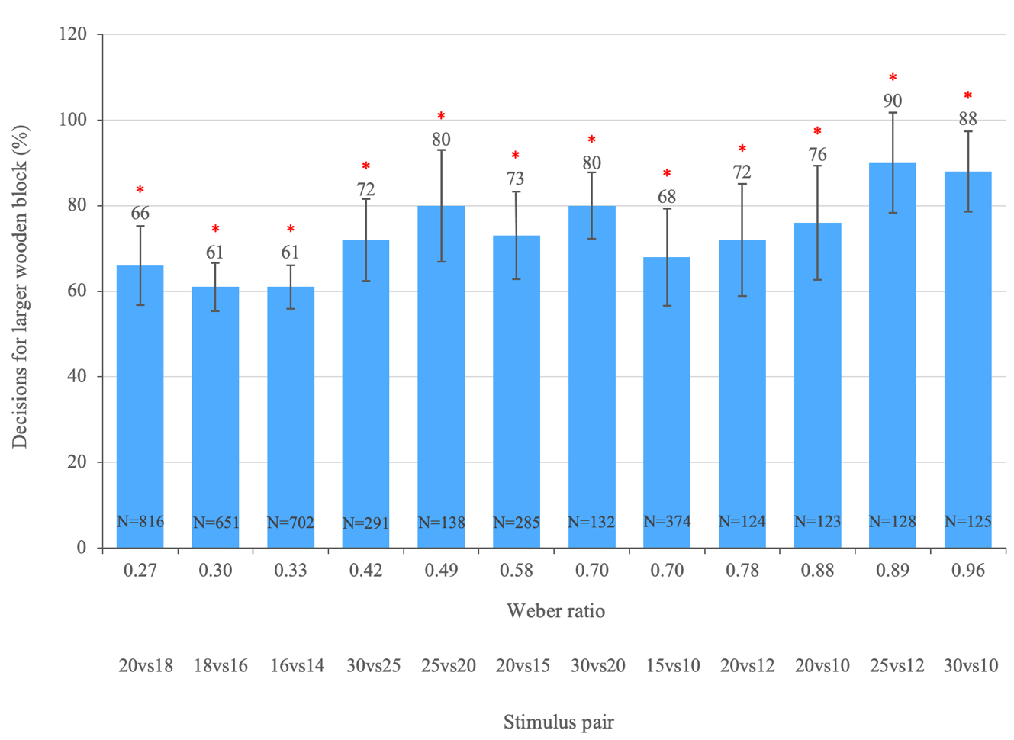
Figure 7. Mean (+/- SD) percentages of decisions for the larger of two simultaneously presented wooden blocks for the group of spider monkeys (N = 9), subdivided by Weber ratios. * = Significant differences between observed frequencies and expected frequencies (one-sample Student’s t-test, p < 0.05). N = Number of decisions made by the group to reach the learning criterion or the maximum number of sessions for the Weber ratio, with a total of 3889 trials.
At the individual level, eight out of nine animals displayed a significant percentage of correct choices for the highest Weber ratio of 0.96 (two-tailed Binomial test, p < 0.05; Table 6). Furthermore, eight out of nine animals significantly made the correct choice for at least one of the three most challenging stimulus combinations, with Weber ratios 0.27, 0.33 and 0.33. Only Sorujo did not. Seven monkeys had a score of 100% correct choices for at least one of the Weber ratios larger than 0.42. Chanel and Bart displayed the highest overall performance, whereas Nena and Thalia displayed the lowest overall performance.
Table 6. Mean percentages of decisions for the larger of two simultaneously presented wooden blocks made by each individual monkey until the learning criterion was reached, subdivided by increasing Weber ratio. The percentages of decisions that significantly differed from chance are highlighted in green (two-tailed Binomial test, *p < 0.05, **p < 0.01).
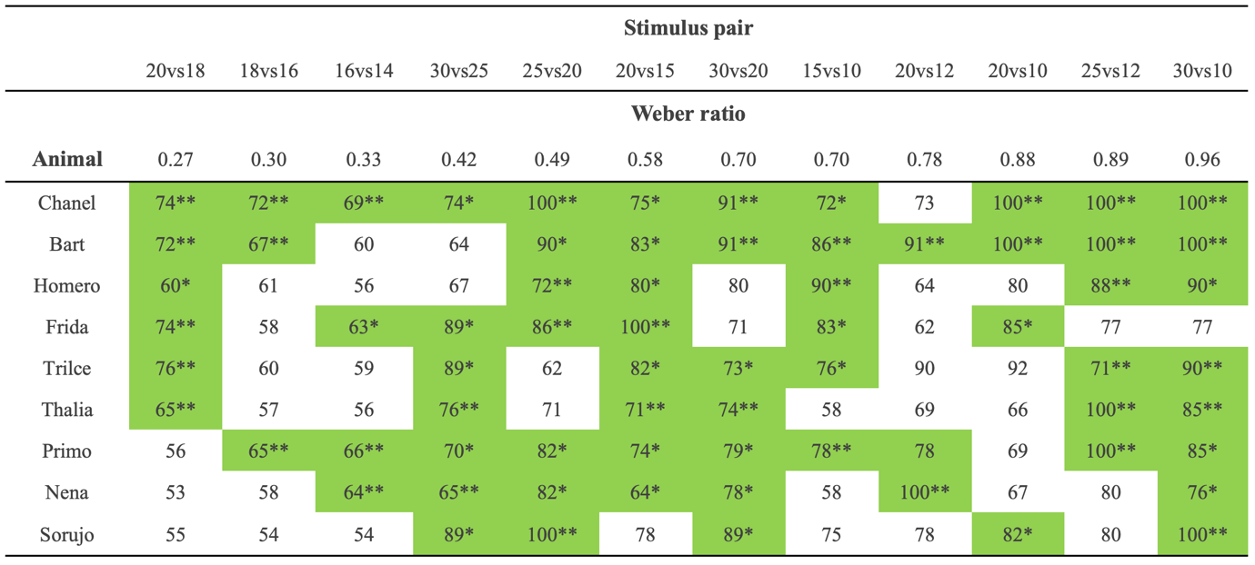

Discussion
The aim of this study was to assess the ability of spider monkeys to visually discriminate between different sizes of a given type of food and to determine the limits of their visual size discrimination with non-edible objects. The results of the present study show that spider monkeys indeed have the ability to visually discriminate between different sizes of food and wooden blocks.
The spider monkeys increasingly preferred the larger of two simultaneously presented food pieces with increasing size difference between the two food pieces, except for Weber ratios < 0.11 for the cube- and hemisphere food pieces. The animals – as a group – performed similarly in discriminating between the three different food shapes, but displayed a slightly higher percentage of choices for the larger piece of two simultaneously presented food pieces when these were ball-shaped. The reason for this could be that round shapes are more common in nature than square shapes are. The animals were also able to successfully discriminate between different sizes of wooden blocks, with the lowest percentage of correct choices for the smallest Weber ratios: 0.27, 0.30 and 0.33. The animals displayed variation in individual performance across both experiments.
The discrimination of objects of different size has rarely been tested in primates in contrast to discrimination of different quantities (Schmitt et al., 2013). However, animals are confronted with objects of various sizes throughout their lives, including foods, conspecifics, and predators. Therefore, the ability to visually discriminate between items based on size differences is suggested to be substantially important in different behavioural contexts, such as food evaluation, social conflict, object manipulation and sexual selection. For many frugivorous primate species, the size of a fruit is the primary selection criterion and trait during foraging (Dias da Silva et al., 2020; Flörchinger et al., 2010). Accordingly, an animal’s ability to select the larger one of two fruit items can have significant impact on its fitness, and when competing with conspecifics, it may favour individuals who are better at selecting the larger fruit items (Schmitt et al., 2013).
Valenta et al. (2020) found that anthropoid primates feed on larger fruits and ones that exceed a particular size threshold, implying the importance of fruit size. Orangutans (Pongo pygmaeu), for example, have been shown to have strong preferences for ‘primate-fruit’ pulp species of large crop size and the size of the meal that is expected from a feeding visit strongly influences their foraging decisions (Leighton, 1993). Similarly, four species of lemurs in Madagascar’s eastern rain forest have been reported to consume only fruits larger than 10 millimetres in diameter (Dew & Wright, 1998). When comparing primates to birds, Flörchinger et al. (2010) found substantial variations in fruit preference between the two groups; the birds consumed smaller fruits and fed on smaller plants with fewer fruits, whereas the primates consumed larger fruits and fed on higher trees with greater fruit yields.
A study on golden-backed uacaris (Cacajao ouakary, Pitheciidae) demonstrated that they eat fruits of mid-range weight and size and reject those smaller or larger, as the larger and heavier fruit are more difficult to handle and manipulate effectively (Dias da Silva et al., 2020). Furthermore, the food size preferences of four sympatric primate species in Sumatra have been found to be influenced by hand size and limited hand use (Ungar, 1995). He suggests that Sumatran gibbons (Hylobates lar) and long-tailed macaques (Macaca fascicularis) more regularly consume smaller food items than Sumatran langurs (Presbytis thomasi) and orangutans. This can partly be explained by the macaques’ limited gape and hand size, which makes them take fewer larger food items in comparison to langurs and orangutans. Gibbons have limited hand use during ingestion because they need a hand for support and locomotion while feeding and hanging from terminal branches. In contrast, as spider monkeys use their prehensile tail for support and locomotion, they do not have limited hand use and can use both hands during ingestion, allowing them to consume bigger food items. This suggests that the animal’s anatomy and fruit’s handling time may affect the fruit selection process.
Size is also a critical factor in predation behaviours. Predators’ food preferences are influenced by prey size, which is determined by the available prey size range compared to the predator’s most effective capture size (Scott and Murdoch, 1983). Preferences initially increase with prey size because larger prey provides a greater stimulus, but eventually decline with prey size as capturing or handling the prey becomes more difficult. Furthermore, size discrimination is important during sexual selection. A female’s reproductive success and fitness may be increased by selecting larger and higher-quality males to mate with (Schmitt 2013). This has been found in gorillas, which showed a positive correlation between a male’s number of females in his harem and the size of his sagittal crest, representing his strength and health (Caillaud et al., 2008).
Recently, a similar study was performed in Sweden on a group of gibbons (Hylobates lar), which have been shown on average to display a significant preference for the larger of two simultaneously presented cube-shaped food items for Weber ratios of 0.40 and larger. These results differ from the results of the present study as the spider monkeys displayed a significant preference for the larger piece of cube-shaped food for Weber ratios of at least 0.11 and larger. As all the spider monkeys were separated from the group during testing, the individuals did not display any food competition or stealing behaviour. In contrast, the gibbons were not separated during testing and did show food stealing between the individuals. Furthermore, the gibbons have not been exposed to and participated in as many scientific studies in the past as the spider monkeys have before the current study. Therefore, the gibbons were less familiar with the conditions of an experiment. The gibbons also displayed a larger variation in individual performance across the experiment compared to the spider monkeys.
Humans (Homo sapiens), chimpanzees (Pan troglodytes), bonobos (Pan paniscus), olive baboons (Papio anubis) and long-tailed macaques have been found to be able to recognize differences in volume of on average about 20% of three-dimensional cubes (i.e. 50 and 48 mm side length), with three individuals (a bonobo, macaque and human) even discriminating between 5% size differences (Schmitt et al., 2013). Furthermore, even with successive conditions when they did not see the differently sized cubes simultaneously, all four species were able to choose the larger cube, indicating that memorizing specific object traits such as their size has deep evolutionary roots. The spider monkeys in the present study were not tested for size differences smaller than 27% of three-dimensional wooden cubes and only recognized differences in volume from a size difference of at least 42% of three-dimensional wooden cubes on.
Primates are not the only animals able to recognize size differences in objects. Horses have been found to be able to visually discriminate a difference of 14% in circle size (Tomonaga et al., 2015). Albino rats (Mus Rattus) can also distinguish size differences; they chose the larger one of two circles if it was bigger than 40 millimetres in diameter and avoided the circle of less than 30 millimetres in diameter, until the difference in size was reduced below a certain threshold (Lashley, 1912). The rats could discriminate between circles of 30 and 50 millimetres in diameter and squares with a difference of 11 millimetres a side, which is a slightly bigger absolute size difference than that which the spider monkeys in the present study could discriminate. Raccoons (Procyon lotor) were able to discriminate between two differently sized square-shaped cards of 33 and 21.6 cm² and were rewarded when the larger card was shown (Cole, 1907). Two captive California sea lions (Zalophus californianus) were also capable of executing a series of size-discrimination tasks and could discriminate a size-difference ratio as small as 1.06:1 with square-shaped targets of 42.8 and 45.4 cm² in area (Schusterman et al., 1965). In contrast to the spider monkeys in the present study, both sea lions showed a strong preference for the smaller one of the two targets. However, one of the sea lions was planned to be trained to respond to the larger target which therefore resulted in persistent incorrect responding of that sea lion. The other sea lion that was trained to respond to the smaller target showed a virtually errorless performance despite changes in relative size and form of the targets. Like the spider monkeys in the present study, the sea lions displayed a corresponding decrease in correct response as the magnitude of the size-difference ratios decreased. Lastly, Sutherland & Carr (1963) found that octopuses tended to show more response to larger objects than to smaller ones when they were presented with the same object in different sizes and when the differences between the areas of the objects were above a certain threshold.
A notable finding of the present study is that some animals performed better with stimulus combinations with larger-sized wooden blocks than with stimulus combinations with smaller-sized wooden blocks with the same size difference between the wooden blocks, even though the Weber ratios were lower. This finding is in line with results of studies on macaque monkeys, rats and octopuses (Warren, 1953; Dodwell, 1957; Sutherland & Carr, 1963), showing that their performance increased when the area of objects of the same shape was increased. This may suggest that objects of larger size have a higher discriminability for the animals than objects of smaller size. It may be that the larger shapes attract an individual's attention more or are easier to differentiate from the background.
Often, individuals’ choices may be affected when the subject’s attention draws away from the target options by the presence of a ‘decoy’ or element of distraction, or when their motivation is affected (Huskisson et al., 2021). The rats in Lashley (1912) showed a loss of motivation when the difference between the circles was reduced below a limit of one-fourth the area of the larger circle. The preference of the sea lions in their study for a small target over a large target is in line with the notion that avoidance behaviour is caused by high levels of stimulation while approach responses are caused by low levels of stimulation (Schusterman et al., 1965). The subjects in the present study also showed moments of distraction and loss of motivation by other monkeys and external factors, which could have affected their choices. Decreasing the size difference between the wooden blocks after every step, and therefore making it harder for the animals to retrieve the food reward, could have negatively affected the animals’ motivation. In moments that the animals were not able to reach the learning criterion, ‘easier’ stimulus pairs with a big size difference between the blocks could have been repeated to encourage the animals’ motivation and performance.
Furthermore, the present study is also limited in its lack of control. As primates are highly intelligent animals, they can use olfactory, auditory or visual cues for their decisions besides the sizes of the melon pieces and the sizes of the wooden blocks. This has not been thoroughly tested or controlled for. For example, the monkeys can notice the attention of the experimenter. This could have been avoided by wearing sunglasses during the experiment. To control for olfactory cues, the experimenter could have added a food reward to both boxes to avoid the animals making their decision on the odours in only one of the boxes.
The visual acuity of primates can also be a limiting factor for making size discriminations with objects of very similar size. Primates have a relatively high visual acuity and the largest binocular visual field compared to other mammals (Caves et al., 2018). Most of a primate’s visual field is viewed by both eyes simultaneously as they have forward-facing eyes (Heesy, 2004, 2009; Ross & Kirk, 2007), which is useful for fine depth perception (Barlow & Mollon, 1982; McIlwain, 1996). However, the binocular vision may strongly influence a species’ foraging behaviour (Troscianko et al., 2012) and visual acuity depends on the light condition under which it is measured (Heesy, 2009). The spider monkeys in the present study were tested indoors, with no electric light available and occasionally cloudy weather. Therefore, these sub-optimal light conditions may have limited their visual acuity and made it more challenging for the spider monkeys to differentiate objects of similar size. The oldest spider monkey Nena showed less preference for the larger food pieces and displayed the lowest number of correct choices for the larger wooden blocks compared to the other individuals in the group. This could be connected to a decreasing eyesight correlating with age, which therefore may result in increasing difficulties for an older spider monkey to differentiate between various sizes of food items (Ortiz-Peregrina et al., 2020).
A number of intrinsic and extrinsic factors may play a role in primate decision making and can influence a species’ size discrimination abilities. Overall, my findings are consistent with previous research on visual size discrimination in primates and contribute to our understanding of food selection in spider monkeys and their abilities to visually discriminate between differently sized objects used in other behavioural contexts. This can provide valuable insights into their adaptive capacities in dynamic environments. The ability to adapt to environmental changes is a key component of an animal’s fitness (Huebner et al., 2020; Lea et al., 2020) and plays a substantial role in foraging behaviours. As food sources in tropical environments can vary in location, quality and quantity they are rather unpredictable and inconsistent. Therefore, in response to these changes, spider monkeys need to be able to adapt their foraging behaviours to obtain a sufficient amount of critical nutrients and metabolic energy. The ability to visually discriminate between different sizes of food is not only advantageous but also essential to the spider monkeys’ survival in their natural habitats.
Future research could expand upon these findings by examining the factors influencing individual differences in visual discrimination performance and learning patterns, such as previous experience, age, genetic background, or cognitive abilities (Matzel & Sauce, 2017). Experiments on the relation of fruit size to individual hand size could be performed to examine the individual effects in spider monkeys. What the present findings do not tell us is what underlies the animals’ competence in the kinds of tasks used here. Further interspecies and intraspecies comparisons could offer a better understanding of the evolutionary background of these abilities. A follow up study could also be used to test whether spider monkeys perceive the amount, or quantity, of an item and the size of the item separately. This way, we could determine whether the monkeys would choose one big piece or multiple small pieces.
It would also be interesting to further explore presenting other, more natural, shapes of wooden objects similar to the food items to compare to the results of the wooden blocks. This could increase performance as the monkeys are more familiar with natural shapes than artificial ones. Additionally, half of the monkeys could be trained to respond to the smaller wooden blocks and therefore receive the food reward when they choose these blocks, as was done with the sea lions (Schusterman et al., 1965). This way, the monkeys’ performances with the small blocks and with the large blocks can be compared. Lastly, stimulus pairs with a big difference between the blocks and pairs with a small difference could be presented alternately to increase the motivation of the animals. In moments that the animals would not be able to reach the learning criterion, stimulus pairs with a big difference between the blocks can be repeated to encourage the animals’ motivation.
In conclusion, the present study provides evidence for the abilities and limitations of black-handed spider monkeys to visually discriminate between differently sized objects. The spider monkeys’ preference for the larger food items is reasonable as their food is frequently scarcely distributed in the wild, making it more crucial to obtain the necessary nutrients and metabolic energy from each patch of food source. Assessing the motivation behind decisions can offer significant context to how primates perceive foods and objects. The results contribute to our understanding of the underlying mechanisms of primate feeding ecology and cognitive abilities in changing tropical environments, and to developing efficient conservation management as well as improving general health and welfare of captive primates.

Societal & ethical considerations

By investigating visual size discrimination in spider monkeys, this study aims to advance our understanding of the evolutionary processes underlying primate behaviour, dietary specializations in these primates and their cognitive abilities. The obtained outcomes contribute to improving overall health and welfare of captive animals and could be valuable for conservation programmes aimed at the protection of spider monkeys among other primate species. On a broader scale, studies like the present study on the cognitive abilities and limitations of nonhuman primates, may also contribute to a better understanding of human cognition, visual disorders and other age- or disease-related impairments.
In compliance with the American Society of Primatologists' Principles for the Ethical Treatment of Primates, as well as current Swedish and Mexican legislation, the experiments have adhered to strict ethical guidelines in the treatment of spider monkeys. Participation in the experimental tasks was strictly voluntary and there was no force of any kind applied to the animals. Instead, we did our best to ensure that this study relied on the animals’ intrinsic motivation and willingness to participate in the tasks presented.
In instances where a spider monkey was uninterested or unwilling to participate in a session for any reason, I moved on to another individual and resumed the task at a later time or date. However, the majority of the animals displayed enthusiasm and willingness to participate in these tasks. It has been suggested that cognitive challenges can confer welfare benefits by providing mental stimulation, promoting positive emotional states, and reducing stereotypical behaviour in captive populations. Therefore, the tasks presented in this study are likely to have served as a source of cognitive enrichment for the spider monkeys, positively contributing to their welfare. Furthermore, no food deprivation scheme was employed, ensuring that the animals had consistent access to their regular diet. This reinforces the notion that the animals’ participation in the experiments was voluntary and stimulating.

Acknowledgements

I wish to express my gratitude to my supervisor, Matthias Laska from Linköping University, for always giving me immediate invaluable guidance, support, and advice throughout this Master’s thesis project. I am forever grateful that this opportunity was trusted to me and for this amazing and educational experience. I am also thankful to my co-supervisor, Laura Teresa Hernández Salazar from the Universidad Veracruzana, for helping me settle in and feel welcome in Mexico. Thank you to the Universidad Veracruzana and the Instituto de Neuroetología for a great collaboration on this project. I would like to acknowledge the dedicated caretakers at the field station, especially Señor Gil for taking such good care of the monkeys and making the execution of this research possible. Many thanks my co-workers at the field station and now dear friends, Carlos, Erika, Luiz and Rodrigue with whom I had the pleasure of sharing this experience, for making my stay in Mexico even better. Lastly, I am beyond grateful to my family and friends for supporting me through all the defining years of my full academic journey.

References

Barlow, H. B., & Mollon, J. D. (Eds.). (1982). Senses. Cambridge University Press Archive.

Beran, M. J., Evans, T. A., & Harris, E. H. (2009). When in doubt, chimpanzees rely on
estimates of past reward amounts. Proceedings of the Royal Society B, 276(1655), 309-314.

Bosshard, T. C., Salazar, L. T. H., & Laska, M. (2022). Numerical cognition in black-handed
spider monkeys (Ateles geoffroyi). Behavioural Processes, 201, 104734.

Caillaud, D., Levréro, F., Gatti, S., Menard, N., & Raymond, M. (2008). Influence of male
morphology on male mating status and behavior during interunit encounters in western lowland
gorillas. American Journal of Physical Anthropology, 135(4), 379-388.

Campbell, C. J. (Ed.). (2008). Spider monkeys: Behavior, ecology and evolution of the genus
Ateles (Vol. 55). Cambridge University Press, Cambridge.

Caves, E. M., Brandley, N. C., & Johnsen, S. (2018). Visual acuity and the evolution of signals.
Trends in ecology & evolution, 33(5), 358-372.

Cole, L. W. (1907). Concerning the intelligence of raccoons. Jour. Comp. Neur. and Psych.,
(Vol. 17), 211.

Dew, J. L., & Wright, P. (1998). Frugivory and Seed Dispersal by Four Species of Primates in
Madagascar's Eastern Rain Forest 1. Biotropica, 30(3), 425-437.

Dias da Silva, R. H., Castro Sa, M. J., Baccaro, F. B., Tománek, P., & Barnett, A. A. (2020). Juggling options: Manipulation ease determines primate optimal fruit‐size choice. Biotropica, 52(6), 1275-1285.

Di Fiore, A., Link, A., & Dew, J. L. (2008). Spider monkeys: Behavior, ecology and evolution of the genus Ateles, 81-137. Cambridge University Press.

Dodwell, P. C. (1957). Shape recognition in rats. British Journal of Psychology, 48(3), 221-229.

Dominy, N. J., Lucas, P. W., Osorio, D., & Yamashita, N. (2001). The sensory ecology of primate food perception. Evolutionary Anthropology, 10(5), 171-186.

Emlen, J. M. (1966). The role of time and energy in food preference. The American Naturalist, 100(916), 611-617.

Flörchinger, M., Braun, J., Böhning-Gaese, K., & Schaefer, H. M. (2010). Fruit size, crop mass, and plant height explain differential fruit choice of primates and birds. Oecologia, 164, 151-161.

González‐Zamora, A., Arroyo‐Rodríguez, V., Chaves, Ó. M., Sánchez‐López, S., Stoner, K.
E., & Riba‐Hernández, P. (2009). Diet of spider monkeys (Ateles geoffroyi) in Mesoamerica:
current knowledge and future directions. American Journal of Primatology, 71(1), 8-20.

Hecht, S. (1924). The visual discrimination of intensity and the Weber-Fechner law. The Journal of general physiology, 7(2), 235.

Heesy, C. P. (2004). On the relationship between orbit orientation and binocular visual field
overlap in mammals. The Anatomical Record Part A, 281(1), 1104-1110.

Heesy, C. P. (2009). Seeing in stereo: the ecology and evolution of primate binocular vision
and stereopsis. Evolutionary Anthropology, 18(1), 21-35.

Huebner, F., Fichtel, C., & Kappeler, P. M. (2018). Linking cognition with fitness in a wild
primate: fitness correlates of problem-solving performance and spatial learning ability.
Philosophical Transactions of the Royal Society B, 373(1756), 20170295.

Huskisson, S. M., Egelkamp, C. L., Jacobson, S. L., Ross, S. R., & Hopper, L. M. (2021). Primates’ food preferences predict their food choices even under uncertain conditions. Anim. Behav. Cognit, 8, 69-96.

Lashley, K. S. (1912). Visual discrimination of size and form in the albino rat. Journal of Animal Behavior, 2(5), 310.

Laska, M., Hernandez Salazar, L. T., & Rodriguez Luna, E. (2000). Food preferences and nutrient composition in captive spider monkeys, Ateles geoffroyi. International Journal of Primatology, 21, 671-683.

Lea, S. E., Chow, P. K., Leaver, L. A., & McLaren, I. P. (2020). Behavioral flexibility: A review, a model, and some exploratory tests. Learning & Behavior, 48, 173-187.

Leighton, M. (1993). Modeling dietary selectivity by Bornean orangutans: evidence for
integration of multiple criteria in fruit selection. International Journal of Primatology, 14, 257-
313.

Matsuno, T., & Fujita, K. (2009). A comparative psychophysical approach to visual perception
in primates. Primates, 50, 121-130.

Matzel, L. D., & Sauce, B. (2017). Individual differences: Case studies of rodent and primate
intelligence. Journal of Experimental Psychology: Animal Learning and Cognition, 43(4), 325.

McIlwain, J. T. (1996). An introduction to the biology of vision. Cambridge University Press.

Menzel, E. W., & Draper, W. A. (1965). Primate selection of food by size: Visible versus invisible rewards. Journal of comparative and Physiological Psychology, 59(2), 231.

Milton, K. (1981). Distribution patterns of tropical plant foods as an evolutionary stimulus to primate mental development. American Anthropologist, 83(3), 534-548.

Milton, K. (1984). The role of food-processing factors in primate food choice. Adaptations for foraging in nonhuman primates: Contributions to an organismal biology of prosimians, monkeys, and apes. New York: Columbia U. Press, 249-279.

Oates, J. F., Waterman, P. G., & Choo, G. M. (1980). Food selection by the south Indian leaf-monkey, Presbytis johnii, in relation to leaf chemistry. Oecologia, 45, 45-56.

Ortiz-Peregrina, S., Ortiz, C., Casares-López, M., Castro-Torres, J. J., Jimenez del Barco, L., & Anera, R. G. (2020). Impact of age-related vision changes on driving. International journal of environmental research and public health, 17(20), 7416.

Perry, J. M., & Hartstone‐Rose, A. (2010). Maximum ingested food size in captive strepsirrhine primates: scaling and the effects of diet. American Journal of Physical Anthropology, 142(4), 625-635.

Pribram, K. H., & Mishkin, M. (1955). Simultaneous and successive visual discrimination by
monkeys with inferotemporal lesions. Journal of comparative and physiological
psychology, 48(3), 198.

Rosenberger, A. L., Halenar, L., Cooke, S. B., & Hartwig, W. C. (2008). Spider monkeys: Behavior, ecology and evolution of the genus Ateles, 19-49. Cambridge University Press.

Ross, C. F., & Kirk, E. C. (2007). Evolution of eye size and shape in primates. Journal of human evolution, 52(3), 294-313.

Schmitt, V., Kröger, I., Zinner, D., Call, J., & Fischer, J. (2013). Monkeys perform as well as apes and humans in a size discrimination task. Animal cognition, 16, 829-838.

Schusterman, R. J., Kellogg, W. N., & Rice, C. E. (1965). Underwater visual discrimination by the California sea lion. Science, 147(3665), 1594-1596.

Scott, M. A., & Murdoch, W. W. (1983). Selective predation by the backswimmer, Notonecta 1. Limnology and Oceanography, 28(2), 352-366.

Stephens, D. W., Brown, J. S., & Ydenberg, R. C. (Eds.). (2007). Foraging: behavior and
ecology. University of Chicago Press.

Suarez, S. A. (2006). Diet and travel costs for spider monkeys in a nonseasonal, hyperdiverse environment. International Journal of Primatology, 27, 411-436.

Sutherland, N. S., & Carr, A. E. (1963). The visual discrimination of shape by octopus: The effects of stimulus size. Quarterly Journal of Experimental Psychology, 15(4), 225-235.

Tomonaga, M., Kumazaki, K., Camus, F., Nicod, S., Pereira, C., & Matsuzawa, T. (2015). A horse's eye view: size and shape discrimination compared with other mammals. Biology letters, 11(11), 20150701.

Troscianko, J., Von Bayern, A. M., Chappell, J., Rutz, C., & Martin, G. R. (2012). Extreme binocular vision and a straight bill facilitate tool use in New Caledonian crows. Nature communications, 3(1), 1110.

Ungar, P. S. (1995). Fruit preferences of four sympatric primate species at Ketambe, Northern
Sumatra, Indonesia. International Journal of Primatology, 16, 221-245.

Valenta, K., Daegling, D. J., Nevo, O., Ledogar, J., Sarkar, D., Kalbitzer, U., ... & Williams, B. (2020). Fruit selectivity in anthropoid primates: size matters. International Journal of Primatology, 41, 525-537.

Warren, J. M. (1953). Effect of geometrical regularity on visual form discrimination by monkeys. Journal of Comparative and Physiological Psychology, 46(4), 237.

