Linköping University | Department of Physics, Chemistry and Biology

Type of thesis, 60 hp | Educational Program: Physics, Chemistry and Biology

Spring term 2024 | LITH-IFM-A-EX—24/4444--SE

The food defence behaviour

of the Mauritian fruit bat

(*Pteropus niger*)

Lucia Haslbauer

Examiner, Jordi Altimiras

Supervisor (internal), Rie Henriksen

Supervisor (external), Ksenia Krivoruchko



**Contents**

1. Abstract 1

2. Introduction 1

3. Methods 4

3.1. Species 4

3.2. Mauritius 5

3.3. Data collection 6

3.3.1. Field site 6

3.3.2. Materials 7

3.3.3. Experimental process 8

3.4. Data editing 9

3.4.1. Defence behaviours 11

3.4.2. Weather data 11

3.5. Data analysis 11

4. Results 13

4.1. Observed behaviours 13

4.2. Activity 14

4.3. Defence behaviour 16

4.4. Weather influence 17

5. Discussion 18

6. Societal and ethical considerations 23

7. Acknowledgements 25

8. References 25

I. Appendix 34

**Tables**

**Table 1**: Ethogram of the solitary and antagonistic behaviours of free ranging *Pteropus niger*. 10

**Table 2**: The total sum of the behaviours as well as the mean and maximum per individual. 34

**Figures**

**Figure** **1:** Mauritius fruit bat (*Pteropus niger*). Picture: Lucia Haslbauer. 4

**Figure 2:** Map of Mauritius with the area of the field site encircled in red. In the top left corner is an overview map of southern countries of Africa with The Islands of Mauritius marked in red (created with Stadia Maps). 7

**Figure 3:** The *Albizia* tree used for research in the garden of the field site. 7

**Figure** **4**: Model of the experimental set-up. Two fruit baskets are installed with an 8.7 m distance in the tree with video cameras attached. Another standing camera is installed in front of the tree 11.6 m away. 8

**Figure** **5**: Basket filled with local fruits (e.g.: papaya, banana, mango, guava). A Panasonic camera, connected to a power bank is attached to the basket. 8

**Figure 6:** Two overview bar plots of the total occurrences of the behaviours displayed. It shows A: the solitary (green) and B: the antagonistic (red) behaviours. 14

**Figure 7**: Number of individuals per night over the time of the data collection (June 2023). It depicts the increase of the number of individuals per night with a higher number of food patches (baskets). 14

**Figure 8:** GLM graph for the count of individuals per night depending on the basket number. 15

**Figure 9:** The boxplot shows the difference in side distribution of individuals per night depending on the period (number of baskets in the tree). Period 1 = one basket, Period 2 = two baskets. Turquoise = Left side, wine-red = Right side. 15

**Figure 10:** The influence of the mean number of individuals counted per night. Figure A: The mean time spent on the tree is lower with a higher number of individuals. B: The mean occurrence of defence behaviours increases with the numbers of individuals. 16

**Figure 11**: The mean aggressive behaviour per night in percentage in correlation with the number of individuals per night. 17

# Abstract

The greater Mauritius fruit bat (*Pteropus niger*) is an endangered bat species on the island of Mauritius with decreasing population numbers. The species faces several threats which are mostly anthropogenic (cullings, roost disturbances, habitat fragmentation, poaching, invasive species, power lines) and highlights the need for better education to enhance conservation efforts. Research about their social behaviour is still scarce and in need of more attention. In this study, their territory defence behaviour is analysed by installing one or two fruit baskets in a tree and video recording their behaviour display. They mostly stayed in one place, defending their food patch and displaying the behaviour of hanging close to the basket the most. The more bats were on the tree, the more defence behaviour was displayed, with flapping wings occurring the most often. The results indicate, with a higher abundance of food patches, more individuals are attracted and therefore more aggressive behaviours can be recorded. This research suggests that resource defence is a significant social behaviour in the Mauritius fruit bat. The established results expand the knowledge about the threatened fruit bats’ behaviour and can aid in educating locals about its important ecosystem role.

Keywords: Communication, Mauritius, Pteropus niger, Resource defence, Social interactions



# Introduction

Bats (Chiroptera) are divided into Microchiroptera, including 17 families and Megachiroptera, which consists of only one family (*Pteropodidae)*. Given the names, their wing span varies from 22–135 cm and 40–220 cm, respectively (Nowak, 1994; Jones and Teeling, 2006). Moreover, Pteropodid bats are distributed throughout the Old-World tropics, spanning from West Africa to the eastern Pacific islands, granting them also the name of “Old-World bats” (Kunz and Pierson, 1994). Additionally, they can be differentiated by their different kind of sensory perception. Laryngeal echolocation is mostly present in non-pteropodid bats (Thiagavel et al., 2018) and is mainly used for navigation and prey detection (Schnitzler and Kalko, 2001). Consequently, many insectivorous non-peteropodid bats depend on non-visual cues to find their mobile prey (Schnitzler and Kalko, 2001), or finding the right flower in nectar feeding bats (Schöner et al., 2016). So far, only two species of the family *Pteropodidae* have been recorded to use echolocation by making a clicking sound with their tongue (Egyptian fruit bat *(Rousettus aegyptiacus);* Yovel et al., 2011) or using their wings (Cave nectar bat (*Eonycteris spelaean)*; Gould 1988). Olfactory and visual cues seem to be more important for Pteropodid bats when foraging (Sanchez et al., 2006), as they have a higher number of photoreceptors and therefore their eyes are better adapted for nocturnal activity (Jones and Teeling, 2006). Besides, fruit eating bats are known to use their olfactory senses the most to forage (Kshitish Acharya et al., 1998; Hodgkison et al., 2007; Brokaw et al., 2021).

Communication is an important part of an animals’ survival as it determines the fitness of an individual and plays an essential role in mate attraction, mate competition and resource defence (Bradbury and Vehrencamp, 2011). Consequently, when foraging, some bats share their knowledge about feeding grounds either involuntarily or voluntarily. Indirect information transfer in echolocating bats has been recorded with individuals eavesdropping on the feeding buzzes of intra- as well inter species individuals to determine the position of the feeding areas (Dechmann et al., 2009). The involuntary communication in fruit bats can also happen through the vocalizations during territorial disputes, which attracts other individuals to the feeding areas (Elmqvist, 1992). Further, it is believed that fruit eating bats’ involuntary communication is based on chemical components from the breath and fur of the individuals, as the roost mates can smell if an individual has been foraging on novel feeding patches and might follow them to the area (Ratcliffe and Ter Hofstede, 2005). In another research Wilkinson (1992) is suggesting that the bats can also smell the chemical composition of urine and might be able to understand whether food is toxic or not. Other uses of odour include social interactions, such as detecting roost mates (Bouchard, 2001), individual recognition (McCracken and Gustin, 1991) and sexual selection (Voigt et al., 2001).

Direct information transfer can include the use of social calls. Three different kind of these calls are known in Microchiroptera; contact calls, to recruit and coordinate other individuals; territorial calls, used to protect food sources, and jamming calls, which are used to disrupt other bats and prevent them from catching insects. For instance, the microchiropteran common pipistrelles bat (*Pippistrellus pippistrellus)* use a high-frequency social call to defend their food patches (Götze et al., 2020). Further, Wilkinson and Boughman (1998) recorded the use of ‘screech’ calls in the female greater spear-nosed bat (*Phyllostomus hastatus*), which they use to recruit group members and potentially improve the defence of their feeding sites. Other social calls can also have functions like mate attraction (Behr and von Helversen, 2004) and the discrimination between group members (Chaverri et al., 2018). Similarly, pteropodid species have been observed to display these social calls, mostly to defend their feeding patch. Multiple, mostly larger pteropodid species have shown a resource defence behaviour (Elmqvist et al., 1992), including the Livingstone’s fruit bat (*Pteropus livingstonii*) which display a certain behavioural pattern to defend their feeding patch. They use chattering vocalisations, approach or chase the intruder, as well as flap their wings at another individual (Trewhella et al., 2001). The Indian flying fox (*Pteropus giganteus*)displays similar behaviours, like the flapping of wings and teeth display towards conspecifics as well as heterospecifics (Nathan et al., 2009). This behaviour is especially seen on isolated islands that do not have significant native nocturnal predators. In these environments, vocal signals and defence behaviours displayed from vulnerable positions pose minimal danger, except for the possibility of drawing in more competitors (Elmqvist, 1992). Aggressive resource defence is an essential behaviour for an individual’s fitness, even though fighting off an intruder can mean a high risk of injury and predation and a higher energy consumption. Non-aggressive individuals spend less energy and mostly benefit from the resource when it exists in high abundance, since the aggressive individuals are not able to defend it anymore. Aggressive behaviour is only effective with a specific level of defensibility (lower abundance of food and less distributed) if it is too low, they spend a lot of energy trying to defend it without any success (Peiman and Robinson, 2010).

Many species of the *Pteropodidae* family have scarce research available, especially on communication and social behaviours. This also applies for the endemic Mauritius fruit bat (*Pteropus niger*) of the oceanic island Mauritius which is a threatened species of high ecological value (Kingston et al., 2018). Therefore, this study aims to give a better insight into the social interactions, specifically food defence behaviour and communication of *P. niger*. Their displayed food defence behaviour will be analysed via video and audio recordings. The achieved information from this research will add to the baseline knowledge for conservation strategies.

# Methods

## Species

*Pteropus niger* is an endemic fruit bat of Mauritius and the last species of its genus on the island (Cheke and Dahl, 1981; Figure 1). However, on the neighbouring island La Réunion (distance: 226km), where *P. niger* was stated as extinct, a population of 40 individuals was sighted in 2015 (Probst and Sanchez, 2015). Two other species, the small flying fox (*Pteropus subniger*)and Rodrigues flying fox(*P. rodricensis*) were already pushed to extinction by anthropogenic activity on Mauritius (Cheke and Hume, 2008).

*P. niger* are present all over the island of Mauritius, with seasonal foraging-habitat changes, depending on the fruiting of the commercial trees. In the fruiting season of the commercial orchards, the bats are seen foraging more in the West and North of the island. In the non-fruiting season however, they are more distributed in the West, East and South (Seegobin et al., 2022). During the day they can be seen roosting in groups of up to 100 individuals in forested areas, which are preferably at low altitude (< 250m sea level; Cheke and Dahl, 1981; Nyhagen, 2001 as cited by Nyhagen et al., 2005; Seegobin et al., 2022) and in high trees (Florens et al., 2017b). The species prefers a few native as well as exotic tree species for roosting, for instance *Eucalyptus* spp., Tecoma (*Tabebuia pallida*), *Araucaria* spp., Bois noir (*Albizia lebbek*), and Bois de natte (*Labourdonnaisia glauca*) (Oleksy, 2015). They tend to roost close to settlements and their foraging sites (Oleksy et al., 2019; Seegobin et al., 2022) and fly out at crepuscular and night times to feed. These roosting colonies serve as “information centers”, which often leads them to forage in groups (Ward and Zahavi 1973; Kunz and Fenton 2005). They are opportunistic feeders and forage for fruits, flowers, nectar and leaves of endemic as well as exotic plants, like mango (*Mangifera indica*), litchi (*Litchi chinensis*) and longan (*Dimocarpus longan*) (Cheke and Dahl, 1981). Consequently, they have a high impact on seed dispersal of native plants and might contribute to the pollination of fruit trees (Nyhagen et al., 2005; Florens et al., 2017a). Additionally, the alien plant species are deficient in many nutrients compared to endemic ones (Nelson et al., 2000), which underlines the importance of native species for the fruit bat.

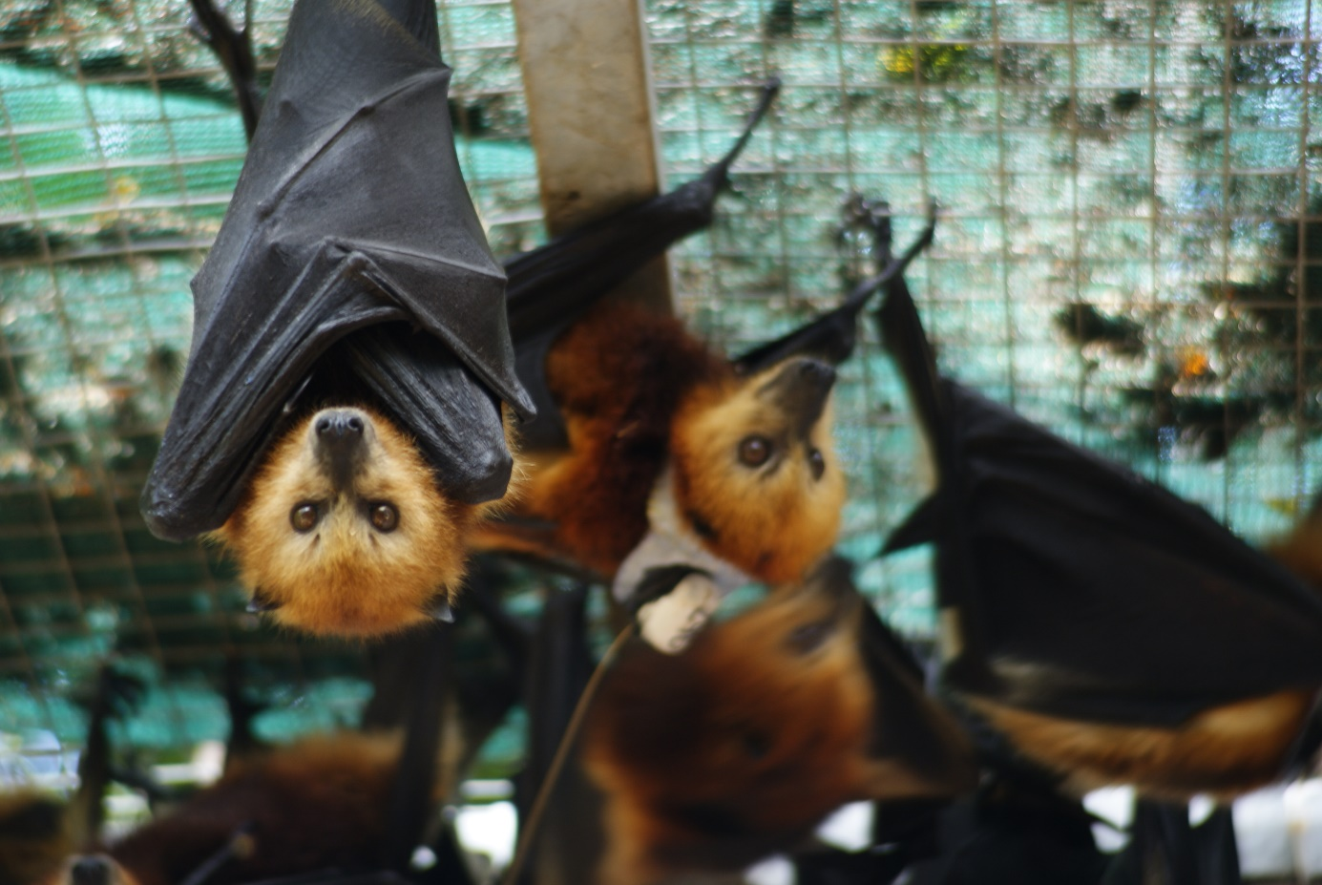

**Figure** **1:** Mauritius fruit bat (*Pteropus niger*). Picture: Lucia Haslbauer.

Non-reproductive adult females of *P. nige*r have a weight range between 380–540 g and an average forearm length of 152 mm (Nyhagen et al., 2005). The mating behaviour and reproductive cycle of *P. niger* is researched very little. Cheke and Dahl (1981) were able to observe mating pairs leaving the roosting group in April to “copulate noisily”. The mating season presumably starts in May and the young are born in December (Kingston et al., 2018). Other species of the genus have been reported to form harems but also seasonal groups of females and males or single male or female monogamous groups have been recorded (McCracken and Wilkinson, 2000). Many species of the genus *Pteropus* reach sexually maturity between one and two years of age and birth one young annually (Falanruw, 1988). There is no precise knowledge on that for *P. niger* (Kingston et al., 2018).

The endemic fruit bat is listed as Endangered by the International Union for Conservation of Nature (IUCN) since 2018 (Kingston et al., 2018) after the several mass cullings ordered by the Mascarene government as from 2015 (Anon., 2015). These cullings reduced the population number by about 50% (Vincenot et al., 2017) and was condemned by multiple scientists (Florens, 2016; Olival, 2016). The reduction of the bat population was ordered due to their foraging on commercial fruit trees and the damage they are inflicting on the crops (Tollington et al., 2019; Oleksy et al., 2021). Though without he commercial fruit trees the bats can starve, as many endemic plants are in scarce numbers (Kingston et al., 2018).

Further threats include human activity, disturbing roosts and diminishing endemic flora (Nelson et al., 2000), invasive alien species (Nyhagen, 2004; Krivek, 2017; Reinegger et al., 2021), climate change and the worsening of cyclones (Cheke and Dahl, 1981; Nurse et al., 2001), as well as illegal poaching for consumption (Kingston et al., 2018). If these threats continue and the fruit bat population could be reduced by 64-80% within the next 12-20 years. With this trend it could have a devastating effect on the local ecosystem and consequently for the whole island, as *P. niger* is the only remnant of large frugivores who disperses big seeds (Nyhagen et al., 2005; Hansen and Galetti, 2009; Krivek, 2017).

## Mauritius

Mauritius is an 1865 km² large subtropical oceanic island located in the Indian Ocean around 900 km from Madagascar (Doorga, 2022; Figure 3). It has two climatic seasons, in the summer months from November to May the weather is humid with mean temperatures of 24.7°C, mean precipitation of 1344 mm, an average wind force of 9.77 km/h and a higher likelihood of cyclones. During the Winter months of May to October, it is mostly dry with a mean precipitation of 666 mm, stronger wind force at 12.43 km/h and a mean temperature of 20.4°C (1971-2000; Anon., 2024).

Mauritius inhabits a high percentage of endemic plant species, though many are threatened by extinction due to habitat fragmentation, invasive plants, and high seed predation of alien animal species (Maunder et al., 2002; Baider et al., 2010; F. B. V. Florens et al., 2016). Mauritius' exceptional flora has created a habitat for various endemic animal species. However, alien species like the Common Myna (*Acridotheres tristis*) and long-tailed macaques (*Macaca fascicularis*) compete for food and negatively impact local fauna and flora (Krivek, 2017; Lowe et al., 2000; Reinegger et al., 2021). Since the first human activity in the early 1700s, about 98% of the natural vegetation went extinct (Gosling et al., 2017), and its remnants are strongly fragmented which means a reduced habitat for endemic species (Florens, 2013). Anthropogenic activities, like overexploitation, introduction of exotic species but also the use of fire as a tool for deforestation, degraded the ecosystems of the endemic species (Cheke and Hume, 2008; Norder et al., 2017). With the colonists, domestic animals as well as the Java deer (*Rusa timorensis*) and rats (*Rattus rattus*) were brought to the island, which had a negative effect on the local ecosystem (Peters et al., 2016). As a result, multiple animal and plant species went extinct (Cheke and Hume 2008).

## Data collection

### Field site

The research was conducted in the southwest of Mauritius, with the research station located in Tamarin (20°20’07.5” S, 57°22’51.3” E; Figure 3), in an area of low resident density. A high tree of the genus *Albizia* was available for research in the garden (Figure 4) and a colony of the fruit bats was known to roost close to the house, which simplified the attraction of the bats. Other food sources were seen in neighbouring gardens e.g. papaya trees, guava, custard apple etc., so the provided novel food source should not have been a special treat, other than that it was already pre-cut. Only the mangoes were not in season and might have influenced the attraction of the fruit bats. The data collection was carried out for eleven weeks from July to September (04.07.- 15.09.2023).

**Figure 2:** Map of Mauritius with the area of the field site encircled in red. In the top left corner is an overview map of southern countries of Africa with The Islands of Mauritius marked in red (created with Stadia Maps).

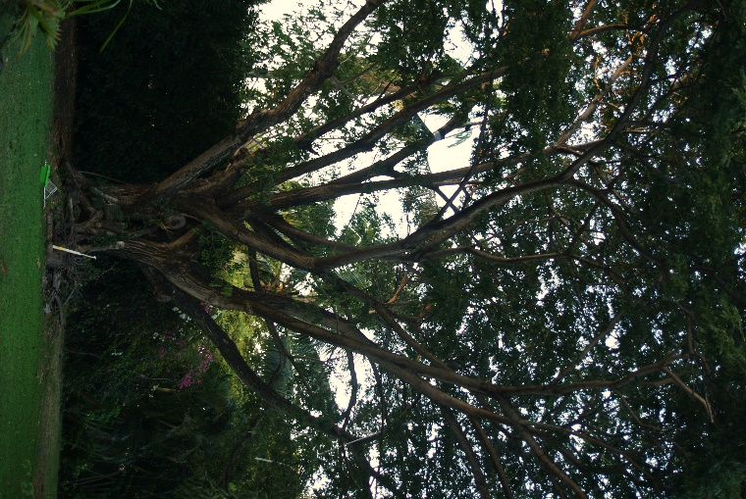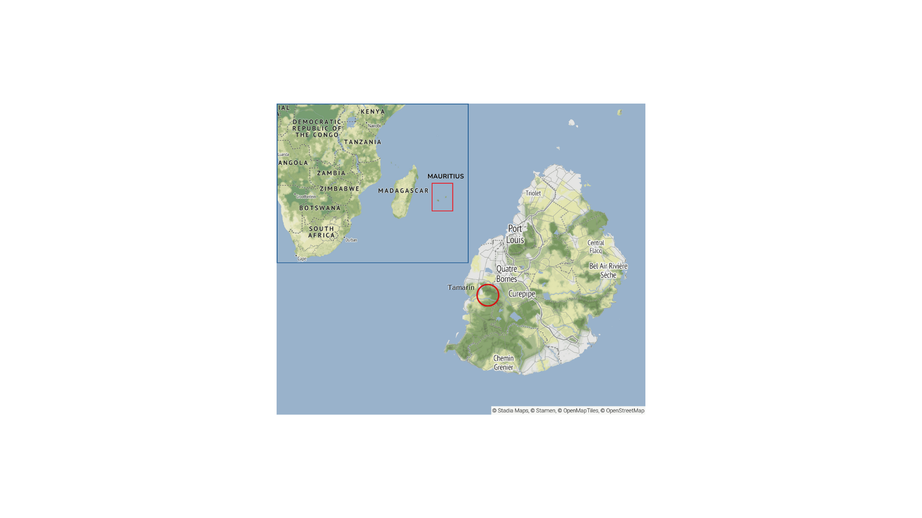

**Figure 3:** The *Albizia* tree used for research in the garden of the field site.

### Materials

To record the defence behaviour of the wild fruit bats, two metal baskets (27x20x12), each with an 80 cm long metal pole attached to it, were installed 8.7 m from each other in the tree (Figure 5). The baskets were attached to a nylon string in order to be pulled up the tree and be accessible by the bats. Both baskets had a Panasonic camera with an infrared filter (model: HX-A1M) attached to the metal pole, to record infrared video material and acoustic displays. To ensure the camera to run through the night, a power bank (ECO, model: ECO 600, 10000mAh/37Wh; Value, model: XS-20, 20000mAh) was connected and attached with zip ties (Figure 6). To start and control the recordings, the application “Image App” by Panasonic was used.

Another metal pole (6 m) was installed, 11.6 m from the tree to have an overview on the two baskets and the behaviours of the bats (Figure 5). A VSYSTO camera (K5X, version 1119) was attached to the metal pole, which was connected to a power bank and attached to the pole using zip ties. This camera was activated with the help of the affiliated application. Two floodlights were installed at the roof of the neighbouring house and directed at the tree to make the behaviours visible in the video recordings.

**Figure** **4**: Model of the experimental set-up. Two fruit baskets are installed with an 8.7 m distance in the tree with video cameras attached. Another standing camera is installed in front of the tree 11.6 m away.

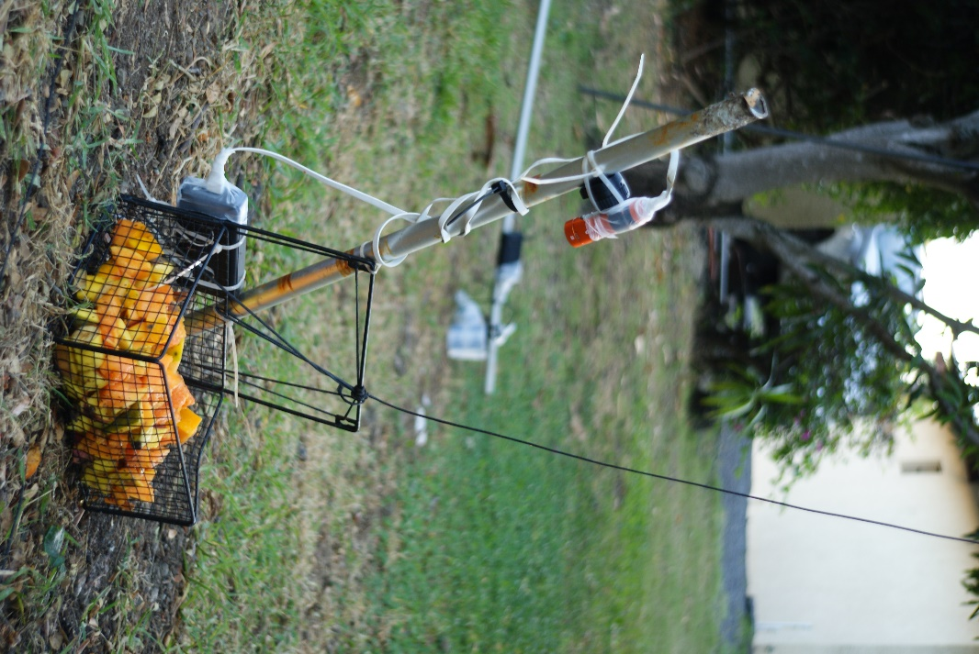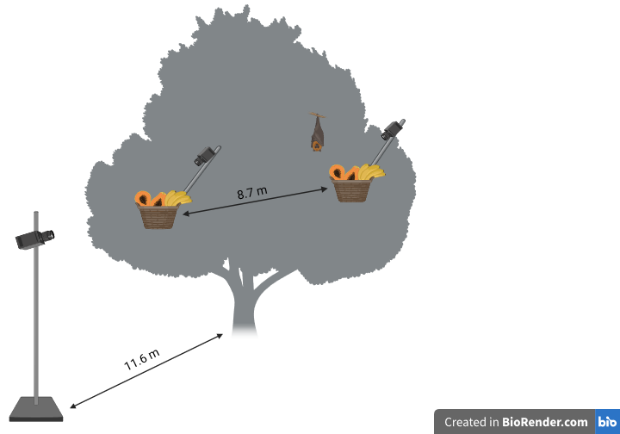

**Figure** **5**: Basket filled with local fruits (e.g.: papaya, banana, mango, guava). A Panasonic camera, connected to a power bank is attached to the basket.

### Experimental process

For one month previous to the start of the experiment, one of the baskets filled with local pre-cut fruits (e.g.: papaya, banana, mango, guava) was installed every night in the tree, to slowly attract the foraging bats without recording the behaviour.

Eventually the cameras were installed and the recording of the behaviours were started on the 04.07.2023. In Period one, only one basket was installed on the right side of the tree (04.-13.07). After the 13.07. two baskets, each on one side of the tree were installed, which is defined as Period 2. The baskets were pulled up around 30 min before sunset (GMT+4). The next day the data was transferred to a hard drive. To evaluate the difference between a solitary individual and in social interactions, observations were done ad libitum and continuously during the whole night.

## Data editing

The recorded videos of the overview pole were watched manually with increased speed (maximum x8) and the observed behaviours noted in an Excel sheet. An ethogram was created by evaluating the observations of the solitary and social behaviours of the experiment (Table 1) and follows the structure of the ethograms of Markus and Blackshaw (2002) and Welch et al. (2020). The ethogram is divided into solitary and social behaviours. The solitary behaviours are subdivided into locomotive and stationary behaviours. The social behaviours include only antagonistic behaviours, since affiliative behaviours were not observed. For each behaviour, the time of night, the individuals’ random number (e.g. P503), the number of individuals which were visible at the time on the tree and on which side of the tree (R or L) the observed individual was present was noted. Additionally, the time the bats spent on the tree was also recorded.

**Table 1**: Ethogram of the solitary and antagonistic behaviours of free ranging *Pteropus niger*.

|  |  |  |  |
| --- | --- | --- | --- |
| Category | Type | Behaviour | Definition |
| Solitary | **Locomotive** | Flying past | Flying past the tree and quickly getting out of sight again |
| Landing | Bat lands bipedally or quadrupedally |
| Landing attempt | Bat tries to land bipedally or quadrupedally |
| Climbing around | Climbing around in the tree with no apparent goal |
| Climbing to basket | A climbing movement towards the basket |
| Pacing | Climbing away and to the basket again in a short time |
| Grab fruit | Grabbing fruit (or the attempt), with forearm claw or mouth |
| **Stationary** | Hanging far | Bat hanging anywhere on the tree bipedally or monopedally with wings folded across body or loosely by sides of body |
| Hanging close | Attentive roosting position — body relaxed, eyes open and ears directed towards a source of interest |
| Hanging on basket | Bat hanging on the basket bipedally or monopedally with wings folded across body or loosely by sides of body |
| Open wings | One or both wings are opened while hanging, with stretching motions |
| Social | **Antagonistic** | Flapping wings | Strong and fast open wing movement with flapping sound, both wings rapidly drawn together in direction of another individual, making a clapping sound as they meet |
| Flapping wings close | The same as flapping wings but during an active fight, when the individuals are in close proximity to each other and the wings can touch the opponent |
| Displaced | The individual leaves the area as a result of another approaching individual |
| Displacing | An individual which makes another individual to leave the area |
| Lunge | An individual makes a sudden movement with one or two wings at another individual |
| Boxing | Individual punches another individual with their wings and wing knuckles |
| Wrestling | Individual has body contact with another individual with folded wings and pushes them around |
| Open wings individual | One or both wings are opened at another individual’s direction while hanging |
| Shake wings | Wings shaken repeatedly at another individual |
| Approach individual | Individual climbs in the direction of another individual |
| Fleeing | A bat climbs away fast from another individual, sometimes being followed by named individual |
| Chasing | A bat follows another individual which climbs away or flees from a situation |

### Defence behaviours

To determine whether residents or intruders win more often, the individuals who were in a fight were assigned to two different categories. Depending on whether an individual was displaced or displacing in a fight, they were put in the category “winner” and “loser” respectively. The individuals which were close to the basket first, were put in the category “resident”. The individuals that were challenging the residential bat and intruding their space, were put in the category “intruder”. The antagonistic behaviours were defined as defence behaviours.

### Weather data

The weather data was taken from the website visualcrossing.com. The data is from the closest weather station to the field site around 10 km air miles away in Vacoas-Phoenix (-20°19'1.514'' N, 57°31'35.504 E; Anon., 2024), though differences can occur due to the difference of altitudes (~ 400 m). For the data analysis, only the weather data of the night was used, to not manipulate the statistical tests, as the bats are not active during the day and the temperature change might have indicated a statistical significance.

## Data analysis

The number of bats recorded per night were summed and defined as the “activity” of the bats per night. The number of individuals visible at the time of the observed behaviours is defined as the “individuals on the tree”. The “rate of aggressiveness” was calculated by taking the number of the defence behaviours per individual and dividing it with all the behaviours the individual was displaying during the observation and multiplying it by 100.

All descriptive and statistical analysis was conducted with the program R-studio (version: 2023.12.1.402; Posit team, 2024). For all statistical analysis a significance level of 0.05 was utilized, indicating a 5% probability of incorrectly rejecting the null hypothesis. The package ggplot2 (Wickham and Wickham, 2016) was applied for all the graphical representations. The package lme4 (Douglas Bates et al., 2015) was used for General Linear Mixed models (GLMM). GLMMs with “individuals per night” as a random effect were conducted, as the observed individuals were not reliably identifiable and therefore repetition might occur. The “poisson” distribution was fitted and the following variables were used as fixed effects: disturbances, date, position (Left/Right), baskets (one/two), occurrence of defence behaviour, rate of aggressiveness, weather parameters (temperature, humidity, precipitation, wind speed, wind gusts and cloud cover) and individuals per night. The following was tested with GLMMs:

* If the activity and the number of baskets have an influence on the side the bats were present.
* If the disturbances from other experiments (capturing bats) on the premises have an influence on the activity of the bats.
* If the number of bats present have an influence on the defence behaviour.
* If the weather parameters temperature, humidity, precipitation, wind speed, wind gusts and cloud cover had an influence on the activity of the bats.

To determine the activity on the tree depending on the side (Right or Left) of the tree an Exact binomial test was conducted. To test if the increase of the number of baskets has an influence on the activity of the bats, a Negative Binomial Regression model was conducted, because of the overdispersion of the data. To apply Negative Binomial Regression models the package MASS was used (Venables and Ripley BD, 2002). To test whether the number of individuals per night had an influence on the time they spent on the tree, a General Linear model was conducted (GLM).

To examine whether residents or intruders were winning more often, a Pearson’s Chi squared test was used. Additionally, two spearman correlation tests and two GLMs were conducted to test the influence of the aggression rate on the outcome of a fight (winning or losing).

# Results

## Observed behaviours

The audio data was intended to be analysed for vocalizations associated with the defensive behaviour of *P. niger.* When evaluating the data, it became clear, that the audio recordings were in a very low quality with a lot of noise which made an analysis impossible.

Occasionally heavy rains and wind, the climbing bats or other unknown reasons resulted in the disconnection of the power bank or camera and therefore only a part or short period of the night was recorded. Sometimes the malfunction of the cameras and power banks resulted in no recordings for the night. In the end 27 days of data was able to be used which approximates to 267 hours of video recordings.

In total 913 bats (repetition might occur) were observed. Among all the observed behaviours “hanging close” (712) was displayed the most often and “landing attempt” (4) the least. The same applies to the solitary category, while in the antagonistic category “flapping wings” (142) was seen the most often and “chasing” (10) the least (Figure 7, Appendix: Table 2).

When individuals were alone on the tree they were mostly grabbing a fruit from the basket, then positioned themselves close to the basket and were feeding on the fruit, until they climbed back to the basket to grab another fruit and repeat the behaviours. When they were not feeding on fruit, they were mostly hanging relaxed close to the basket, grooming and defecating or just observing the surroundings, but would occasionally pace around the basket. In a few cases it was observed that a bat went to the other basket to feed, when it got displaced from one basket.

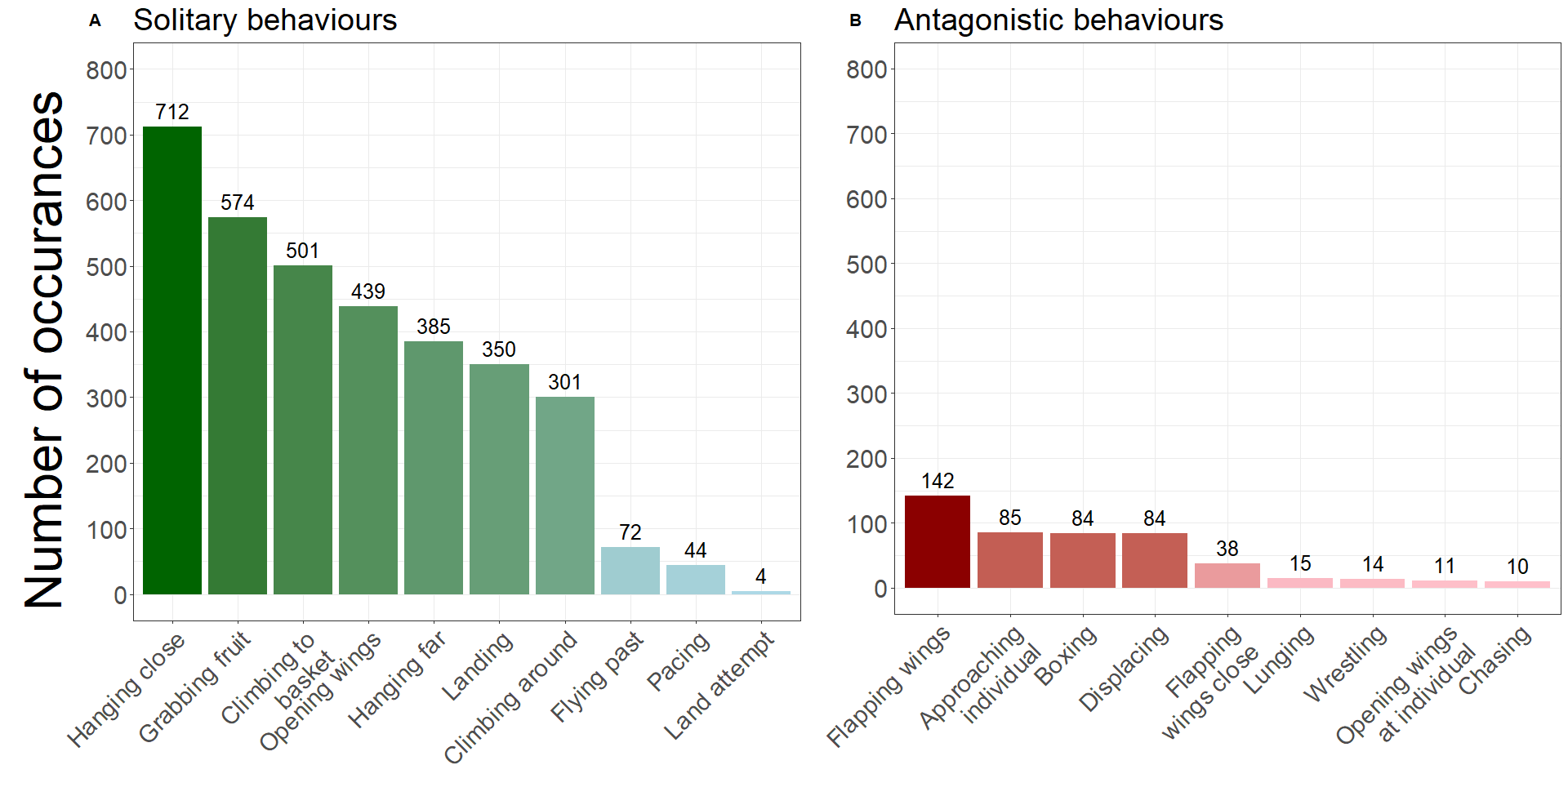

**Figure 6:** Two overview bar plots of the total occurrences of the behaviours displayed. It shows A: the solitary (green) and B: the antagonistic (red) behaviours.

## Activity

With a higher number of food patches, the activity increased (P < 0.001, Negative Binomial GLM, figure 7 and 8).

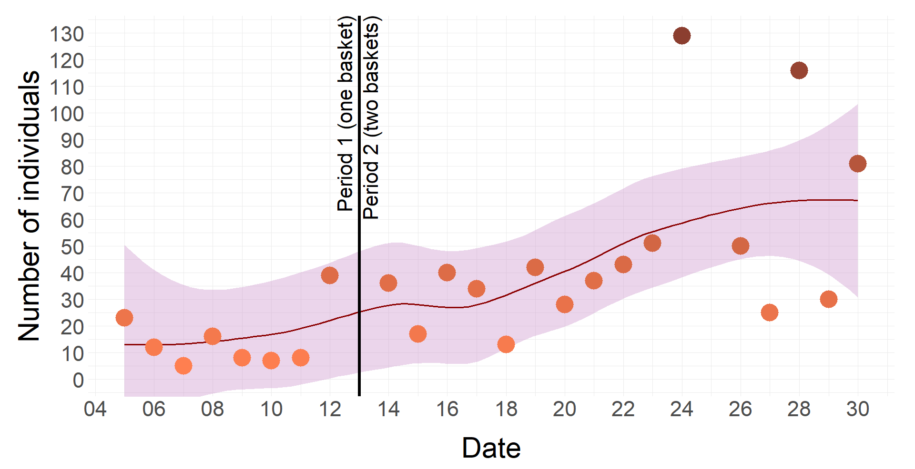

**Figure 7**: Number of individuals per night over the time of the data collection (June 2023). It depicts the increase of the number of individuals per night with a higher number of food patches (baskets).

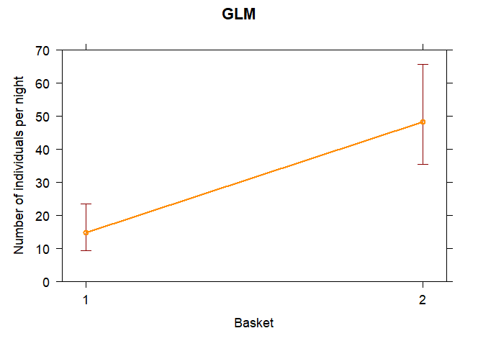

**Figure 8:** GLM graph for the count of individuals per night depending on the basket number.

In both periods, more activity has been recorded on the right side of the tree than on the left side (p < 0.001, Exact binomial test), with an estimated 80.5 % chance that the bats are present on the right side when the period is not taken into account. In Period 2, the higher number of baskets has an influence on the side the bats appear more often, as the probability of the bats appearing on the right side decreases (p < 0.001, GLMM, family = binomial, Figure 9).

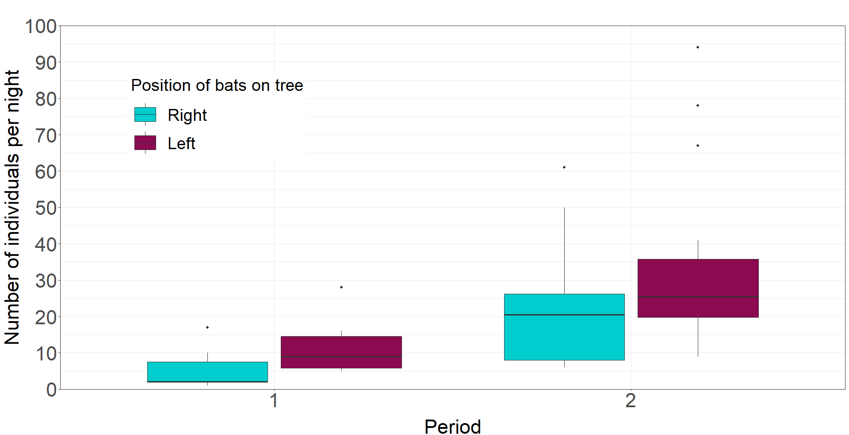

**Figure 9:** The boxplot shows the difference in side distribution of individuals per night depending on the period (number of baskets in the tree). Period 1 = one basket, Period 2 = two baskets. Turquoise = Left side, wine-red = Right side.

The time spent on the tree is influenced by the activity of bats. With an increase of individuals per night, the mean time an individual spent on the tree decreases (p < 0.001, GLM, Figure 10A). The possible disturbance by other experiments, namely capturing bats in close proximity of the tree does not have an influence on the activity of the bats.

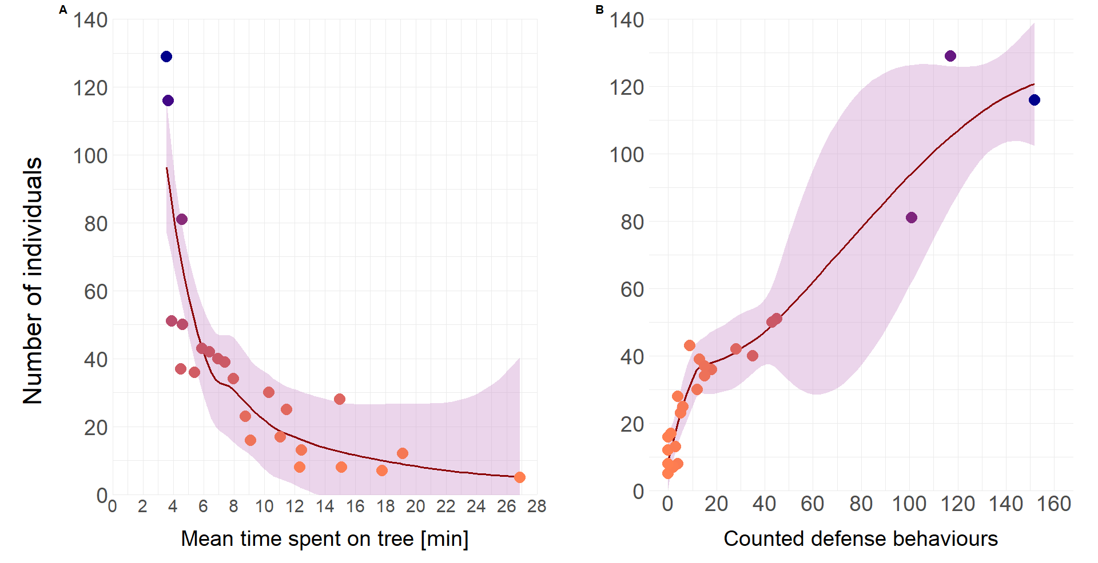

**Figure 10:** The influence of the mean number of individuals counted per night. Figure A: The mean time spent on the tree is lower with a higher number of individuals. B: The mean occurrence of defence behaviours increases with the numbers of individuals.

## Defence behaviour

A higher number of individuals during the night increased the rate of aggressive behaviour of the individuals (p < 0.01, GLMM). Subsequently, more individuals on the tree results in a higher likelihood of displaying defence behaviour (p < 0.001, GLMM, family = poisson; Figure 10B).

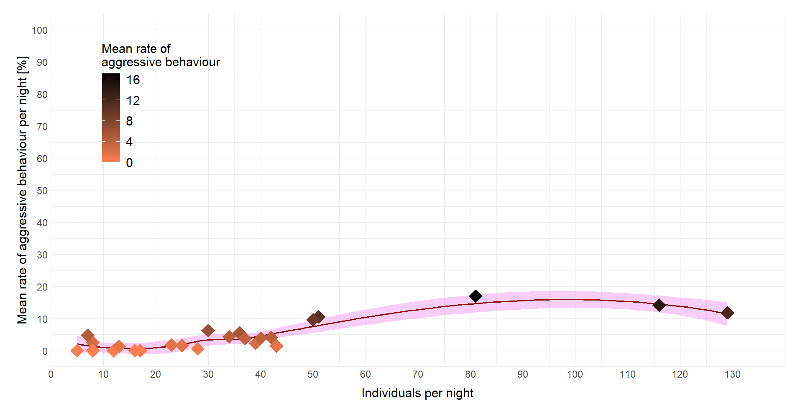

**Figure 11**: The mean aggressive behaviour per night in percentage in correlation with the number of individuals per night.

The “residents” (the bat that was in the area/tree first) lost significantly more often (p < 0.001, Pearson’s Chi-squared test) than the “intruders” (the bat that tries to intrude the space). Sometimes when an individual did not move immediately or came back after being displaced, the aggressive defence behaviour continued and intensified. A higher rate of aggression correlated positively with a higher chance of winning the fight (rS = 0.37, Spearman correlation; p < 0.0001, GLM, family = poisson).

## Weather influence

It was tested if the weather parameters temperature, humidity, precipitation, wind speed, wind gusts and cloud cover have an influence on the hourly activity of the bats. No parameter had an impact on the activity of the bats.

# Discussion

The Mauritian fruit bat (*Pteropus niger*) plays an important ecological part in the ecosystem of the island Mauritius, as it is the only remaining large seed disperser of native plants (Nyhagen et al., 2005; Hansen and Galetti, 2009; Florens et al., 2017a; Kingston et al., 2018). Not only the fruit bat relies on the food sources and nutrition of the endemic plant species (Nyhagen et al., 2005; Florens et al., 2017a), but also many native plants, like *Sideroxylon grandiflorum* (Sapotaceae) depend on the fruit bat for propagation (Baider and Florens, 2006). To ensure high impacting strategies for conservation and rehabilitation of the ecosystems, further basic knowledge of the key species is necessary (Kingston et al., 2018). To improve the knowledge about the social behaviours of the endangered Mauritian fruit bat (*Pteropus niger*), nightly observations of their food defence behaviour were conducted. An ethogram of the observed solitary and antagonistic behaviours of *Pteropus niger* was established (Table 1).

Activities of *P. niger* were dominated by the solitary behaviours of hanging close to the basket, grabbing a fruit, climbing to the basket and opening the wings. Hence, the behaviours were revolving around getting to the basket, feeding from it and staying close to it. Hanging close to the basket had the highest frequency of occurrences in this study. This behaviour might be important to the bats due to energy saving achievements by reduced locomotion after feeding (Nathan et al., 2009). Additionally, it might serve as a way to occupy their feeding territory, by staying close to the food source (Trewhella et al., 2001).

The opening of the wings could serve as thermoregulatory purposes, relaxing, as well as warning signs for an intruding bat. Thermoregulatory uses were observed in other species, where they opened and stretched their wings with increased ambient temperatures (Ochoa-Acuña and Kunz, 1999; Markus and Blackshaw, 2002; Ransaleleh et al., 2021). As this research was conducted during the night and the temperatures were quite stable, thermoregulatory purposes are unlikely. Though, a relaxing intention for stretching might could still be probable (Markus and Blackshaw, 2002). Opening and moving the wings might also have served as a defence behaviour, as it makes the bat seem bigger and intimidate the other individuals (Welch et al., 2020). Distinguishing between different kinds of wing movements was often not possible, as other bats were frequently not visible behind leaves and/or a more detailed observation was not feasible because of the low light and video quality. Only when it was very certain that the opening of the wings was directed at an individual, it was noted as “opening wings at individual”, which only occurred 0.28% of all behaviours (11 times) in the whole study.

Flapping wings occurred the most often out of the aggressive behaviours. It was also used when bats were just flying past. It seems to be the first stage of their territory defence and is most effective when individuals are still further away and a fight with body contact is not necessary.

The recorded defence behaviours were also observed in other species to either defend food or other resources such as roosting territory or mates (Elmqvist et al., 1992; Trewhella et al., 2001; Markus and Blackshaw, 2002; Fernandez et al., 2014). Often, they reported more behaviours, for instance biting, baring teeth, hooking, opening the mouth, sniffing and vocalisations. The observed fights in this study might have included these behaviours, but they were not visible due to the fast-paced fights and low light conditions. While vocalizations could not be analysed in this study, other research (Trewhella et al., 2001) and personal observations indicate that *P. niger* uses vocalizations during fights, similar to many species that emit specific vocalizations during aggressive behaviours. Seba's short-tailed bats (Carollia perspicillata) for instance display three different kinds of vocalisation during fights. With their emitting vocalisations, individuals are also able to distinguish each other (Fernandez et al., 2014).

A higher activity on the right side of the tree is most likely explained due to the fact, that the first basket was installed on the right side, followed by the second one on the left side. Additionally, the right basket seemed to be better reachable by the bats, as a higher abundance of small branches were around, which could explain that the right side was still in favour when two baskets were installed. Due to several limitations, including daily variations in video camera placement and the left basket being further from the overview camera than the right basket, data inaccuracies might have occurred.

With more baskets installed, a higher number of bats in the tree were observed, which increased the number of individuals per night. Subsequently, with more activity, more defence behaviour and a higher rate of aggressiveness was recorded and therefore the bats spent less time on the tree, as they were displaced more frequently. The rise of the bat activity over the consecutive days could be connected with an information transfer in the day roosts (Ward and Zahavi 1973). Chemical substances in breath, fur and urine can give roost mates cues about possible novel food sources (Wilkinson, 1992; Ratcliffe and Ter Hofstede, 2005) and therefore might have attracted the bats in our study to follow their roost neighbours. Additionally, the vocalisations emitted while fighting, might have attracted other bats to the tree (Elmqvist, 1992).

There might have been an influence on the variance of activity per night by the alteration of resource value, considering that every day a different fruit collection was put in the baskets. The prepared fruit did not always have the same ripeness and might have resulted in differing appearance of bats, since *P. niger* prefers ripe fruits (Krivek, 2017) and uses their olfactory senses to identify these (Kshitish Acharya et al., 1998; Hodgkison et al., 2007; Brokaw et al., 2021). Additionally, this study was conducted in semi natural setting, considering that the bats are wild, but were lured to the garden with pre-cut fruit. Only the papaya, guava and banana were in season and bought locally. The mangoes were not in season and were imported and might have attracted the bats more intensely, as they are higher in sugar content (11.5 and 25%; Tharanathan et al., 2006). In other experiments *P. niger* showed a favourism toward the fruit (pers. obs.). The foraging behaviour of *P.niger* is quite diverse, including native as well as exotic fruits (Cheke and Dahl, 1981; Nyhagen et al., 2005; Florens et al., 2017a). Exotic fruits might become more and more important for their diet, as the native plant populations are reduced continuously (Maunder et al., 2002; Baider et al., 2010; Florens et al., 2016, Florens et al., 2017b). This poses a threat to the nutrition of the bats, because when the economic fruiting trees are only carrying fruits in a specific season (October – December), malnourishment and also death can occur (Oleksy, pers. communic.). Also, the high abundance of exotic plant species in native forests reduces the production of flowers and fruits, which subsequently has an effect on the conservation of *P. niger*, as it includes species which fruits the bats are feeding on (Nyhagen et al. 2005; Baider and Florens 2006; Krivek, 2017).

More individuals on the tree resulted in a higher likelihood of displaying defence behaviour. When the individual did not move immediately, the aggressive defence behaviour continued and often intensified, which has also been observed by Trewhella et al. (2001) in *Pteropus livingstonii*. In this study the aggressive behaviours often started with an approach of either the intruder or resident. When neither of them left the area a fight with bodily contact started. Often it began with a flapping of wings and ended with an individual displacing the other, followed by a flapping of wings. Occasionally, a bat tried to flee from the fight by climbing away but often got chased after and finally driven off the tree. These sequences of behaviours with increased aggressiveness are also common in other species. In day roosts of *Pteropus Alecto* and *Carollia perspicillata* the individuals defend their roosting territory and/or mate. When an intruder approaches, they display ritualised defence behaviours which are occurring in a certain pattern and increase in aggressiveness if the intruder continues to approach (Markus and Blackshaw, 2002; Fernandez et al., 2014).

The results indicate that the residents lose more often than they win, in congruence with the research of Robbins (2004) who observed captive resident *Pteropus scapulatus* to lose more often to intruders, which might be due to the controlled fruit abundance and small sample of individuals. Trewhella et al. (2001) on the other hand observed the opposite in *Pteropus livingstonii*. In the study the trees flowered on the end of the branches and bats settled more on the upper part of the tree. In the present study the bats were not captive but the provided fruits were also not prepared in a natural way. The fruit baskets were concentrated in one or two areas, which also forced the bats to be more present in only these areas. A natural tree would have feeding opportunities all over the branches and a territory defence might be differently established. Therefore, this study’s structure is more similar to the one from Robbins, which explains the accordance of the results.

As some individuals were more successful in deterring other individuals regardless of the status, a difference in dominance is likely (Robbins, 2004). Welch et al. (2020) observed a difference of dominance according to age, with older individuals being more dominant. In other research, males have been observed to be more aggressive and dominant than females, often defending their territory and mates (*Pteropus poliocephalus* and *P. gouldi*, *Carollia perspicillata*, *Cynopterus sphinx, Pteropus giganteus*) (Nelson, 1965; Fernandez et al., 2014; Doss and Nagarajan-Radha, 2017; Prajapati et al., 2020). As in this study neither sex, nor age data were collected, a specific reason for the occurring dominance cannot be determined. Therefore, a more detailed analysis in the defence and a possible sexual dimorphism in attack behaviour was not achievable.

With two baskets installed, the abundance of the fruit increased and the non-aggressive individuals might have had a higher success by choosing the basket which is less defended. Given that the baskets were installed nearly 9 meters apart, this distance might have been too great for a single aggressive individual to effectively defend both food patches. Doing so would have required increased energy expenditure, suggesting an advantage for the non-aggressive individuals (Peiman and Robinson, 2010). Nonetheless, the right basket seemed to be more attractive to the bats. Either because it was better approachable, as discussed above, or the bats were more used to the right basket, because it was installed the longest.

The analysis demonstrates, that no weather parameter had a significant influence on the presence of the bats. Unfortunately, our analysis had some limitations, due to insufficient data (one month) and no measuring of the local weather parameters, which might vary due to the weather stations position around 10 km air miles away and at higher altitude.

Other research suggested that an influence of varying weather parameters is possible. With extreme temperatures (lower than 10°C and higher than 30°C) less locomotive activity is observed (Funakoshi et al., 1991; Thomson et al., 1998). Even cloud cover seems to have an impact on bat activity, with more cloud coverage less flying activity can be recorded (Trewhella et al., 2001). Moreover, wind forces over 5km/h make it difficult for bats to fly (Thomson et al., 1998). Wind gusts and heavy rains, often as part of cyclones can have an influence on the activity of bats, kill them and damage their roosting trees. Higher wind force and precipitation does not only prevent bats to go foraging but also has a devastating effect on fruit trees, since it reduces their fruiting outcome (Cheke and Dahl, 1981; McConkey et al., 2004). Cyclones are more common during the summer, so as the time of research was placed during the winter months (May-October), cyclones could not have impacted the behaviour (Nigel and Rughooputh, 2013).

To the latest knowledge, this research is the first scientific recording of the resource defence behaviour in *Pteropus niger.* It adds to the foundation of the basic knowledge of the endangered species, which is needed to implement sufficient education to improve conservation strategies (Kingston et al., 2018). This study indicates that the defence of the feeding territory is an important social behaviour of the Mauritian fruit bat. Similarities but also discrepancies with other research exists, which might be due to the existing limitations, which resulted in insufficient data. For a better analysis a longer period of data collection, measuring of local weather parameters, as well as different equipment and better camera placements should be considered. Further studies over an annual cycle, could give a better insight over the seasonal behaviour of the fruit bats, with possible sexual differences of dominance display and influences of weather parameters as seen in other species. In conclusion, further research on *Pteropus nigers* behaviour and ecology is essential for developing effective conservation strategies to ensure the survival of this endangered species and the preservation of the Mauritian ecosystem.

# Societal and ethical considerations

This study provides additional baseline knowledge about the behaviour of the endangered fruit bat *Pteropus niger* which can be used to raise awareness and inform local residents about the critical ecosystem services of the species. Especially because the Mauritian fruit bat has an important ecological role as a seed disperser as it is the only remnant of the largest frugivores on the island (Nyhagen et al., 2005; Hansen and Galetti, 2009; Krivek, 2017). Mauritius is part of the 17 Sustainable Development goals (SDGS) which were adopted in 2015 by all United Nations Member States. As an insular developing nation, Mauritius toggles various problems, including the “protection, restoration and promotion of sustainable use of terrestrial ecosystems” (goal Nr. 15; United Nations, 2015). The deforestation on Mauritius leads to land degradation, erosion (Norder et al., 2017), as well as destruction and fragmentation of ecosystems (Florens, 2013) which lead to the extinction of species and reduction of biodiversity (Baider and Florens, 2016; Baider et al. [2010](https://link.springer.com/article/10.1007/s10531-012-0304-4#ref-CR6)). This has a direct impact on the Mauritian fruit bat, as it includes the loss of roosting trees through deforestations, illegal logging and habitat destruction (Florens 2013). With the loss of habitat the population of bats decreases, which consequently leads to a further loss of biodiversity due to the native plants that rely on the fruit bat (Baider and Florens, 2016; Baider et al., [2010](https://link.springer.com/article/10.1007/s10531-012-0304-4#ref-CR6)). Erosion also reduces the ecosystem services a land can give (water, nutrients, agricultural substrate), so not only does the deforestation directly affect the survival of the fruit bats but automatically the survival of the human population of Mauritius (Norder et al., 2017), mostly the less fortunate people (Tsakok, 2023).

Goal number 13 of the SDGS embodies the fight against climate change and prevention of its effects (United Nations, 2015), which are prominent in small island nations. Devastating effects of climate change with rising ocean levels and vulnerability to extreme weather events (Nurse et al., 2001; Church et al., 2013) can already be seen in the island communities of Tuvalu, Kiribati, the Marshall Islands, and the Maldives (Rayfuse, 2009). Similar effects have impacted the island of Mauritius and its fruit bats, with cyclones damaging the roosts of *P. niger*, reducing their food availability and killing animals, resulting in a decline of their population numbers (Cheke and Dahl, 1981; Nurse et al., 2001). Additionally, the rise of temperature and precipitation changes the habitats and makes it easier for exotic and invasive species to spread, driving away the native species including *P.niger* (Doorga, 2022).

National Parks and Conservation Service (NPCS) and Non-government organisations (NGOs), namely the Ecosystem Restoration Alliance (ERA) and the Mauritian Wildlife Foundation (MWF) are attempting to educate the public and farmers (Kingston et al., 2018) but are struggling to implement long lasting conservation strategies that lead to a stable ecosystem (Florens, 2013). For an improved conservation of the threatened bat species, a better education is needed to improve the motivation and financial aid (Chandr Jaunky et al., 2021; Ramesh and Chandr Jaunky, 2021). Florens and Vincenot (2018) proposed that rather than resorting to culling, efforts should focus on educating the government, public, and farmers about non-lethal methods for deterring the fruit bats. For instance, using nets over the trees, pruning of fruit trees to make them less accessible for bats (max 4 m) or sound deterring systems (Kingston et al., 2018). the

The research was conducted under the permit provided by the Ministry of Agro-Industry and Food Security (National Parks and Conservation Service). It was carried out with non-invasive study methods and concentrated on the infliction of the least human influence as possible.

# Acknowledgements

I first and foremost thank Ksenia Krivoruchko for her help as my first supervisor. She taught me her expertise in bat handling and vast knowledge about bat research but also about the island of Mauritius. I am grateful for Prof. Yossi Yovel (University Tel Aviv) for funding and providing me this project. Further I would like to thank Rie Henriksen for her support as my second supervisor and her open ear for my problems. I especially thank my friends Sophie and Marina who were always offering me a shoulder to cry on when R-studio didn’t work.

# References

Anonymus. (2015). Sixth National Assembly Parliamentary Debates of the Republic of Mauritius. No. 33 of 2015. Available at: <http://mauritiusassembly.govmu.org/English/hansard/Documents/2015/hansard3315.pdf>. (Accessed on 22 March 2024)

Anonymus. (2024). Mauritius Meteorological Services. http://metservice.intnet.mu/ (Accessed on 22 March 2024)

Anonymus. (2024). Visiualcrossing. [https://www.visualcrossing.com/weather/weather-data services/vacoas/metric/2023-07-01/2023-10-01](https://www.visualcrossing.com/weather/weather-data%20services/vacoas/metric/2023-07-01/2023-10-01). (Accessed on 22 March 2024).

Baider, C., Florens, F. V., Baret, S., Beaver, K., Matatiken, D., Strasberg, D., and Kueffer, C. (2010). *Status of plant conservation in oceanic islands of the western Indian Ocean.*

Behr, O., and von Helversen, O. (2004). Bat serenades—Complex courtship songs of the sac-winged bat (Saccopteryx bilineata). *Behavioral Ecology and Sociobiology*, *56*(2), 106–115. https://doi.org/10.1007/s00265-004-0768-7

Bouchard, S. (2001). Sex discrimination and roostmate recognition by olfactory cues in the African bats, Mops condylurus and Chaerephon pumilus (Chiroptera: Molossidae). *Journal of Zoology*, *254*(1), 109–117. https://doi.org/10.1017/S0952836901000607

Bradbury, J. W., and Vehrencamp, S. L. (2011). *Principles of animal communication* (2nd ed). Sinauer Associates Sunderland, Mass.; WorldCat.

Brokaw, A. F., Davis, E., Page, R. A., and Smotherman, M. (2021). Flying bats use serial sampling to locate odour sources. *Biology Letters*, *17*(10), 20210430. https://doi.org/10.1098/rsbl.2021.0430

Chandr Jaunky, V., Jeetoo, J., and Michael Thomas, J. (2021). Willingness to pay for the conservation of the Mauritian flying fox. *Global Ecology and Conservation*, *26*, e01504. https://doi.org/10.1016/j.gecco.2021.e01504

Chaverri, G., Ancillotto, L., and Russo, D. (2018). Social communication in bats. *Biological Reviews*, *93*(4), 1938–1954. https://doi.org/10.1111/brv.12427

Cheke, A. S., and Dahl, J. F. (1981). The Status of bats on western Indian Ocean islands, with special reference to Pteropus. *Mammalia*, *45*(2). https://doi.org/10.1515/mamm.1981.45.2.205

Cheke, A. S., and Hume, J. P. (2008). *Lost land of the dodo: An ecological history of Mauritius, Réunion and Rodrigues*. Yale University Press.

Church, J. A., Clark, P. U., Cazenave, A., Gregory, J. M., Jevrejeva, S., Levermann, A., Merrifield, M. A., Milne, G. A., Nerem, R. S., Nunn, P. D., Payne, A. J., Pfeffer, W. T., Stammer, D., Unnikrishnan, A. S., 2013. Sea Level Change. In: Stocker, T. F., Qin, D., Plattner, G.-K., Tignor, M., Allen, S. K., Boschung, J., Nauels, A., Xia, Y., Bex, V., Midgley, P. M. (Eds.). (2013). Climate Change: [The Physical Science Basis. Contribution](https://drs.nio.res.in/drs/handle/2264/4605) [of Working Group I to the Fifth Assessment Report of the Intergovernmental Panel on](https://drs.nio.res.in/drs/handle/2264/4605) [Climate Change. Cambridge University Press, Cambridge, United Kingdom and New](https://drs.nio.res.in/drs/handle/2264/4605) York, NY, USA.

Dechmann, D., and Safi, K. (2005). Studying communication in bats. *Cognition, Brain, Behavior*, *9*, 479–496.

Doorga, J. R. S. (2022). Climate change and the fate of small islands: The case of Mauritius. *Environmental Science and Policy*, *136*, 282–290. https://doi.org/10.1016/j.envsci.2022.06.012

Doss D, P. S., and Nagarajan-Radha, V. (2017). Male resource defence behaviour strengthens harem size in promiscuously mating fruit bats. *Acta Chiropterologica*, *19*(2), 329–336.

Douglas Bates, M., Bolker, B., and Walker, S. (2015). Fitting linear mixed-effects models using lme4. *Journal of Statistical Software*, *67*(1), 1–48.

Elmqvist, T., Cox, P. A., Rainey, W. E., and Pierson, E. D. (1992). Restricted pollination on Oceanic islands: Pollination of Ceiba pentandra by flying foxes in Samoa. *Biotropica*, *24*, 15-23.

Falanruw, M. (1988). On the status, reproductive biology and management of fruit bats of Yap. *Micronesica*, *21*(1–2), 39–51.

Fernandez, A. A., Fasel, N., Knörnschild, M., and Richner, H. (2014). When bats are boxing: Aggressive behaviour and communication in male Seba’s short-tailed fruit bat. *Animal Behaviour*, *98*, 149–156. https://doi.org/10.1016/j.anbehav.2014.10.011

Florens, F. B. V. (2013). Conservation in Mauritius and Rodrigues: Challenges and achievements from two ecologically devastated oceanic islands. *Conservation Biology: Voices from the Tropics*, 40–50.

Florens, F. B. V. (2016). Mauritius culls threatened fruit bats. *Nature*, *530*(7588), 33–33. https://doi.org/10.1038/530033a

Florens, F. B. V., Baider, C., Marday, V., Martin, G. M. N., Zmanay, Z., Oleksy, R., Krivek, G., Vincenot, C. E., Strasberg, D., and Kingston, T. (2017a). Disproportionately large ecological role of a recently mass-culled flying fox in native forests of an oceanic island. *Journal for Nature Conservation*, *40*, 85–93. <https://doi.org/10.1016/j.jnc.2017.10.002>

Florens, F. V., Baider, C., Seegoolam, N. B., Zmanay, Z., and Strasberg, D. (2017b). Long‐term declines of native trees in an oceanic island's tropical forests invaded by alien plants. *Applied Vegetation Science*, *20*(1), 94-105.

Florens, F. B. V., Baider, C., Martin, G. M. N., Seegoolam, N. B., Zmanay, Z., and Strasberg, D. (2016). Invasive alien plants progress to dominate protected and best-preserved wet forests of an oceanic island. *Journal for Nature Conservation*, *34*, 93–100. https://doi.org/10.1016/j.jnc.2016.09.006

Florens, F. V., and Vincenot, C. E. (2018). Broader conservation strategies needed. *Science*, *362*(6413), 409–409.

Funakoshi, K., Kunisaki, T., and Watanabe, H. (1991). Seasonal changes in activity of the northern Ryukyu fruit bat Pteropus dasymallus dasymallus. *Journal of the Mammalogical Society of Japan*, *16*(1), 13–25.

Galván, I., Garrido-Fernández, J., Ríos, J., Pérez-Gálvez, A., Rodríguez-Herrera, B., and Negro, J. J. (2016). Tropical bat as mammalian model for skin carotenoid metabolism. *Proceedings of the National Academy of Sciences*, *113*(39), 10932–10937.

Gosling, W. D., de Kruif, J., Norder, S. J., de Boer, E. J., Hooghiemstra, H., Rijsdijk, K. F., and McMichael, C. N. H. (2017). Mauritius on fire. *Biotropica*, *49*(6), 778–783. JSTOR.

Gould, E. (1988). Wing-clapping sounds of Eonycteris spelaea (Pteropodidae) in Malaysia. *Journal of Mammalogy*, *69*(2), 378-379.

Götze, S., Denzinger, A., and Schnitzler, H.-U. (2020). High frequency social calls indicate food source defense in foraging Common pipistrelle bats. *Scientific Reports*, *10*(1), 5764. https://doi.org/10.1038/s41598-020-62743-z

Greville, L. J., Ceballos-Vasquez, A., Valdizón-Rodríguez, R., Caldwell, J. R., and Faure, P. A. (2018). Wound healing in wing membranes of the Egyptian fruit bat (Rousettus aegyptiacus) and big brown bat (Eptesicus fuscus). *Journal of Mammalogy*, *99*(4), 974–982. <https://doi.org/10.1093/jmammal/gyy050>

Hansen, D. M., and Galetti, M. (2009). The forgotten megafauna. *Science*, *324*(5923), 42-43.

Hodgkison, R., Ayasse, M., Kalko, E. K. V., Häberlein, C., Schulz, S., Mustapha, W. A. W., Zubaid, A., and Kunz, T. H. (2007). Chemical Ecology of Fruit Bat Foraging Behavior in Relation to the Fruit Odors of Two Species of Paleotropical Bat-Dispersed Figs (Ficus hispida and Ficus scortechinii). *Journal of Chemical Ecology*, *33*(11), 2097–2110. <https://doi.org/10.1007/s10886-007-9367-1>

Jones, G., and Teeling, E. C. (2006). The evolution of echolocation in bats. *Trends in Ecology and Evolution*, *21*(3), 149-156.

Kingston, T., Florens, F., Oleksy, R., Ruhomaun, K., and Tatayah, V. (2018). *Pteropus niger (The IUCN Red List of Threatened Species, 2018)*.

Krivek, G. (2017). *The influence of invasive alien plant control on the foraging habitat quality of the Mauritian flying fox (Pteropus niger)*.

Kunz, T. H. and Pierson, E. D. 1994. Bats of the World: and introduction. Pp. 1–46 in Nowak, R. W. (ed.) Walker’s bats of the world. Johns Hopkins University Press, Baltimore.

Kshitish Acharya, K., Roy, A., and Krishna, A. (1998). Relative role of olfactory cues and certain non-olfactory factors in foraging of fruit-eating bats. *Behavioural Processes*, *44*(1), 59–64. https://doi.org/10.1016/S0376-6357(98)00028-X

Lowe, S., Browne, M., Boudjelas, S., and De Poorter, M. (2000). *100 of the world’s worst invasive alien species: A selection from the global invasive species database* (Vol. 12). Invasive Species Specialist Group Auckland.

Markus, N., and Blackshaw, J. K. (2002). Behaviour of the Black Flying Fox *Pteropus alecto*: 1. An Ethogram of Behaviour, and Preliminary Characterisation of Mother-Infant Interactions. *Acta Chiropterologica*, *4*(2), 137–152. https://doi.org/10.3161/001.004.0203

Maunder, M., Page, W., Mauremootoo, J., Payendee, R., Mungroo, Y., Maljkovic, A., Vericel, C., and Lyte, B. (2002). The decline and conservation management of the threatened endemic palms of the Mascarene Islands. *Oryx*, *36*(1), 56–65.

McConkey, K. R., Drake, D. R., Franklin, J., and Tonga, F. (2004). Effects of Cyclone Waka on flying foxes (Pteropus tonganus) in the Vava’u Islands of Tonga. *Journal of Tropical Ecology*, *20*(5), 555–561.

McCracken, G. F., and Gustin, M. K. (1991). Nursing Behavior in Mexican Free-tailed Bat Maternity Colonies. *Ethology*, *89*(4), 305–321. https://doi.org/10.1111/j.1439-0310.1991.tb00376.x

McCracken, G. F., and Wilkinson, G. S. (2000). Bat mating systems. In *Reproductive biology of bats* (pp. 321–362). Elsevier.

Nathan, P. T., Karuppudurai, T., Raghuram, H., and Marimuthu, G. (2009). Bat Foraging Strategies and Pollination of Madhuca latifolia (Sapotaceae) in Southern India. *Acta Chiropterologica*, *11*, 435–441. https://doi.org/10.3161/150811009X485657

Nelson, J. E. (1965). Behaviour of Australian pteropodidae (Megacheroptera). *Animal Behaviour*, *13*(4), 544–557.

Nelson, S. L., Miller, M. A., Heske, E. J., and Fahey, G. C. (2000). Nutritional Consequences of a Change in Diet from Native to Agricultural Fruits for the Samoan Fruit Bat. *Ecography*, *23*(4), 393–401. JSTOR.

Nigel, R., and Rughooputh, S. (2013). Application of a RUSLE-based soil erosion modelling on Mauritius Island. *Soil Research*, *50*, 645–651. https://doi.org/10.1071/SR12175

Norder, S., Seijmonsbergen, A., Rughooputh, S., Loon, E., Tatayah, V., Kamminga, T., and Rijsdijk, K. (2017). Assessing temporal couplings in social–ecological island systems: Historical deforestation and soil loss on Mauritius (Indian Ocean). *ECOLOGY AND SOCIETY*, *22*, 29. <https://doi.org/10.5751/ES-09073-220129>

Nowak, R. M. (1994). *Walker's bats of the world*. JHU Press.

Nurse, L. A., Sem, G., Hay, J. E., Suarez, A. G., Wong, P. P., Briguglio, L., and Ragoonaden, S. (2001). Small island states. *Climate Change*, 843–875.

Nyhagen, D. F. (2004). A study of the bat-fruit syndrome on Mauritius, Indian Ocean. *Phelsuma*, *12*, 118–125.

Nyhagen, D. F., Turnbull, S. D., Olesen, J. M., and Jones, C. G. (2005). An investigation into the role of the Mauritian flying fox, Pteropus niger, in forest regeneration. *Biological Conservation*, *122*(3), 491–497. https://doi.org/10.1016/j.biocon.2004.08.012

Ochoa-Acuña, H., and Kunz, T. H. (1999). Thermoregulatory behavior in the small island flying fox, Pteropus hypomelanus (Chiroptera: Pteropodidae). *Journal of Thermal Biology*, *24*(1), 15–20. <https://doi.org/10.1016/S0306-4565(98)00033-3>

Oleksy, R. (2015). The impact of the Mauritius Fruit Bat (Pteropus niger) on commercial fruit farms and possible mitigation measures. *Detailed final report to The Rufford Foundation*.

Oleksy, R. Z., Ayady, C. L., Tatayah, V., Jones, C., Froidevaux, J. S. P., Racey, P. A., and Jones, G. (2021). The impact of the Endangered Mauritian flying fox *Pteropus niger* on commercial fruit farms and the efficacy of mitigation. *Oryx*, *55*(1), 114–121. https://doi.org/10.1017/S0030605318001138

Oleksy, R. Z., Ayady, C. L., Tatayah, V., Jones, C., Howey, P. W., Froidevaux, J. S. P., Racey, P. A., and Jones, G. (2019). The movement ecology of the Mauritian flying fox (Pteropus niger): A long-term study using solar-powered GSM/GPS tags. *Movement Ecology*, *7*(1), 12. https://doi.org/10.1186/s40462-019-0156-6

Olival, K. J. (2016). To Cull, or Not To Cull, Bat is the Question. *EcoHealth*, *13*(1), 6–8. https://doi.org/10.1007/s10393-015-1075-7

Peiman, K. S., and Robinson, B. W. (2010). Ecology and Evolution of Resource-Related Heterospecific Aggression. *The Quarterly Review of Biology*, *85*(2), 133–158. https://doi.org/10.1086/652374

Peters, N., Neer, W. van, Debruyne, S., and Peters, S. (2016). Late 17th century AD faunal remains from the Dutch ‘Fort Frederik Hendrik’ at Mauritius (Indian Ocean). *Archaeofauna*, 159–184.

Prajapati, J., Chalise, M., and Karmacharya, D. (2020). Habitat and Behavioral Observation of Indian Flying Fox Pteropus giganteus (BRÜNNICH, 1782) in Sallaghari, Bhaktapur, Nepal. *Journal of Natural History Museum*, *31*, 79–94. https://doi.org/10.3126/jnhm.v31i1.39376

Probst, J.-M., and Sanchez, M. (2015). Découverte d’une nouvelle colonie de Roussette des Mascareignes Pteropus niger (Kerr, 1792) dans l’Est de La Réunion. *Bulletin Phaethon*.

Ramesh, V., and Chandr Jaunky, V. (2021). Public awareness and perception towards conservation of Mauritian Flying Fox (Pteropus niger): Structural equation modelling. *Materials Today: Proceedings*, *37*, 2269–2278. https://doi.org/10.1016/j.matpr.2020.07.703

Ransaleleh, T. A., Whajuni, I., Kawatu, M., Nangoy, M. J., and Wiantoro, S. (2021). Behavior of the black flying fox, Pteropus alecto (Chiroptera: Pteropodidae) in cages. *Biodiversitas Journal of Biological Diversity*, *22*(12).

Ratcliffe, J. M., and Ter Hofstede, H. M. (2005). Roosts as information centres: social learning of food preferences in bats. *Biology Letters*, *1*(1), 72-74.

Reinegger, R. D., Oleksy, R. Z., Bissessur, P., Naujeer, H., and Jones, G. (2021). First come, first served: Fruit availability to keystone bat species is potentially reduced by invasive macaques. *Journal of Mammalogy*, *102*(2), 428–439. https://doi.org/10.1093/jmammal/gyaa182

Robbins, S. J. (2004). *Foraging Interference and Fruit Palatability in Pteropus Scapulatus (Megachiroptera: Pteropodidae): Management Implications*.

Schnitzler, H.-U., and Kalko, E. K. V. (2001). Echolocation by Insect-Eating Bats: We define four distinct functional groups of bats and find differences in signal structure that correlate with the typical echolocation tasks faced by each group. *BioScience*, *51*(7), 557–569. [https://doi.org/10.1641/0006-3568(2001)051[0557:EBIEB]2.0.CO;2](https://doi.org/10.1641/0006-3568(2001)051%5b0557:EBIEB%5d2.0.CO;2)

Schöner, M. G., Simon, R., and Schöner, C. R. (2016). Acoustic communication in plant–animal interactions. *Current Opinion in Plant Biology*, *32*, 88-95.

Seegobin, V. O., Oleksy, R. Z., and Florens, F. B. V. (2022). Foraging and roosting patterns of a repeatedly mass-culled island flying fox reveals opportunities to mitigate human–wildlife conflict. *Biodiversity*, *23*(2), 49–60. https://doi.org/10.1080/14888386.2022.2107569

Seegobin, V. O., and Probst, J. (2020). Seawater ingestion by the Mauritius flying fox. *African Journal of Ecology*, *58*(4), 836–839. <https://doi.org/10.1111/aje.12749>

Tharanathan, R. N., Yashoda, H. M., and Prabha, T. N. (2006). Mango *(Mangifera indica L.)*, “The King of Fruits”—An Overview. *Food Reviews International*, *22*(2), 95–123. https://doi.org/10.1080/87559120600574493

Thiagavel, J., Cechetto, C., Santana, S. E., Jakobsen, L., Warrant, E. J., and Ratcliffe, J. M. (2018). Auditory opportunity and visual constraint enabled the evolution of echolocation in bats. *Nature Communications*, *9*(1), 98. https://doi.org/10.1038/s41467-017-02532-x

Thomson, S., Brooke, A., and Speakman, J. R. (1998). Diurnal activity in the Samoan flying fox, Pteropus samoensis. *Philosophical Transactions of the Royal Society of London. Series B: Biological Sciences*, *353*(1375), 1595–1606.

Tollington, S., Kareemun, Z., Augustin, A., Lallchand, K., Tatayah, V., and Zimmermann, A. (2019). Quantifying the damage caused by fruit bats to backyard lychee trees in Mauritius and evaluating the benefits of protective netting. *PLOS ONE*, *14*(8), e0220955. https://doi.org/10.1371/journal.pone.0220955

Trewhella, W., Rodríguez-Clark, K., Davies, J. G., Reason, P., and Wray, S. (2001). Sympatric fruit bat species (Chiroptera: Pteropodidae) in the Comoro Islands (Western Indian Ocean): Diurnality, feeding interactions and their conservation implications. *Acta Chiropterologica*, *3*, 135–147.

United Nations (2015). Transforming Our World: The 2030 Agenda for Sustainable Development. Resolution Adopted by the General Assembly on 25 September 2015, 42809, 1-13. https://doi.org/10.1007/s13398-014-0173-7.2

Vaughan, T. A., and Vaughan, R. P. (1986). Seasonality and the behavior of the African yellow-winged bat. *Journal of Mammalogy*, *67*(1), 91–102.

Venables WN, Ripley BD (2002). Modern Applied Statistics with S, Fourth edition. Springer, New York. ISBN 0-387-95457-0, <https://www.stats.ox.ac.uk/pub/MASS4/>.

Vincenot, C. E., Florens, F. V., and Kingston, T. (2017). Can we protect island flying foxes? *Science*, *355*(6332), 1368–1370.

Voigt, C. C., von Helversen, O., Michener, R., and Kunz, T. H. (2001). The economics of harem maintenance in the sac-winged bat, Saccopteryx bilineata (Emballonuridae). *Behavioral Ecology and Sociobiology*, *50*(1), 31–36. <https://doi.org/10.1007/s002650100337>

Ward, P., and Zahavi, A. (1973). The importance of certain assemblages of birds as “information‐centres” for food‐finding. *Ibis*, *115*(4), 517-534.

Welch, M. J., Smith, T., Hosie, C., Wormell, D., Price, E., and Stanley, C. R. (2020). Social Experience of Captive Livingstone’s Fruit Bats (Pteropus livingstonii). *Animals*, *10*(8), 1321. https://doi.org/10.3390/ani10081321

Wickham, H., and Wickham, H. (2016). *Data analysis*. Springer.

Wilkinson, G. S., and Wenrick Boughman, J. (1998). Social calls coordinate foraging in greater spear-nosed bats. *Animal Behaviour*, *55*(2), 337–350. https://doi.org/10.1006/anbe.1997.0557

Yovel, Y., Geva-Sagiv, M., and Ulanovsky, N. (2011). Click-based echolocation in bats: Not so primitive after all. *Journal of Comparative Physiology A*, *197*(5), 515–530. https://doi.org/10.1007/s00359-011-0639-4

# Appendix

**Table 2**: The total sum of the behaviours as well as the mean and maximum per individual.

|  |  |  |  |
| --- | --- | --- | --- |
| Behaviour | Total sum | Mean  (per individual) | Maximum  (per individual) |
| Hang close | 712 | 0.782 | 6 |
| Grab fruit | 574 | 0.630 | 9 |
| Climb to basket | 501 | 0.550 | 3 |
| Open wings | 439 | 0.482 | 21 |
| Hang far | 385 | 0.423 | 4 |
| Landing | 350 | 0.384 | 3 |
| Climb around | 301 | 0.330 | 6 |
| Flapping wings | 142 | 0.156 | 6 |
| Approach individual | 85 | 0.093 | 4 |
| Boxing | 84 | 0.092 | 4 |
| Displacing | 84 | 0.092 | 2 |
| Fly Past | 72 | 0.079 | 1 |
| Pacing | 44 | 0.048 | 15 |
| Flapping wings close | 38 | 0.042 | 15 |
| Lunge | 15 | 0.016 | 4 |
| Wrestling | 14 | 0.015 | 2 |
| Fleeing | 13 | 0.014 | 2 |
| Open wings at individual | 11 | 0.012 | 2 |
| Chasing | 11 | 0.012 | 2 |
| Shake wings | 10 | 0.011 | 1 |
| Landing attempt | 4 | 0.004 | 1 |