Linköping University | Department of Physics, Chemistry and Biology
Type of thesis, 60 hp | Educational Program: Physics, Chemistry and Biology
Spring term 2022 | LITH-IFM-x-EX—22/4121--SE

Effects of commercial hatchery processes on the stress susceptibility in domestic chicken (Gallus gallus)

Hedvika Suchankova

Examiner, Rie Henriksen
Supervisors, Per Jensen & Enya Van Poucke

Contents
1. Abstract 1
2. Introduction 2
2.1. Commercial production process of laying hens 2
2.2. Physiology of stress 4
2.3. Early life stress effects 4
2.4. Behavioral reaction to stress in chickens 6
2.5. Aims of the study 7
3. Materials and Methods 8
3.1. Experimental animals 8
3.2. Housing and care 9
3.3. Stress Treatments 10
3.3.1. Transportation 10
3.3.2. Regrouping 11
3.4. Tests evaluating the stress treatments 12
3.4.1. Weight recordings 12
3.4.2. Tonic Immobility 12
3.4.3. HPA-axis reactivity assessment 13
3.4.4. Behavioral observations 14
3.5. Statistical analysis 15
4. Results 15
4.1. Weight data 15
4.2. Tonic immobility 16
4.3. Plasma CORT 17
4.4. Behavioral Observations 17
5. Discussion 18
5.1. Study effects on weight 19
5.2. Effects of transport on the fear response during TI 20
5.3. Effects of regrouping on plasma CORT levels and behavioral response 22
5.4. The big picture 23
6. Societal and ethical considerations 24
7. Acknowledgments 26
8. References 26

Abstract
The aim of this study was to investigate if the current industrial procedures affect later stress susceptibility, hence affecting the ability of the commercial White Leghorn hybrids to cope with later life stressors. Both hatchery non-processed (CC), and hatchery processed (HC) groups underwent equal experimental conditions with differences only in their experience during incubation and subsequent processing the day after hatching. Chickens were subjected to weekly weighing, and two experimental stressors; transportation with a tonic immobility test (TI) and regrouping with blood plasma CORT values supported by behavioral observations. Overall, the HC group exhibited higher feather pecking occurrence. There were no significant effects of the industrial procedures otherwise. Also, no overarching significant effects on the coping mechanisms of transportation or regrouping were found in either of the studied groups, and the CC group performed significantly more fearfully in the TI test. Lastly, both treatment groups seemed to exhibit a long-term resilience to stressors, suggesting a continuous strong genetic selection for resilience and coping with highly stressful and currently inevitable experiences in their early life.

Key words: stress - hatchery - White Leghorn - early life stress - commercial process - chickens

Introduction

2.1 Commercial production process of laying hens
The chicken industry encompasses two separate sectors: the egg layers and the broilers. The meat industry in Sweden strongly overshadows the egg industry by production numbers, partly because of the significantly shorter life span of broiler chicken (Swedish National Veterinary Institute, 2020). Broilers experience rapid and drastic growth over a short time since they are slaughtered between 30 to 40 days for the conventionally reared and about ten weeks for the organically reared (Nicol, 2015, Wall H., 2021). The layers have substantially slower growth and longer life span since they begin to lay eggs at approximately 16 weeks of age and then they are kept in egg production until the laying slows down around 72 weeks of their age (Augere-Granier, 2019). Commercial layers are selectively bred for daily egg production and against broodiness (sitting on eggs) (Nicol, 2015). Overall, the commercial production of chickens puts high demands on each breed with specific phenotypic selection, as well as drastic housing and handling conditions in order to maximize production (Nicol, 2015). Therefore, many natural behaviors are reduced or completely removed from the repertoire while some harmful behaviors such as feather pecking, and stereotypies have increased in abundance (Nicol, 2015).

The commercial egg production in Europe consisted of more than 400 million laying hens in 2018 (Augere-Granier, 2019), and over seven million laying hens, nearing eight million in Sweden in 2020 (Swedish National Veterinary Institute, 2020). The most common layers for egg production in Sweden are hybrids bred from the White Leghorn. The process of specialized large-scale egg production begins with grandparental hybrid lines that are kept by only a handful of companies in the world (Nicol, 2015). These highly selected lines give rise to all the parental lines which lay eggs for pullet production at each commercial hatchery (Swedish National Veterinary Institute, 2020).

From the time eggs are laid until one day post-hatch, chickens undergo many different handling procedures. Initially, they are placed into large noisy incubators and then transported into a large hatcher a few days before hatching (Hedlund & Jensen, 2021). Newly hatched chickens are separated from their shells and placed on a conveyor belt system, throughout which chickens get manually sex-sorted with males being discarded (Augere-Granier, 2019; Hedlund & Jensen, 2021). Females then undergo the vaccination process followed by fast speed belts and multiple drops that deliver them into a machine which counts every individual (Hedlund & Jensen, 2021). Lastly, chickens are boxed, loaded onto trucks, and transported to the rearing farms (Hedlund & Jensen, 2021).

Besides the hatchery experience, the transportation is another potentially stressful process for animals since it involves unfamiliar loud and mechanical sounds, road unevenness, and other environmental changes such as temperature and humidity. In addition, animals are not provided with feed and water over the duration of the transport time, and when they reach their final destination, they are presented with an entirely novel environment (Mancinelli et al. 2017). Furthermore, transportation of chickens is in most cases an inevitable process as pullets are often transported at least twice, but often most three times throughout their lives (Cheng & Jefferson, 2008). The first transport is from a hatchery to a rearing farm, and it occurs a day after hatching. Secondly, pullets are transported to the laying farms at approximately 16 weeks of age (Swedish National Veterinary Institute, 2020). The last transport experience is usually to a slaughter house (Cheng & Jefferson, 2008).

About 64 percent of layers in the Swedish commercial egg production are housed in either single-tiered or multi-tiered indoor floor systems, but all housing systems are required to provide enrichment such as perches, a nest and a litter (Augère-Granier, 2019; Swedish National Veterinary institute, 2020).

The process of rearing laying hens is a highly automated large-scale potentially highly stressful process that often hinders natural behaviors such as raising of offspring, maintenance of close family bonds, foraging behavior, changes to the circadian rhythm, and often dust bathing and perching among others (Fahey & Cheng, 2009; Nelson, 2011; Costa et al., 2012). The early life stress effects due to the current commercial practices at the hatchery need to be investigated further since egg production affects billions of chickens all around the world.

Physiology of stress
Stress can be defined as “an environmental effect on an individual which overtaxes its control systems and reduces its fitness or appears likely to do so” (Broom, 2019). In order to cope with such stress, individuals need to engage in a specific physiological and psychological response. When an individual is exposed to a stressor, it activates the hypothalamic-pituitary-adrenal (HPA) axis with the sympathetic nervous system (SNS). The SNS activation is a rapid neurological reaction that promotes the fight or flight response. The HPA axis, on the other hand, reacts slightly slower in terms of minutes rather than seconds (Tasker & Herman, 2011). The HPA axis functions as a negative feedback loop-based system with secretion of hormones, such as glucocorticoids. Glucocorticoids such as corticosterone (CORT) play a key role in maintaining the needed homeostatic balance in occurrence of stress by influencing behavioral coping responses (Daskalakis et al., 2015). In addition, the HPA axis inhibits inflammation, which is caused by the immune system, and stimulates gluconeogenesis in the liver to create the needed energy for restoration of said homeostatic balance. When the stressor ceases to exist, the negative feedback loop engages and the secretion of glucocorticoids is inhibited until their concentrations in the system decrease (Matteri, 2000, p. 47; Papadimitriou & Priftis, 2009; Tasker & Herman, 2011; Wang et al., 2012).

This system is highly effective for homeostatic balance if the stressor is not of a permanent presence. However, when an individual is constantly exposed to stressors, prolonged glucocorticoid abundance results in their chronically increased baseline concentrations in the system and elevated sensitivity of the HPA axis, as well as decreased response of the negative feedback loop (Rice et al., 2008; Daskalakis et al., 2015).

2.3 Early life stress effects
Stress during a developmental period is especially dangerous since it can have detrimental permanent effects on an individual's health and coping mechanisms. Considering that the earlier the stress occurs in the development, the more an individual is in potential harm (Lindström, 1999; Ericsson et al., 2016). Increased stress during a sensitive prenatal period can have permanent effects on the brain development, causing changes to the HPA-axis, for example (Franke et al., 2020). These brain changes are correlated to a delay in development, permanently impaired learning ability, language delay, as well as psychiatric disorders in humans (Franke et al., 2020). The effects of maternal stress have also been extensively studied in many species such as non-human primates and rodents with observed changes to the HPA-axis sensitivity and baseline CORT levels, decreased immune function, as well as increased pessimism, fear and cognitive deficits (Weinstock, 2008; Henriksen et al., 2011).

Though maternal stress effects have been likewise observed in oviparous species with decreased birth weight of the offspring among those previously mentioned, the incubation period of an egg plays a crucial role in an individual's development (Henriksen et al., 2011). It has been shown that high doses of CORT injected into chicken eggs during an incubation period significantly reduced their growth rate after hatching, as well as significantly increased aggressive behavior with an early life onset (Henriksen et al., 2011; Ahmed et al., 2014). Additionally, chickens with high CORT levels in the eggs during their incubation had increased mortality, reduced growth, as well as earlier termination of development (Eriksen et al., 2003).

Exposure to excess glucocorticoids during an early life can also have detrimental effects on an individual's health since the development continues (Matteri, 2000). Immune system suppression, hyperglycaemia, catabolism, poorer growth during developmental period, and increased pessimism among others have been shown to be affected by chronic stress, that is linked to the excess of glucocorticoids (Matteri, 2000; Miller & O'Callaghan, 2002; Ericsson et al., 2016). In humans, early life stress contributes to about 30 % of all anxiety disorders, and it generally increases the risk of mental illnesses (Pechtel & Pizzagalli, 2011; Cohen et al., 2013). Similar impacts of early life stress were observed in non-human primates that exerted cognitive deficits with correlated changes to their brain morphology (Rice et al., 2008). In mice and rats, it has also been shown that injections of glucocorticoids in early life caused morphological changes in the brain (Daskalakis et al, 2015). Early life stress in these species was also shown to decrease hippocampal-dependent memory in their adulthood (Cohen et al., 2013).

Previous research in chickens showed that chronic stress in early life increased aggressive behaviors such as feather pecking, decreased size and quality of laid eggs, as well as delayed sexual maturation and fecundity (Lindström, 1999; Nazar & Marin, 2010; Hedlund et al., 2019; Hedlund et al., 2021). Since commercial pullet production of laying hens is such a large, mechanized process, chickens experience a substantial number of potential stressors during their incubation period such as loud incubators, conveyor belts processing and transport (Knowles et al., 2004; Hedlund et al., 2019; Hedlund & Jensen, 2020; Giersberg et al., 2021). Further stressors also exist after the newly hatched chicks are delivered to the rearing farms. Individuals are often housed in overcrowded pens, which may be subject to reorganization leading to changes of group structure from time to time.

It has been previously shown that chickens that underwent this commercial process had significantly higher levels of plasma CORT compared to chickens hatched in smaller-scale conditions even on the day of hatching (Hedlund et al., 2019). Further research showed that these differences in baseline CORT levels between commercially and non-commercially processed White Leghorn chickens are present even until 20 weeks of age (Hedlund et al., 2021). Hence, the stress within the commercial process of pullet production may result in a long-term or permanent elevation of CORT, therefore impacting chicken welfare.

Additionally, elevated baseline CORT levels correlate with an increased reactivity of the HPA axis, resulting in significantly higher CORT values after an introduction of an experimental stressor such as a restraint, social isolation, or social regrouping (Fahey & Cheng, 2009; Goerlich et al., 2012; Hedlund et al., 2019). In conclusion, corticosteroid concentrations in the system serve as good indicators of physiological stress, as well as indicators of the HPA axis’ reactivity (Ericsson et al., 2016; Hedlund & Jensen, 2020).

2.4 Behavioral reaction to stress in chickens
A strong behavioral reaction with elicited behaviors such as increased feather pecking, immobility caused by fear, aggression, excess beeping, increased pessimism, or cannibalism has been shown to complement the immediate or long-term physiological stress with the elevated CORT values (Janczak et al., 2006; Costa el al., 2012; Ericsson et al., 2016; Hedlund et al., 2021). Tonic immobility (TI) is a widely used test for fear assessment when a chicken is briefly restrained and subsequently released, it undergoes tonic immobility, which is a paralysis-like state during which the animal seems dead to its potential predators. The time length of this state indicates level of fear, hence stress and provides a measurable scale and comparable results between individuals or groups (Knowles et al., 2004; Forkman et al., 2007; Yoshidome et al., 2021). TI is often a useful test to assess fearfulness in response to a specific stressor by performing TI before and shortly after experiencing the said stressor. Preceding similar studies on the differences between hatchery chickens and control groups that measured fearfulness by TI show mixed results., but supporting research is needed since effects of the commercial hatching process is not vastly studied in layers (Ericsson et al., 2016; Hedlund, et al., 2019). Additional standardized behavioral tests for assessment of fear are, for example, novel arena, novel object, social separation, and behavioral observations after regrouping. All these tests assess the time length of returning to a normal behavioral repertoire such as foraging, grooming and positive social behaviors or task completion (Dawkins, 1989; Collias & Collias, 1996; Kruit et al., 1990). In other words, those individuals that exhibit a longer stress response before returning to standard behaviors have a greater difficulty to cope with such stressors. Elevated behavioral stress responses and decreased ability to cope with new stressors, therefore, may serve as indicators of potentially poor animal welfare (Hedlund et al., 2021; Nazar & Marin, 2010). For that reason, simultaneous evaluation of physiological, as well as behavioral responses to stressors is important for assessing animal welfare.

2.5 Aims of the study
This study aimed to assess if the potentially highly stressful experience of the commercial hatchery affects the way how chickens would handle stressors later in life and how susceptible they would be to them. Both hatchery non-processed and hatchery processed groups underwent equal experimental conditions with differences only in their experience during incubation and subsequent processing the day after hatching. Therefore, all following tests were to assess the effects of these commercial methods. Since the commercial hatching process is presumed more stressful, the hatchery processed group was hypothesized to have stronger behavioral reactions to these stressors with equivalently stronger physiological responses.

Materials and Methods

3.1 Experimental animals
Two female-only hybrids of the White Leghorn (Gallus gallus) groups from the same parental flock in commercial production at Lohmann Sverige AB were studied. The hatchery non-processed group (CC) consisted of chickens that were incubated and processed at the research facilities at Linkoping University (LiU). The hatchery processed group (HC) consisted of chickens that were hatched and processed at the commercial hatchery, Lohmann Sverige AB, and lastly transported for approximately five to six hours by a commercial truck to the LiU’s research facilities. Both groups underwent the same experimental conditions from Day 1 post-hatching after all chickens arrived at the research facility. The entire timeline of the experimental period is outlined in Table 1.

Table 1. Timeline of the experimental period.
Day | Treatment/Event | Day | Treatment/Event
-24 | CC Eggs transported from the commercial hatchery and placed into a fridge | 37 | Post-transport TI test
-21 | CC and HC eggs were placed into incubators | 53 | Baseline (pre-regrouping) behavioral observations
-11 | Candling | 56 | Baseline (pre-regrouping) blood sampling
-3 | CC and HC eggs moved to hatchers | 58 | Regrouping + behavioral observations
0 | Hatch day | 60 | Treatment (post-regrouping) blood sampling
1 | CC and HC taken out of the incubators, and processed according to their treatment | 62 | Second baseline (post-regrouping) behavioral observations
9 | Vaccination, wing tagging, perches added to pens | 67 | Culling/ end of the experimental period
35 | Pre-transport TI test | Weighing Days: 1, 9, 16, 23, 30, 37, 44, 51, 57
36 | Transport

3.2 Housing and care
24 days before hatching (Day -24) a total number of 270 While Leghorn eggs (CC) were picked up from Lohmann Sverige AB and transported in a pre-cooled Styrofoam box to the research facilities at Linköping University (LiU). They were placed into a cooler with an automatic egg rotation feature at a stable temperature of 15 °C. The eggs remained in the cooler for three days in order to synchronize the beginning of treatment group (HC) incubation. 21 days before hatching (Day -21) the eggs were once again briefly transported into the LiU Hatchery facility. After the eggs reached room temperature, they were evenly divided and placed into two identical incubators. On the same day the HC group was placed into a large incubator at the commercial hatchery after spending approximately 24 hours in order to reach 25-26 °C. Since the commercial incubator is significantly larger it took approximately five hours to reach a temperature of 37.8 °C. Both HC and CC groups were subject to the same incubator settings at a stable temperature of 37.8 °C, humidity of 55%, and continuous egg rotation. The CC group was checked for egg fertility on day -11 and 31 eggs were discarded. The remaining 239 eggs were as evenly as possible distributed back into the two incubators. On day -3 all the eggs at the commercial hatchery, as well as LiU research facility, were moved into a hatcher that was set for a stable temperature of 37.5 °C and humidity of 65%. Both groups hatched on day 0, however they remained in the hatcher until day 1. On day 1 the CC group was sex-sorted and the males culled. However, due to a sex-sorting error in the CC group, 10 males remained throughout the experiment, although they were not included in any data analysis. On the same day HC group was sex sorted and processed according to the industrial protocol, as previously discussed, and delivered to the LiU research facility. The CC group was not provided with feed but had access to water until the HC group arrived to simulate lack of feed during the transportation. After receiving leg rings, 71 CC and 105 HC females with the additional 10 males were placed as evenly as possible, but leaving the experimental groups intact, into four equally sized pens, 90 cm x 180 cm. Each pen was equipped with a sawdust substrate, water and feed ad libitum and a heat lamp. The lighting was set to a 12 hour rotation system between dark and light cycle. Pens were cleaned on a weekly basis and provided with fresh sawdust.

There was a mortality of three chicks during the first week, leaving the overall count to 70 + 10 individuals in the CC group, and 103 females in the HC group. Throughout the experimental period, the CC chicks were vaccinated with all mandatory vaccinations. Marek’s vaccine was administered into the peritoneal cavity on day 9 post-hatch. The HC group was equally hand-handled with a needle for the equivalent time without any injection to simulate the vaccination process to assure equal treatment for both groups. In addition, both groups received a wing tag and a perch was added to each pen. All four pens were expanded to 90 cm x 270 cm on day 23, and the heat lamp was removed. Water and feed bells were elevated throughout the experiment to an appropriate height.

On day 36 chickens were transported to a larger LiU facility. They were again distributed into four equally sized pens, 120 cm x 360 cm. The groupings within each pen remained the same. Water and feed were provided ad libitum and each pen contained two perches. The lighting was set to a 12-hour rotation system between dark and light cycle. Pens were again cleaned weekly. The experimental period ended on day 67 when all the remaining individuals were culled. The culling was performed in concordance with the ethical permit number 14916-2018.

3.3 Stress Treatments

3.3.1 Transportation
To mimic standardized transportation that pullets experience at 16 weeks of age, both treatment groups were transported on day 36 into a larger research facility within LiU. Each pen was divided into two large cardboard boxes (58 x 35 x 41 cm) with holes for air circulation and with a small layer of sawdust at the bottom. The eight boxes were divided between two standard passenger cars with internal air conditioning temperature set at 20 degrees Celsius. For the purpose of the greater effect of transportation, the cars were driving for approximately one hour on both highways and smaller local roads.

3.3.2 Regrouping
Since chickens form strong social bonds with rigid hierarchies for life, changing these established structures may result in significant social stress (Fahey & Cheng, 2009). This practice, however, is not uncommon within the commercial process and for that reason regrouping was chosen as a tested stressor on the two study groups. Both CC and HC groups were as evenly as possible spread among two pens per treatment group. In order to regroup standing social groups and also treat all individuals uniformly, all chickens were firstly hand-caught and placed into crates. Subsequently, half of the population of each pen was relocated to the second pen of the same treatment. The grouping within the pens of the same treatment was therefore changed, while the two treatment groups, HC and CC, remained intact (Figure 2). To assess the physiological stress response, plasma CORT concentrations were obtained, and additional behavioral observations were taken.
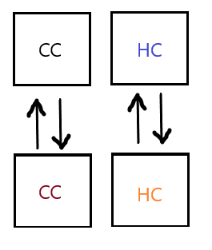
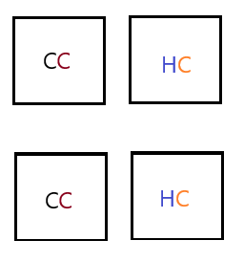
Figure 3. (A) Pre-regrouping and regrouping simulation of pen structure. (B) Post-regrouping.
B
A

3.4 Tests evaluating the stress treatments

3.4.1 Weight recordings
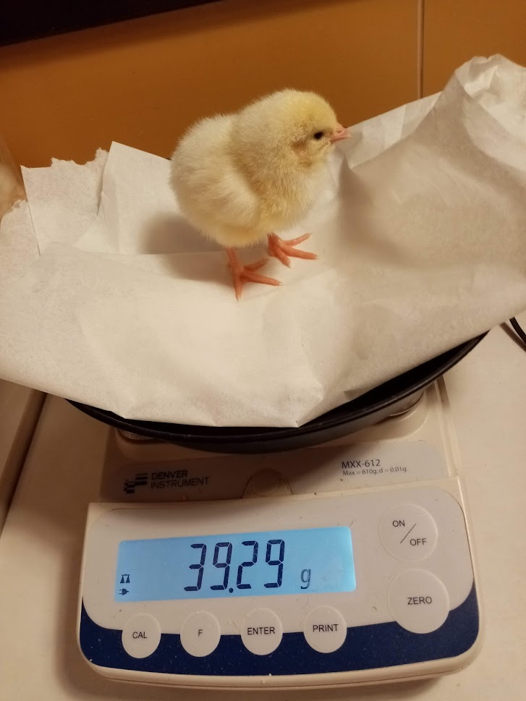
All chickens were weighed weekly from day 1 to day 57 in total of nine weighing occurrences. Chickens were hand-caught into crates and then individually weighed on a table balance scale with a precision of 0.01 g up to weighing on day 30 (Figure 1, left), and 0.1 g for the last three weighing occurrences (Figure 1, right).
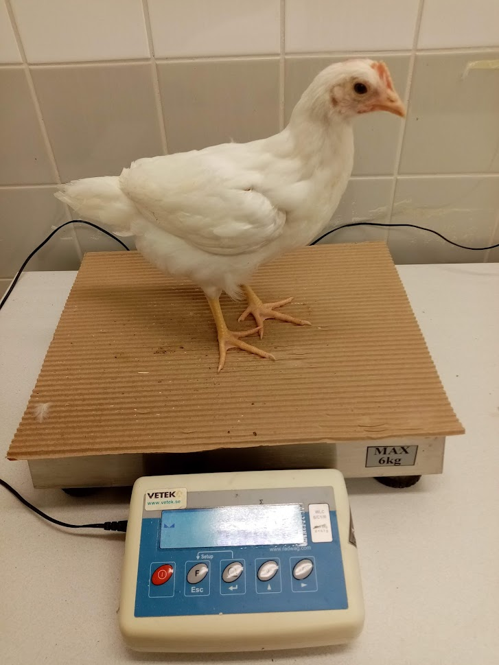
Figure 1. Weighing procedure up to day 30 (left). Weighing procedure from day 37 (right).

3.4.2 Tonic Immobility
Tonic immobility test was performed on days 35 (baseline), and 37 (treatment), with the transportation as a stressor in between on day 36. The TI method was conducted in concordance with an experimental design by Hedlund and Jensen (2021). The same initially randomly chosen 42 individuals from which 40 were subject to statistical analysis, 20 CC and 20 HC, were tested during both times. Number of attempts to induce each individual into the TI, the time of first beep, as well as the first head movement and the righting time were noted. Maximum number of induction attempts was set to three and the maximum time for righting was set to 600 seconds. The same experimenter handled induction both times to avoid differences in applied pressure and handling. Similarly, all chickens were individually hand-caught and briefly carried into a study room by another person to ensure undistracted isolation from the flock. Chickens were induced into TI by placing a hand on their chest, slowly turning them on their backs while placing them onto a TI cradle (Figure 2). Slight pressure was applied for 10 seconds to prevent further movement and to induce the TI. After 10 seconds, the hand was lifted and TI timing began. If the chicken stood up within the next five seconds, the TI was deemed uninduced and the induction was repeated. Researchers also stepped back or to the side to avoid close proximity and eye contact with the tested subjects. Video recordings were taken of each TI test and later analyzed. Any first perceived voluntary head movement was recorded as a First Head Movement. This test was double blind. One researcher chose tested chickens and the second researcher induced chickens into TI without knowing which group was tested.
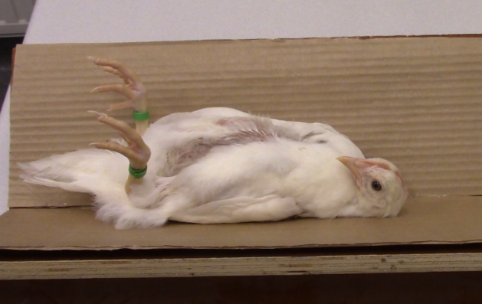
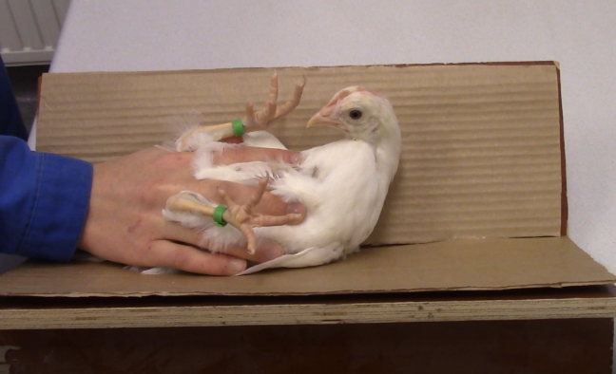
Figure 2. TI induction procedure (left). Chicken in TI (right).

3.4.3 HPA-axis reactivity assessment
To determine the reactivity of the HPA-axis—the physiological response to the regrouping— plasma CORT concentrations were obtained. All individuals, hatchery non-stressed (N=22), and hatchery stressed (N=22) were randomly selected for blood sampling prior to regrouping on day 53. The same individuals were blood sampled again after the regrouping on day 60. Each tested chicken was hand-caught and carried from its pen into another room where it was blood sampled by venipuncture of the brachial vein using Sterican syringe needles. The blood was collected with the help of Microvette heparinized tubes (200 μL). All blood samples were stored in a cooler and processed later on the same day of their collection. The process included centrifuging at 1300 RPM for at least 5 minutes with the resulting plasma being pipetted into a 0,5mL tube. All plasma samples were then stored in a freezer at -20 degrees Celsius until further analysis. Subsequent corticosterone analysis was performed according to the ELISA test product manual from Enzo Life Sciences.

3.4.4 Behavioral observations
Behavioral observations of stress and comfort behaviors were collected as supporting data of the effects of regrouping. Group level 0-1 behavioral observations in 30 seconds segments for a total of 1 hour per observation session were performed on days 53, 58, and 62 to observe potential behavioral changes to a changed social grouping within the pens. Baseline observations were taken 5 days before regrouping on day 53. Immediate observations on day 58 were recorded after chickens were regrouped. Second post-regrouping baseline was obtained 4 days after regrouping. Observations were performed at approximately the same time during the day with two pens observed at the same time for the first hour and the other two remaining pens for the second hour. Each of the two researchers observed one pen at a time. The 0-1 sampling was done in a concordance with a revised behavioral ethogram for stress-related or coping behaviors obtained from Wichman et al. (2021) (Table 2).

Table 2. Ethogram for regrouping observations, from Wichman et al., 2021.
Behavior | Description
Preen | Beak touches plumage of bird itself
Dustbathe | Lying down, scratching and or rubbing litter into the plumage
Aggression | Frontal displays with raised hackles towards other birds, head pecking, jumping or kick at other bird
Severe Peck | Hard and fast pecks and/or pulling at other birds’ feathers
Gentle Peck | Light, repeated pecks at the feathers of another bird
Stretch | Either wing or leg is lifted off ground and away from body as far as possible
Wing shake | Both wings are lifted in upwards movements
Run | Moving faster than walking pace, both feet leave the ground in each step
Spar | Frontal displays, often accompanied by little jumps
Vocalize | Louder vocalization like gakel call or short loud sound

3.5 Statistical analysis
All data were analyzed using SPSS software version 28. Graphs were made using Microsoft Excel. Behavioral observations data could not be subject to a statistical analysis since each pen represented an independent replicate, and therefore a total of four independent replicates (two per treatment) was insufficient to carry out proper statistical testing. However, the means were calculated for additional support of the plasma CORT data. CORT data were analyzed using a generalized linear model with repeated measures. Seven samples (five pre-regrouping from the CC group and two post-regrouping from the HC group) were not subjected to the analysis due to insufficient dilution of the plasma during the ELISA protocol procedure. TI and weight data were analyzed with t-tests. Additionally, weight change between days 30 and 37 was computed to investigate possible transport effects.

Results

4.1 Weight data

Weight differences between the HC and CC treatments were significant (p < 0.001) only on day 1 when the CC weighed more on average compared to the HC group. Otherwise, there was no significant weight difference between the groups. However, there was an observable trend of the CC group having slightly higher weight on average compared to the HC group on days 51 (p < 0.15) and 57 (p < 0.08). The data are summarized in Figure 4.

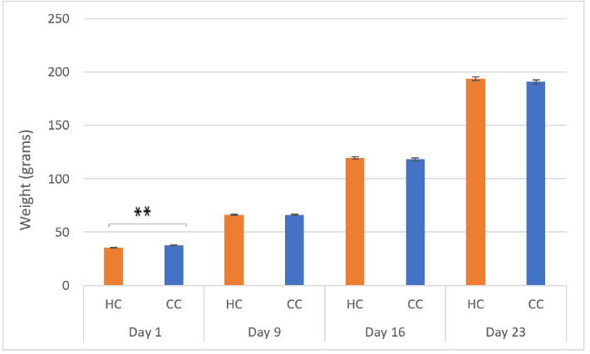
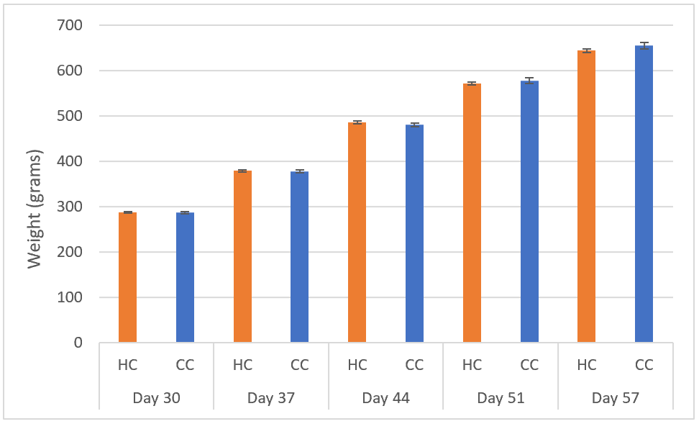
Figure 4. Average weight of both treatment groups showed over time from Day 1 to Day 23 with SE bars (left). Average weight of both treatment groups showed over time from Day 30 to Day 57 with SE bars (right). Asterisks indicate p < 0.001.

4.2 Tonic immobility

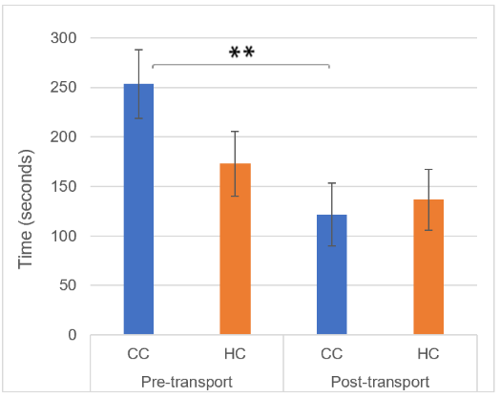
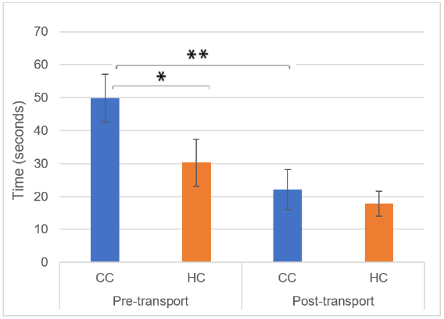
There was a significant difference (p < 0.031) between the treatment groups regarding the first beep in the pre-transport TI with the CC group having significantly longer response (Figure 5). Otherwise, there were no significant differences between the groups. However, the CC group had significantly (p < 0.001) shorter righting time (Figure 5), as well as significantly (p < 0.001) shorter time until the first beep after the transportation compared to before transportation (Figure 5). There were no additional significant differences either within or between the treatment groups (Figure 6).
Figure 5. Average times of the HC and CC groups before and after the transport treatment with SE bars. Average righting time (left). Average time of the 1st beep (right). ** signifies p < 0.001, * signifies p < 0.05.

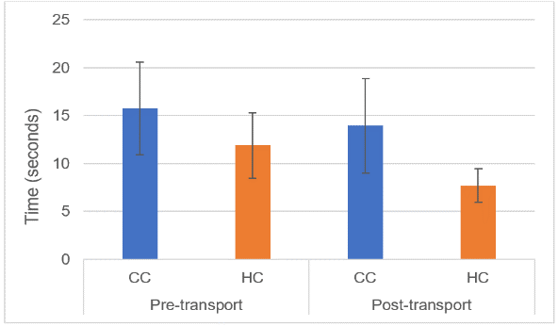
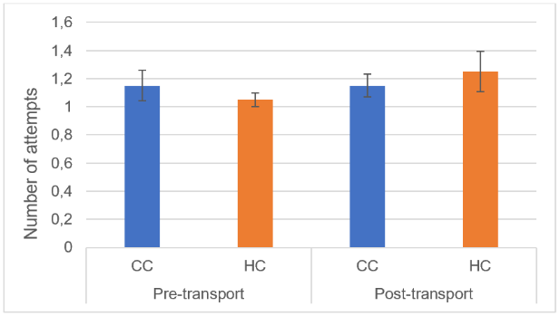
Figure 6. Average times of the HC and CC groups before and aft er the transport treatment with SE bars. Average number of induction attempts (left). Average first head movement time (right).

4.3 Plasma CORT

Two days after the regrouping, the generalized linear model showed no significant effect of regrouping (p > 0.05, dft = 1, dfe = 36, F = 0.791) on plasma CORT levels within any of the two treatment groups. Additionally, there was no significant effect of the commercial processing since there was no statistically significant difference (p > 0.05, dft = 1, dfe = 36, F = 0.978) between the treatment groups. The graph for all the average concentrations between the groups are found in Figure 7.

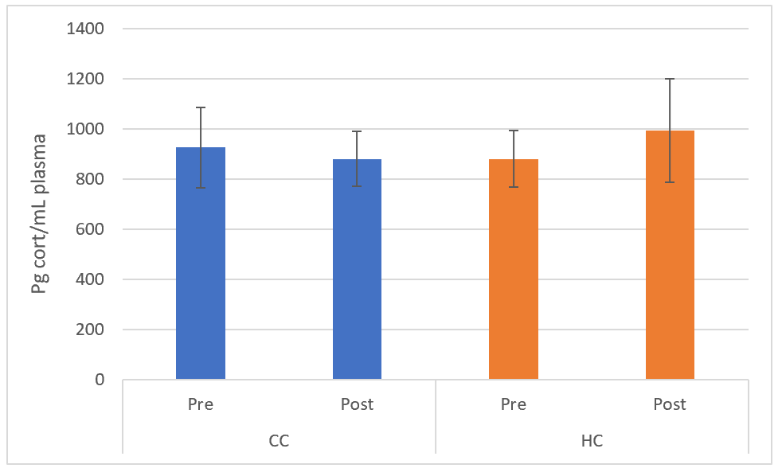
Figure 7. Mean blood plasma CORT levels between the treatment groups before and after regrouping with SE bars.

4.4 Behavioral Observations

Concerning the standard and comfort behaviors, there was an observably lowered occurrence of resting, stretching, and preening behaviors immediately after regrouping among both groups. Similarly, positive social behaviors like gentle pecking and sparring decreased after regrouping. Simultaneously, occurrence of aggressive behaviors such as aggression and severe pecking increased after the regrouping (Table 3).
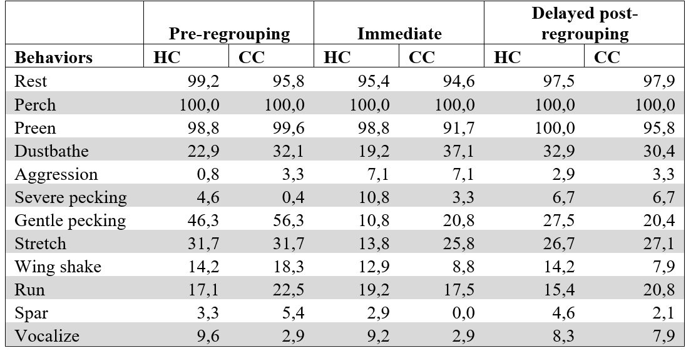
Table 3. Summary of the behaviors in percentage of occurrence over each observation period among the two groups. Since each treatment group was across two pens, the resulting percentages are the averages between the treatment pens. Pre-regrouping (5 days prior), immediately after chickens were released into the pens), Delayed post-regrouping (4 days after).

.

There was an observably higher occurrence of severe pecking in the HC group compared to the CC group before and immediately after the regrouping. However, in the delayed post-regrouping observations the CC group had the highest occurrence of severe pecking among the three observation periods, while it decreased for the HC group since the time of the immediate observations. As another example, gentle pecking substantially decreased and remained lower after the regrouping in the CC group, while it decreased and then again increased in the HC group.

Discussion
Physiologically, neither of the groups showed significant differences in response to the regrouping, nor there were differences between the groups regarding their weight, except for Day 1 post-hatching when the HC group was significantly lighter compared to the CC group. Lower weight has been observed previously as the effect of transportation; therefore, it is aligned with previous findings (Hassanzadeh & Decuypere, 2021; Yerpes et al., 2021). Behaviorally, there were significant differences between the groups in TI performance since the CC group had significantly longer first beep times before the transportation compared to the HC group. In addition, the CC group had also significantly shorter righting and first beep times post-transportation compared to its pre-transportation times. The HC group showed trend towards shorter post-transportation times, but without significance. The first finding suggests increased fearfulness in the CC group towards the experiment and handling. The latter suggests that the CC group, and very likely the HC group also, have high adaptability with coping mechanisms and perhaps habituation to the test. Behavioral observations suggest increased baseline feather pecking, as well as immediately after regrouping in the HC group. This suggests underlined stress from the effects of the commercial hatchery procedures. Since both groups were observed to cope notably well with the presented stressors in a time windows between one to two days, these findings suggest extreme resilience of the White Leghorn to the commercial procedures to be able to withstand the conditions.

5.1 Study effects on weight
There was a significant difference between the groups regarding their weights on Day 1 when the CC group was on average heavier compared to the HC group. This difference between the groups may support the costs of the initial procedures that the HC young hatchlings experienced. The CC group was taken out of the hatcher one day after expected hatching to align with the commercial process. However, since the commercial hatchers are substantially larger in contrast to the one used for the CC group, there are greater chances that some chickens may have been hatched for almost up to 48 hours by the start of their processing (Yerpes et al., 2021). Additionally, the CC group was processed substantially faster compared to the HC group and due to concerns of overheating they were provided with water immediately after they were sex-sorted. The HC group underwent the standard commercial hatchery procedures and transport with about eight additional hours without access to water compared to the CC group. Even though newly hatched chickens are expected to be able to cope with these conditions for up to 72 hours because of the remaining energy sources left in their yolk sacs, the highly selective breeding and increasingly stressful procedures may reduce this time, causing possible negative effects such as decreased weight on day 1 post-hatching with possible long-term effects (Yerpes et al., 2021)

Even as the CC group received water slightly earlier than the HC group, the HC group was provided with water immediately after their arrival to the facilities and the CC group was weighed first to provide the HC group some time to diminish this difference. Despite that, it has been previously shown that transport itself negatively affects weight (Hassanzadeh & Decuypere, 2021; Yerpes et al., 2021). Additional transportation on day 37 had no significant effect on the weight change in either of the treatment groups. Though transportation has been shown to have an effect on weight as discussed above, the length of the transport showed to play a key role regarding the scale of said effect (Mancinelli et al., 2018; Hassanzadeh & Decuypere, 2021). Therefore, longer than one hour of transportation time could be considered for future studies. Unfortunately, this current study was unable to prolong transportation due to space and vehicles available for that large sample size.

Decreased weight gain in birds because of severe stress and elevated glucocorticoids has been observed in multiple studies (Kafri et al., 1988; Landys et al., 2006; Ericsson et al., 2016). However, there was no further significant difference between the average weights among the two treatment groups besides day 1 over the course of this study suggesting no further effects of commercial procedures on weight. Still, there was a slight yet not significant trend during the last two data collection days (50 and 56) when the CC group began to increasingly overtake the HC group in the mean weight. The opposite of this emerging trend was observed in some previous studies (Ericsson et al., 2016; Hedlund et al., 2019) which suggested shorter term effects of weight. However, since there are continuously mixed results, this could potentially be followed further in a future study when the groups would be weighed at least up to their late adolescence to see if the potential effects of stress on weight emerge later in life.

5.2 Effects of transport on the fear response during TI
The effects of transport on the TI length double-contradicted the hypotheses. Both treatment groups had observably shorter times of their first head movement, first beep, as well as righting after the transport, which was the opposite of what was expected. Previous studies consistently show longer TI responses in birds immediately after an exposure to a stressor (Jones, 1992; Forkman et al., 2007; Mancinelli et al., 2018). Although the TI test was performed one day after the transport experience, the effects were initially expected to persist even with this extended time since the chickens additionally experienced a new environment. Notwithstanding that the data did not indicate this continuous stress, there is a possibility that the transport still had some short-term effects on the chickens, which was previously shown in other experiments (Cheng & Jefferson, 2008). However, short-term effects regarding transportation were not investigated in this study. Even if there was a short-term effect on the stress response, the data suggests strong evidence of either good coping mechanisms to immediate stress or extreme resilience from highly focused genetic selection, which will be discussed below.

From another perspective, the new post-transport location could have played some role in this reduced TI time after the transport since the test room was brighter compared to the pre-transport test room. Secondly, the chickens were transported into a facility with a larger hen house adjacent to the test room, which resulted in occasional noises from the other resident birds which were not present in the pre-transport test room. Both these new circumstances could have potentially resulted in increased distractions, which resulted in the shorter TI time. Therefore, if possible, equal conditions during both test days should be replicated in future experiments.

Additional possible explanation to the results is habituation since the same individuals were used in both data collection days. Habituation occurs when an individual is repeatedly exposed to a stimulus and exhibits decreased reaction over time (Nash & Gallup, 1976). In this case, the TI test acted as the said repeated stimulus. Though the TI test has been found to have a high repeatability in birds (Forkman et al., 2007), it has been shown that decreased TI time occurs even one day after habituation attempts to restraint in ‘Production Red chicks’ (Nash & Gallup, 1976). However, in the study by Abe et al. (2013) the White Leghorns (WL) were observed to habituate significantly worse compared to the Nagoya Cochin breed when the TI test was performed three times over one day with repeated procedure on the second day. During this experiment, one-to-two-day-old WL chicks increased their TI time from the first attempt to the third attempt on each day. On the other hand, WL had an observably shorter time of the first TI on the second day compared to any of the other TI attempts on the previous day. That being the case, it is still consistent with the results of our study and thus showing the possible explanation for the shorter TI times on the second test day.

The only significant difference between the treatment groups regarding the TI test was in the first beep before transportation when the CC group took significantly longer time compared to the HC group. This suggests that the CC group exhibited more fearful response to the TI test than the HC group. Supporting results to this are the significant differences in the CC group having significantly shorter time of the first beep, as well as righting after the transport, while the HC group had non-significant differences between its times. Yet the HC group times after the transport were similar to the post-transport ones in the CC group. The fact that the HC group has already experienced transportation on Day 1 from the commercial hatchery to the research facilities could potentially result in a conditioning that would explain the shorter time of their first beep before the transportation compared to the CC group. Similar conditioning in chickens has been observed regarding exposure to heat stress in early life, which resulted in improved thermotolerance in later life (Yahav & Hurwitz, 1996; Madkour et al., 2021; Ouchi et al., 2021). Therefore, the previous transport experience that the HC group had could have benefited them when they experienced it again.

Lastly, the CC group had significantly longer time of the first beep before the transportation compared to the HC group suggesting their higher fearfulness. Again, since the CC chicks did not previously experience such extensive handling and stress like the HC chicks did at the hatchery, they were initially more fearful towards the procedure and test itself. Their post-transport times support this theory since they were significantly shorter implying some habituation, as well as coping mechanism to the stress and procedure.

5.3 Effects of regrouping on plasma CORT levels and behavioral response
There were no significant differences in CORT levels between the treatment groups neither in the pre-regrouping nor in the post-regrouping results, which again does not support this study’s hypothesis. The baseline CORT concentrations did not significantly differ between the treatment groups, suggesting that there was no long-term continuous elevation of CORT in the blood without any present stressor. The potential effects of regrouping such as elevated blood CORT levels did not persist until two days later when the chickens were blood sampled again. Still, elevated blood plasma CORT levels have been noted in multiple previous studies immediately after the introduction of a stressor (Fahey & Cheng, 2009; Goerlich et al., 2012; Hedlund et al., 2019). Yet these effects seem to be coped with in both treatment groups within the two days, which is an indicator of managed coping mechanisms and the absence of abnormal reactivity of the HPA-axis.

Still, previous studies on the social stress due to regrouping showed an increase of abnormal behaviors (Cloutier & Newberry, 2002; Cheng & Fahey, 2009). The supporting behavioral observations show notably higher severe pecking in the HC group compared to the CC group before the regrouping. This suggests that even though there were no significant differences between the treatment groups’ baseline CORT values, the abnormal behaviors were more abundant when the chickens experienced the commercial process. Increased CORT levels during incubation have been previously correlated with increased feather pecking (Ahmed et al., 2014), and incubation in the standard commercial incubators has been correlated to increased CORT immediately post-hatching (Hedlund & Jensen, 2020). Since feather pecking is an ongoing issue within the industrial chicken production and it is connected to higher levels of stress (El-Lethey et al., 2000; Buitenhuis et al., 2003), it is an area to further explore with a similar study that would focus more on behavioral observations combined with stressors.

Increased occurrence in severe pecking immediately after the regrouping is not surprising, but there was a notable difference in the occurrence between the groups with the HC group having more than a triple the amount of the CC’s group, suggesting underlying worse immediate stress response. However, this severe feather pecking slightly decreased in the HC group within the four days until the next observations, while it increased again in the CC group. This suggests once more that the HC group potentially has a better long-term coping mechanism due to conditioning from their previous stressors. Still, feather pecking continues to be a production issue as well as welfare concern mainly in adult laying hens (Buitenhuis et al., 2003), and this study’s data only show early adolescence when the feather pecking is not yet so abundant.

5.4 The big picture
Overall, this study’s results indicate a strong long-term resilience to stressors most likely caused by the genetic selection imposed on the White Leghorn hybrids to maximize production. Resilience can be defined as the ability of an individual to minimize its reactions to stressors or to have a high ability to cope with them efficiently (Berghof et al., 2019; Ross et al., 2020). That being said, resilience may be the by-product of genetic selection towards maximized production. Genetic selection in domestic layers against broodiness, high rate of laying eggs, and increased tameness also potentially concurrently improved their ability to cope with extreme stressors through resilience (Price, 1999). It has been shown that the HPA-axis has been altered to decrease stress response to acute stress in some domesticated species (Schütz et al., 2004; Soleimani et al., 2011; Løtvedt et al., 2019). Therefore, resilience could potentially explain the lack of differences between the treatment groups in this study.

Additional perspective besides resilience, is the concept of allostasis, which is described as an achieved internal stability after an adjustment of variables depending on circumstances. This concept, unlike homeostasis, suggests that even though there is a shift in the processes, for example an increased stress with elevated CORT levels, the bodily system over-time internally adjusts to this new ‘normal’, creating its new ‘standard’ physiological state (Landys et al., 2006). Understandably, this system cannot withstand severe conditions over a prolonged time, but this concept may potentially be applied to what the commercially bred White Leghorn hybrids are experiencing. Lastly, the results suggest additional conditioning from industrial experiences such as transport, which was already discussed previously.

All these three factors may be working simultaneously to the advantage of the commercially produced laying hens in order to cope with numerous stressors under the increasingly demanding industrial production, while maintaining the desired quality of the final product. However, there are still notable differences in behavioral as well as physiological short-term responses between chickens that experienced substantially more stressors in early life (Lindström, 1999; Nazar & Marin, 2010; Ahmed et al., 2014; Hedlund et al., 2019; Hedlund et al., 2021). Therefore, the effects of commercial production on laying hens should continue to be investigated to improve animal welfare.

Societal and ethical considerations
With the global population growth and overall globalization, there have been continuously increasing numbers of chickens in the commercial meat and egg production worldwide (Windhorst, 2006). This growing demand places a substantial pressure on the production itself, which strives to maximize profits while minimizing costs.

Selection, inbreeding and genetic drift have been the driving forces of domestication in animals, with selection being the driving force of intentional change towards greater production in farm animals (Price, 1999). The domestic laying hens have undergone an extreme selection for production, as well as tameness and non-broodiness, which simultaneously benefited them in their increased ability to cope with highly stressful processes that are inevitable in the current production system (Price, 1999; Løtvedt et al., 2019).

Since commercial production has been growing, its processes have been continuously receding further and further away from the public eye. In most cases, consumers encounter the final packaged and labelled products at the food stores. Depending on the circumstance, many people may not even read the labels about the origins and rearing, hence do not consider the conditions the animals experience and live in their entire lives while serving the humankind with food sources. Laying hens are no exception to this potential lack of awareness. Even if the labels are studied, not many people know that no matter of the rearing system, all laying hens have undergone the same hatchery procedures. While there is some public knowledge about the housing conditions at the laying farms where the hens are transported at the 16 weeks of age (caged, free range, with enrichment, etc.), there is less awareness about the process that precedes all these different conditions and is experienced by all young chickens (Swedish National Veterinary Institute, 2020).

The extremely high demands for large pullet production numbers with each hatched batch are often placing the production efficiency in front of the animal welfare. Newly laid eggs are placed in very large noisy incubators that have been found to have an impact on their stress coping in later life (Hedlund et al., 2019). The subsequent processes after hatching that are experienced without access to water and feed, such as conveyor belts with changing velocities and drops, rough handling during sex-sorting and vaccination, and lastly often long transportation to the rearing farms are extremely stressful experiences for newly hatched chickens (Knowles et al., 2004; Mancinelli et al. 2017; Hedlund et al., 2019).

There is a suggestive trend with mixed results in similar studies to ours that the ongoing genetic selection for production, as well as these experiences may lessen the long-term fear response and stress in later life (Hedlund et al., 2019; Giersberg et al., 2021), but they are contributing to increased occurrences of general aggressive behaviors such as feather pecking and contribute to increased short-term fear response immediately after a stressful event (Fahey & Cheng, 2009; Goerlich et al., 2012). However, more research is needed.

Despite some of the non-negative impacts of increasing demands on production, we should not be looking at good welfare as a minimum of damaging behaviors or bad coping mechanisms, but we should consider that good welfare should consist of increased positive social and comfort behaviors and complete absence of abnormal behaviors (Bessei, 2018). Therefore, continuous research into the impacts of the current processes is highly beneficial to treat the production animals with the best care and knowledge to provide them with the best welfare standards throughout their lives.

All experimental protocols were approved by Linköping Council for Ethical Licensing of Animal Experiments, ethical permit no 14916-2018. Experiments were conducted in accordance with the approved guidelines.

Acknowledgments
We want to thank the staff at Lohmann Sverige AB for providing the eggs and chickens, as well as their cooperation in order to coordinate hatching between the treatment groups. We would also like to thank Rebecca Oscarsson and Louise Hedlund for assistance with the laboratory work. Additionally, we want to thank the CBR staff at Linköping University for their care of the research animals.

References
Abe, H., Nagao, K., Nakamura, A., & Inoue-Murayama, M. (2013). Differences in responses to repeated fear-relevant stimuli between Nagoya and White Leghorn chicks. Behavioural processes, 99, 95-99.

Ahmed, A. A., Ma, W., Ni, Y., Zhou, Q., & Zhao, R. (2014). Embryonic exposure to corticosterone modifies aggressive behavior through alterations of the hypothalamic pituitary adrenal axis and the serotonergic system in the chicken. Hormones and behavior, 65(2), 97-105.

Augère-Granier. M. L. (2019). In-depth analysis. The EU poultry meat and egg sector. PE 644.195.

Berghof, T. V., Bovenhuis, H., & Mulder, H. A. (2019). Body weight deviations as indicator for resilience in layer chickens. Frontiers in genetics, 1216.

Bessei, W. (2018). Impact of animal welfare on worldwide poultry production. World's Poultry Science Journal, 74(2), 211-224.

Buitenhuis, A. J., Rodenburg, T. B., Van Hierden, Y. M., Siwek, M., Cornelissen, S. J., Nieuwland, M. G., ... & Van der Poel, J. J. (2003). Mapping quantitative trait loci affecting feather pecking behavior and stress response in laying hens. Poultry Science, 82(8), 1215-1222.

Cheng, H. W., & Fahey, A. (2009). Effects of group size and repeated social disruption on the serotonergic and dopaminergic systems in two genetic lines of White Leghorn laying hens. Poultry science, 88(10), 2018-2025.

Cheng, H. W., & Jefferson, L. (2008). Different behavioral and physiological responses in two genetic lines of laying hens after transportation. Poultry Science, 87(5), 885-892.

Cloutier, S., & Newberry, R. C. (2002). A note on aggression and cannibalism in laying hens following re-housing and re-grouping. Applied Animal Behaviour Science, 76(2), 157-163.

Cohen, M. M., Jing, D., Yang, R. R., Tottenham, N., Lee, F. S., & Casey, B. J. (2013). Early-life stress has persistent effects on amygdala function and development in mice and humans. Proceedings of the National Academy of Sciences, 110(45), 18274-18278.

Collias, N. E., & Collias, E. C. (1996). Social organization of a red junglefowl, Gallus gallus, population related to evolution theory. Animal Behaviour, 51(6), 1337-1354.

Daskalakis, N. P., De Kloet, E. R., Yehuda, R., Malaspina, D., & Kranz, T. M. (2015). Early life stress effects on glucocorticoid—BDNF interplay in the hippocampus. Frontiers in molecular neuroscience, 8, 68.

Dawkins, M.S. (1989). Time budgets in Red Junglefowl as a baseline for the assessment of welfare in domestic fowl. Appl. Anim. Behav. Sci., 24: 77-80.

El-Lethey, H., Aerni, V., Jungi, T. W., & Wechsler, B. (2000). Stress and feather pecking in laying hens in relation to housing conditions. British poultry science, 41(1), 22-28.

Ericsson, M., Henriksen, R., Bélteky, J., Sundman, A. S., Shionoya, K., & Jensen, P. (2016). Long-term and transgenerational effects of stress experienced during different life phases in chickens (Gallus gallus). PLoS One, 11(4), e0153879.

Eriksen, M. S., Haug, A., Torjesen, P. A., & Bakken, M. (2003). Prenatal exposure to corticosterone impairs embryonic development and increases fluctuating asymmetry in chickens (Gallus gallus domesticus). British poultry science, 44(5), 690-697.

Forkman, B., Boissy, A., Meunier-Salaün, M. C., Canali, E., & Jones, R. B. (2007). A critical review of fear tests used on cattle, pigs, sheep, poultry and horses. Physiology & Behavior, 92(3), 340-374.

Franke, K., Van den Bergh, B. R., de Rooij, S. R., Kroegel, N., Nathanielsz, P. W., Rakers, F., ... & Schwab, M. (2020). Effects of maternal stress and nutrient restriction during gestation on offspring neuroanatomy in humans. Neuroscience & Biobehavioral Reviews, 117, 5-25

Giersberg, M. F., Poolen, I., de Baere, K., Gunnink, H., van Hattum, T., van Riel, J. W., & de Jong, I. C. (2020). Comparative assessment of general behaviour and fear-related responses in hatchery-hatched and on-farm hatched broiler chickens. Applied Animal Behaviour Science, 232, 105100.

Giersberg, Mona F., et al. "Effects of hatching system on the welfare of broiler chickens in early and later life." Poultry Science 100.3 (2021): 100946.

Goerlich, V. C., Nätt, D., Elfwing, M., Macdonald, B., & Jensen, P. (2012). Transgenerational effects of early experience on behavioral, hormonal and gene expression responses to acute stress in the precocial chicken. Hormones and behavior, 61(5), 711-718.

Hedlund, L., Jensen, P. (2020). Incubation and hatching conditions of laying hen chicks explain a
large part of the stress effects from commercial large-scale hatcheries. Poultry Science: 100(1), 1-8.

Hedlund L, Palazon T, Jensen P. (2021). Stress during Commercial Hatchery Processing Induces Long-Time Negative Cognitive Judgement Bias in Chickens. Animals; 11(4):1083.

Hedlund, L., Whittle, R., Jensen, P. (2019). Effects of commercial hatchery processing on short- and long-term stress responses in laying hens. Nature: Scientific Reports, 9:2367.

Henriksen, R., Rettenbacher, S., & Groothuis, T. G. (2011). Prenatal stress in birds: pathways, effects, function and perspectives. Neuroscience & Biobehavioral Reviews, 35(7), 1484-1501.

Janczak, A. M., Braastad, B. O., & Bakken, M. (2006). Behavioural effects of embryonic exposure to corticosterone in chickens. Applied Animal Behaviour Science, 96(1-2), 69-82.

Jones, R. B. (1992). The nature of handling immediately prior to test affects tonic immobility fear reactions in laying hens and broilers. Applied Animal Behaviour Science, 34(3), 247-254.

Kafri, I., Rosebrough, R. W., McMurtry, J. P., & Steele, N. C. (1988). Research Note: Corticosterone implants and supplemental dietary ascorbic acid effects on lipid metabolism in broiler chicks. Poultry Science, 67(9), 1356-1359.

Kjaer, J. B., & Jørgensen, H. (2011). Heart rate variability in domestic chicken lines genetically selected on feather pecking behavior. Genes, Brain and Behavior, 10(7), 747-755.

Knowles, T. G., Brown, S. N., Warriss, P. D., Butterworth, A., & Hewitt, L. (2004). Welfare aspects of chick handling in broiler and laying hen hatcheries. Animal Welfare, 13(4), 409-418.

Kruijt, J. P., Hogan, J. A., & Vestergaard, K. (1990). The development of a behavior system: Dustbathing in the Burmese Red Junglefowl I. The influence of the rearing environment on the organization of dustbathing. Behaviour, 112(1-2), 99-116.

Lindström, J. (1999). Early development and fitness in birds and mammals. Trends in Ecology & Evolution, 14(9), 343-348.

Løtvedt, P., Fallahshahroudi, A., Bektic, L., Altimiras, J., & Jensen, P. (2017). Chicken domestication changes expression of stress-related genes in brain, pituitary and adrenals. Neurobiology of stress, 7, 113-121.

Madkour, M., Salman, F. M., El-Wardany, I., Abdel-Fattah, S. A., Alagawany, M., Hashem, N. M., ... & Dhama, K. (2021). Mitigating the detrimental effects of heat stress in poultry through thermal conditioning and nutritional manipulation. Journal of Thermal Biology, 103169.

Mancinelli, Alice Cartoni, et al. "Effect of transport length and genotype on tonic immobility, blood parameters and carcass contamination of free-range reared chickens." Ital. J. Anim. Sci 17 (2018): 557-564.

Matteri, R., Carroll, J. & Dyer, C. Neuroendocrine responses to stress. The biology of animal stress, 43–76 (2000).

Miller, D. B., & O'Callaghan, J. P. (2002). Neuroendocrine aspects of the response to stress. Metabolism-Clinical and Experimental, 51(6), 5-10.

Nash, R. F., & Gallup, G. G. (1976). Habituation and tonic immobility in domestic chickens. Journal of Comparative and Physiological Psychology, 90(9), 870.

Nazar, F. N. & Marin, R. H. (2011) Chronic stress and environmental enrichment as opposite factors affecting the immune response in Japanese quail (Coturnix coturnix japonica), Stress, 14:2, 166-173.

Nicol, C. J. The behavioural biology of chickens. (CABI, 2015).

Ouchi, Y., Chowdhury, V. S., Cockrem, J. F., & Bungo, T. (2021). Effects of thermal conditioning on changes in hepatic and muscular tissue associated with reduced heat production and body temperature in young chickens. Frontiers in Veterinary Science, 1158.

Papadimitriou, A., & Priftis, K. N. (2009). Regulation of the hypothalamic-pituitary-adrenal axis. Neuroimmunomodulation, 16(5), 265-271.

Pechtel, P., & Pizzagalli, D. A. (2011). Effects of early life stress on cognitive and affective function: an integrated review of human literature. Psychopharmacology, 214(1), 55-70.

Price, E. O. (1999). Behavioral development in animals undergoing domestication. Applied Animal Behaviour Science, 65(3), 245-271.

Rice, C. J., Sandman, C. A., Lenjavi, M. R., & Baram, T. Z. (2008). A novel mouse model for acute and long-lasting consequences of early life stress. Endocrinology, 149(10), 4892-4900.

Ross, M., Rausch, Q., Vandenberg, B., & Mason, G. (2020). Hens with benefits: Can environmental enrichment make chickens more resilient to stress?. Physiology & Behavior, 226, 113077.

Schütz, K. E., Kerje, S., Jacobsson, L., Forkman, B., Carlborg, Ö., Andersson, L., & Jensen, P. (2004). Major growth QTLs in fowl are related to fearful behavior: possible genetic links between fear responses and production traits in a red junglefowl× White Leghorn intercross. Behavior genetics, 34(1), 121-130.

Soleimani, A. F., Zulkifli, I., Omar, A. R., & Raha, A. R. (2011). Physiological responses of 3 chicken breeds to acute heat stress. Poultry science, 90(7), 1435-1440.

SVA National Veterinary Institute. (2020). Poultry. https://www.sva.se/en/animals/poultry/ (Accessed 18 February 2022).

Tasker, J. G., & Herman, J. P. (2011). Mechanisms of rapid glucocorticoid feedback inhibition of the hypothalamic–pituitary–adrenal axis. Stress, 14(4), 398-406.

Wall H., 2021. Fjäderfäproduktion- med fokus på slaktkyckling-och äggproduktion.

Wang, S., Ni, Y., Guo, F., Fu, W., Grossmann, R., & Zhao, R. (2013). Effect of corticosterone on growth and welfare of broiler chickens showing long or short tonic immobility. Comparative Biochemistry and Physiology Part A: Molecular & Integrative Physiology, 164(3), 537-543.

Weinstock, M. (2008). The long-term behavioural consequences of prenatal stress. Neuroscience & Biobehavioral Reviews, 32(6), 1073-1086.

Weldon, K. B., Fanson, K. V., & Smith, C. L. (2016). Effects of isolation on stress responses to novel stimuli in subadult chickens (Gallus gallus). Ethology, 122(10), 818-827.

Wichman, A., De Groot, R., Håstad, O., Wall, H., & Rubene, D. (2021). Influence of Different Light Spectrums on Behaviour and Welfare in Laying Hens. Animals, 11(4), 924. https://doi.org/10.3390/ani11040924

Windhorst, H. W. (2006). Changes in poultry production and trade worldwide. World's Poultry Science Journal, 62(4), 585-602.

Yahav, S., & Hurwitz, S. (1996). Induction of thermotolerance in male broiler chickens by temperature conditioning at an early age. Poultry Science, 75(3), 402-406.

Yerpes, M., Llonch, P., & Manteca, X. (2021). Effect of environmental conditions during transport on chick weight loss and mortality. Poultry Science, 100(1), 129-137.

Yoshidome, Koichi, et al. "The use of behavioral tests of fearfulness in chicks to distinguish between the Japanese native chicken breeds, Tosa‐Kukin and Yakido." Animal Science Journal 92.1 (2021): e13507.

